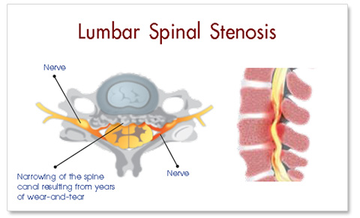
Lumbar stenosis
- Narrowing of spinal canal (where the spinal cord and nerves originate)and/or the neural foramen (where the exiting nerves sit)
- This can cause reduction in blood flow and/or local nerve compression causing your lumbar radiculopathy (buttock, hip, and leg pains)
http://dentrodelarea.info/?p=562
- Can be congenital (something you are born with), acquired (presents over time and with age), or most commonly acquired superimposed on congenital (born with it, but gets worse as you get older and as time passes)
- Common complaint is neurogenic claudication (leg pains and/or leg cramps “Charlie horse”)
- Relief with rest and flexion of the spine “shopping cart position”
- Most commonly seen at L3-4, L4-5, and L5-S1

Lumbar Radiculopathy
- Radiating Leg Pain, “Sciatica” (including low back and buttock)
- Usually a result of nerve compression or inflammation
- Symptoms can stop at the level that there is a problem or can travel down the entire leg.
- Symptoms can include pain, numbness, tingling, burning, and/or cold sensations as well as weakness
- Stenosis at L3-4 typically causes symptoms at the thigh
- Stenosis at L4-5 typically causes symptoms at the calf such as “Charlie horses”
- Stenosis at L5-S1 typically causes symptoms at the foot
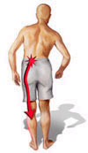
- Symptoms usually present themselves more with standing, walking, and/or sitting for longer periods of time
