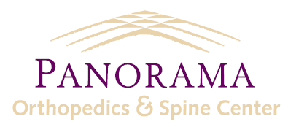
Statement and 3 Taglines-Publications

Panorama Orthopedics and Spine Center, PC complies with applicable Federal civil rights laws and does not discriminate on the basis of color, national origin, age, disability, or sex.
ATTENTION: If you speak [English], language assistance services, free of charge, are available to you. Call 1-303-233-1223

Español (Spanish): ATENCIÓN: si habla español, tiene a su disposición servicios gratuitos de asistencia lingüística. Llame al 1-303-233-1223.

Tiếng Việt (Vietnamese): CHÚ Ý: Nếu bạn nói Tiếng Việt, có các dịch vụ hỗ trợ ngôn ngữ miễn phí dành cho bạn. Gọi số 1-303-233-1223.

