

**Hip Preservation**

**Pre-Operative Packet**

**Dr. Michael B. Ellman, M.D.**

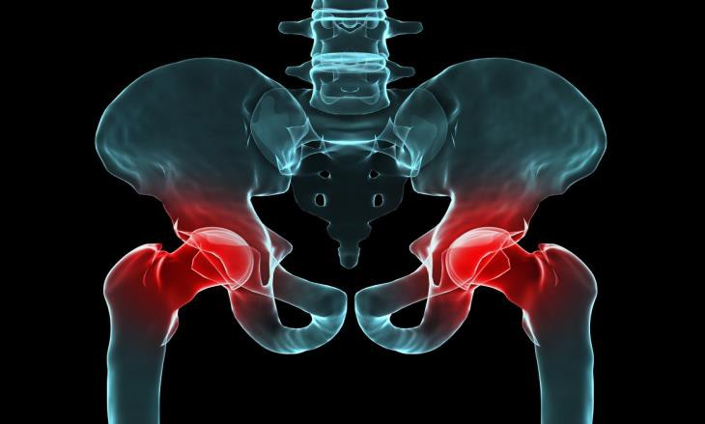

Dear Patient,

Thank you for choosing Dr. Michael Ellman at Panorama Orthopedics to address your medical needs. We are honored to be able to help you throughout your journey. It is important to know that you will have a great deal of support & guidance throughout this process. Your team of specialists includes Dr. Ellman, Barbara Wright (Physician Assistant), Samantha Gutierrez (medical and office assistant), the Panorama Orthopedics staff, and your Physical Therapists. As an approved candidate for hip arthroscopy, Dr. Ellman has confidence in your potential for success. Together, we will set realistic goals to get you to your desirable level of function. It is the mission of this team to work together with you to help you reach your goals.

***You*** are the most crucial member of the team and your active participation is invaluable to the ultimate success of your surgery. Without your commitment to reach your goals and you providing feedback along the way, other team members cannot operate as effectively in their roles. We all rely on you to provide input on what you feel is working, what may not be beneficial, and how you are best motivated.

From our experience, you can expect a challenging yet rewarding road ahead. While no two patients are the same, all experience highs and lows along the way. We encourage you to build friendships with fellow patients, but caution you in comparing yourself or your progress with other patients. You have a unique medical history, injury, surgical procedure, body type, and goals, and your road to recovery will differ from others. The ultimate goal for everyone is to return to their pre-injury level and to stay there, not just how quickly you get there. This requires a progressive return that allows for complete healing of the repaired tissues and a re-balancing of all muscles involved.

We look forward to working with you and encourage you to play an active role in the process.

Sincerely,

Michael B. Ellman, MD, and our Panorama Team

Sports Medicine | Hip Arthroscopy  
Website: [www.panoramaortho.com](http://www.panoramaortho.com)Email:  drellmanpc@panoramaortho.com  
Office: [303-233-1223](tel:303-233-1223)

# Contact Information for Dr. Michael Ellman

Clinical Liaison/Surgery Scheduler: Samantha Gutierrez

Phone: 303-233-1223 Ext: 6605

Fax: 720-497-6730

Email: [drellmanpc@panoramaortho.com](mailto:drellmanpc@panoramaortho.com)

|  |  |  |
| --- | --- | --- |
| Department | Reasons to call | Contact Information |
| **Care Navigation (Triage Dept)**  (7am-5pm M-F)  *Excluding Holidays | * Medical questions or concerns that require immediate attention | Call: 303-233-1223  Extension 1100 |
| **Prescription Line**  (8am-3pm M-F)  *Excluding Holidays | * Refills for prescriptions * Change in prescriptions | Call: 720-497-6662  (Requests after 3pm are handled  the next business day) |
| **Appointment Scheduling**  (7am-5pm M-F)  *Excluding Holidays | * Schedule follow up appointments and office visits * Answers questions regarding patient appts | Call: 303-233-1223  Option 2, then option 1 |
| **Disability/FMLA Paperwork** | * Questions and concerns regarding disability, FMLA, return to work paperwork | Fax forms to: 720-497-6730  Email: [drellmanpc@panoramaortho.com](mailto:drellmanpc@panoramaortho.com) or drop off paperwork in person at any office  **Please allow 5-7 business days for completion** |
| **Pre-Authorizations**  (9am-4:30pm M-F)  *Excluding Holidays | * Insurance authorization questions and concerns regarding surgery, injections and imaging ordered by physician (MRI, CT, ultrasounds, EMG’s) | Call: 303-233-1223  Extension 1011 |
| **Panorama**  **Physical Therapy** | * Schedule physical therapy appointments * Questions or concerns for your Therapist | Centralized Scheduling Office 303-274-7330 |
| **Billing and Customer Service Office** | * Questions on Insurance or Billing | 720-497-6637 |
| **Ortho Colorado Hospital** | * Pre-Admit Testing Questions * Check-in and Surgery Times | 720-321-5450  720-321-5170 |
| **Littleton Hospital** | * General Questions * Check-in and Surgery Times | 303-730-8900 (main hospital line) |
| **South Denver Surgery Center** | * General Questions * Check-in and Surgery Times | 720-360-3400 (main line) |
| **CPM Questions** | * Questions about CPM, problems with CPM | 1-800-845-6364 |
| **Hip Brace Questions** | * Questions about use of hip brace / settings | DonJoy Representative  303-469-3795 |

# 

# Important Surgery Instructions

## Preoperative Instructions

Please follow these instructions carefully. If you have any questions, please contact a member of Dr. Ellman’s team at (303) 233-1223, ext 6605.

**SURGERY SCHEDULING**

Thank you for choosing to schedule surgery with Dr. Michael B. Ellman. We are excited to be involved in your surgical experience. In preparation for your surgery, we would like to inform you of all the necessary steps to be completed prior to your procedure.

* Once you decide to proceed with surgery, you will need to contact Samantha Gutierrez to set up a surgical date. We then submit the surgery order to your insurance for approval. Please note, Dr. Ellman’s schedule books up rapidly and he is typically booked out 1-2 months for hip arthroscopy. We will do our best to accommodate your needs and time requests.
* If you do not hear from our schedulers within 1-2 weeks of scheduling your surgery, please call 303-233-1223; ext 6605 or email drellmanpc@panoramaortho.com
* Once you schedule a surgical date, you will receive a call from a hospital administrator approximately 2 days prior to your surgery to inform you of the specific time of your surgery, including check-in time and hospital directions and information.
* We operate at several locations. Please make note of which facility your surgery will be performed. These are the locations we operate out of:
  + **OrthoColorado Hospital** (connected to St. Anthony’s Hospital)
    - 11650 W. 2nd Place

Lakewood, CO 80228

* + **Littleton Adventist Hospital**
    - 7700 S. Braodway

Littleton, CO 80122

* + **South Denver Surgery Center** 
    - 300 E. Mineral Avenue, Suite 9

Littleton, CO 80122

## Preoperative Checklist

**2-4 WEEKS PRIOR TO SURGERY:**

* **Pre-Operative Health Clearance** 
  + Pre-operative testing may be required prior to surgery. In general, if you are healthy and active, you will not require medical clearance. If you have a known medical condition, however, you may be required to undergo preoperative clearance and testing. **If requested**, this must be done within 30 days of your surgery date, and Dr. Ellman’s office will need the results prior to surgery. Please ask your physician to contact Dr. Ellman’s office at (303) 233-1223; ext 6605 if there are any questions. **If requested**, the following documents should be obtained and sent to Dr. Ellman’s office within 30 days of surgery.
    - Letter for medical clearance from your primary care physician
    - Letter for medical clearance from specialist if necessary (e.g. cardiologist)
    - Possible preoperative lab tests requested:
      * Blood Work
      * EKG (if requested or over 40 years of age)
      * Chest X-ray (if requested or over 40 years of age)
      * Additional testing if necessary or recommended by your Medical Doctors.
      * If you are on anticoagulation or blood thinners, or are a chronic pain patient, please obtain preoperative plan from your PCP or pain physician before surgery.

**Note: You MUST have ALL tests and preoperative clearance completed within 30 days of your surgery and sent to our office at least 5 days prior to your surgical date.**

* Cancel any dental appointments within 2 weeks of your surgery.
* Notify Dr. Ellman if you are having any medical procedures done within one month of your surgery.
* Avoid any cortisone injection into the affected hip within 6 weeks of your surgery.
* **Discontinue birth control 1 month prior to your surgery.**
* Adjust work/social schedule accordingly during your anticipated recovery time.
* Practice the exercises listed at the end of this packet as these will help with your strength after surgery.
* If you smoke, you should attempt to stop smoking. If you cannot stop smoking permanently, if you can abstain for 24 hours before surgery, this is of benefit. It is essential to not smoke for at least 48 hours after surgery to aid in the healing process.

**1 WEEK PRIOR TO SURGERY:**

* Notify Dr. Ellman if there has been a change in your medical condition (cold, infection, fever, etc.) prior to surgery. It may be necessary to reschedule your surgery.
* Arrange for a family member or friend to accompany you to the hospital on the day of surgery, and for someone to stay with you for the first night you return home (typically the day of surgery).
* Please discontinue NSAID medications such as ibuprofen, and Aleve **TWO WEEKS** prior to surgery. Discontinue all over-the-counter herbal medications or dietary supplements **TWO WEEKS** prior to surgery. Discontinue all blood-thinners (Aspirin, Plavix, Coumadin, etc) **ONE WEEK** prior to surgery. You may continue taking Celebrex, Tylenol, tramadol (Ultram), and pain killers (ie. Vicodin/Norco) up until the day before surgery. We have a list of medications to discontinue prior to surgery if there are any questions.
* You should receive a call **within 2-3 days** of your surgery to discuss your **hip brace and CPM machine.** If you do not receive a phone call, please contact the numbers available on the contact sheet in this packet.

**DAY BEFORE SURGERY/DAY OF SURGERY:**

* Stay well hydrated the day before surgery. Drink plenty of fluids including water, Gatorade and juice. Avoid alcohol.
* If you have a cold, fever, or upper respiratory infection before your surgery, please call the office and inform Dr. Ellman’s team.
* ***DO NOT EAT OR DRINK ANYTHING AFTER MIDNIGHT BEFORE YOUR SURGERY OR YOUR CASE WILL BE CANCELLED.***
* You may take your regular medications such as high blood pressure medicines, thyroid medicines, seizure medications, and any cardiovascular medications the morning of surgery with a small sip of water.
* What to bring to surgery: **Insurance card, Photo ID, a list of your regular medications and doses**, athletic shoes, extra shorts, pants with snaps on the side or sweat pants, **crutches** and **hip brace,** and an extra bag to be used after surgery for equipment and postoperative information.
* Arrive at the hospital front desk as instructed. Plan to arrive at the hospital 2 hours before your scheduled surgical time.
* Hip arthroscopy is typically an **OUTPATIENT** surgery, so arrange for a ride home the day of surgery. In some cases, it is acceptable to stay in the hospital overnight if needed.

**AFTER SURGERY**

We require a CPM machine and a hip brace to use after surgery, and you will be contacted prior to surgery to set these up. Please make sure you are educated in how to use the brace and CPM machine. Also, we recommend an ice machine to help control swelling, help with pain control, and speed healing. The ice machine is not covered by insurance but we feel is helpful in healing following your procedure. It is your choice if you would like to purchase the ice machine. We will be happy to set you up with an ice machine at any of our office locations.

**POSTOPERATIVE APPOINTMENTS**

We will schedule your first postoperative visit for you when we schedule your surgery. You will be seen between 1 and 2 weeks after surgery, and then again at approximately 6 weeks and 12 weeks postoperatively. Please call the scheduling desk at 303-233-1223 to schedule your post-operative appointments or if you have any questions.

**PLEASE NOTE:**

Certain procedures that Dr. Ellman performs are considered unlisted because CPT has not yet assigned a procedure code for the procedure.  All of his procedures are medically approved. However, CPT has not yet established a code for the procedure using arthroscopy of the hip.  Some insurance companies will not recognize these codes, and appeals will need to be made.  As a courtesy, we will appeal; however, if your insurance carrier denies the procedure you may be responsible for a portion of the procedure. Please see the attached **Non-Covered Service Waiver** for more information.

## Surgery Descriptions

* **Labral Repair**: The labrum is reattached to the acetabulum with suture anchors and stitches are tied to hold it in place and allow for healing.
* **Labral Debridement**: Removal of small frayed edges of the torn labrum by an arthroscopic shaver tool.
* **Labral Reconstruction**: This procedure is performed when the labrum is small, of poor quality, or not repairable. A piece of allograft (cadaver) or autograft is used to replace the damaged labrum. It is held in place with suture anchors along the acetabular rim.
* **Osteoplasty:**An osteoplasty is performed at the head- neck junction of the femur. During this procedure, a motorized burr is used to shave down the bony abnormality and re-create a “normal” shape of the femoral neck.
* **Rim Trimming:** A rim trimming procedure is used to address the bony abnormality of the acetabulum (socket) of the hip using a motorized burr.
* **Subspine Decompression:** The subspinous region is the area directly above the rim of the socket. If this region is protruding or larger than normal, it can cause another area of impingement and pain. A burr is used to shave down this area to a normal contour to alleviate pain and impingement.
* **Microfracture:** A microfracture technique is performed to address a cartilage lesion on the acetabulum or on the femoral head. A pic (awl) is used to poke holes in the bone where cartilage is missing, with the goal of allowing bone marrow cells to fill the “pothole” with a blood clot, which will then mature into new cartilage. The clot is delicate and requires minimal weight-bearing and good mobility for proper healing.
* **Chondroplasty:** Minimal cartilage damage is repaired using a motorized burr tool to shave off any frayed or loose edges.
* **Capsular Closure:** In every hip arthroscopy, the capsule must be opened at the beginning of the case to allow for instruments to pass into the joint. At the end of the case, a capsular closure is when the surgeon repairs or closes the capsule to restore normal anatomy of the hip joint.
* **Capsular Plication:** A plication is done in some cases to tighten a loose capsule. During a capsular plication, the capsular tissue is overlapped and closed with sutures to hold the tissues together, adding stability to the joint.
* **Synovectomy**: A synovectomy is performed in patients who exhibit significant inflammation of the lining of the joint. During this procedure a heat probe is used to remove the irritated tissue.
* **Greater Trochanteric Bursectomy:** In this procedure, the arthroscope is inserted into the trochanteric bursa on the outside of the hip joint and a shaver is used to shave and remove inflamed bursal tissue.
* **Iliotibial Band Release:** The Iliotibial band (ITB) is a thick band of tissue that runs from the hip to the knee along the outer side of the thigh. A release is done when the ITB is excessively tight, causing irritation (bursitis) to the outer aspect of the hip.

**Hip Arthroscopy Non-Covered Service Waiver**

Patient Name _______________________________________DOB: ________________

Responsible Party (if minor) ________________________________________________

**Non-Covered Service Waiver**

**[ ]** **Standard Flat Fee**: There are several unlisted hip procedures (CPT code 29999/27299) that are deemed medically necessary per Dr. Ellman’s expertise to achieve optimal outcomes following surgery. The following procedures have been demonstrated in the literature to result in improved clinical outcomes following hip arthroscopy:

* Capsular Repair
* Capsular Imbrication or Plication
* AIIS or Subspine Decompression

At least one of these procedures is performed in every case by Dr. Ellman. Unfortunately, these services are still considered “investigational or unproven” by insurance companies and are not reimbursed. Therefore, Panorama will collect a flat fee of $500 *before* your hip arthroscopy procedure. This fee is required to continue the surgical process with Dr. Ellman.

I understand that I am responsible for the standard flat fee payment of $500 prior to my hip arthroscopy procedure.

____________________________________­­­____­­­­­__

**Signature of Responsible Party Date**

**[ ]** **Labral Reconstruction**: In some cases, Dr. Ellman may perform a **labral reconstruction** procedure. A labral reconstruction may be performed in revision settings if a labral repair or debridement has previously failed, or in rare primary settings when the labrum is too severely damaged to repair. During this procedure, a graft is used to reconstruct a new labrum from cadaver tissue. Labral reconstruction procedures are considered “investigational” by some insurance companies, despite studies demonstrating excellent success rates. If Dr. Ellman performs a labral reconstruction in your hip, you may be charged an additional $1,500 *after* surgery to cover costs associated with the procedure. We will always attempt to charge your insurance company first, but if they elect not to pay, you may be responsible for payment following surgery.

I understand that, in the event of a labral reconstruction procedure, I may be charged an additional $1,500 following surgery to cover costs associated with the procedure.

____________________________________­­­____­­­­­__

**Signature of Responsible Party Date**

## 

## Post-Operative Instructions

#### Prescription Medications

## Indocin/Indomethacin: *NECESSARY

* This medication helps to prevent excessive bone growth after surgery, which can occur with any surgery involving the hip joint.
* Take 75 mg tablet take once per day for 5 days in the evening, with food. This medication can cause stomach upset, so be sure to take it with food.
* If you are unable to tolerate this medication, please let the office know so we can put you on an alternative medication. Do NOT take ibuprofen, motrin, advil, aleve, or naproxen while taking this medication.

#### Protonix (Pantoprazole): *NECESSARY

* Take this medication to help with stomach upset due to Indocin postoperatively.
* Take 1 tab (40 mg) daily for 5 days

#### Aspirin: *NECESSARY

* This medication is given to help prevent blood clots after surgery. This may also cause stomach upset so try to take this with food as well.
* Please take 325mg daily.
* You will take this medication for a total of 30 days after surgery.

#### Oxycodone (Optional):

* This medication is for pain.
* This medication is to be taken AS NEEDED.
* Plan to stay on a scheduled dose of 1-2 tablets every 4 hours for the first 2-4 days after surgery.
* After 2-4 days you should be able to space out or discontinue the medication.
* Do not drive, drink alcohol while taking this medication.

#### Colace (Optional):

* Take 1-2 pills throughout the day to prevent constipation, which is common after surgery and while you are taking narcotics for pain control.
* It is normal to take several days to have a bowel movement after surgery.
* Drink plenty of clear liquids as the anesthesia can cause dehydration and constipation

#### Flexeril (Cyclobenzaprine) (Optional):

* Take this medication to help prevent muscle spasm postoperatively.
* Take 1 tab (10 mg) every 8 hours as needed for muscle spasm; do not take more than 30 mg (3 tablets) in one day.

**Zofran (Ondanestron) (Optional):**

* This is an anti-nausea medication. Take this AS NEEDED

#### General Postoperative Instructions

**Wound Care and Showering**

* Leave the surgical bandage on and do not shower for 48 HOURS.
* After 48 hours, remove bandages and gauze, but LEAVE STERI STRIPS (white tape, similar to white band-aids) in place during showers. It is normal to see bloody soaked fluid on the bandages.
* Apply waterproof band-aids to each incision prior to showering. If the wounds get wet while showering, this is OK; however, we prefer to keep the wounds dry during the first 5 days after surgery.
* In between showers, leave open to air with steri strips in place.
* Do not apply lotions or ointments to the incisions.
* Your stitches are absorbable under the skin – you will not need stitches removed after surgery.
* Do not soak incisions in any pool/bath water until 3 weeks postoperatively or until your incisions are completely closed.
* Do not allow pets to sit on your lap or sleep in your bed for at least 4 weeks following surgery. Pets may harbor fleas, mites or other organisms that may cause an infection.

**Physical Therapy**

* Physical therapy should start ideally within the first couple days after surgery.
* If your surgery is on Friday, it is okay to wait until early the following week.
* Choose a PT clinic close to your home so that you are compliant with your program, and schedule your first appointment for the first couple days following surgery (be sure to call and schedule physical therapy PRIOR to your surgery).
* For your first visit, please bring your prescription for physical therapy, provided at your preoperative clinic visit. You and your therapist can access the physical therapy protocol at on our website at [**www.panoramaortho.com**](http://www.panoramaortho.com) **🡪 Services & Treatments 🡪 Hip Arthroscopy 🡪 Therapy & Rehab Protocols (Bottom of Page)** 🡪 **FAI PT Protocol.**
* At your first physical therapy visit, your therapist should instruct you on proper weight bearing and teach your family members how to perform passive, light circumduction of the hip.

**Weight Bearing**

* **You will be PWB (partial weight bearing) flat foot (20 pounds) for a total of 3 weeks. Use crutches throughout this time period while walking.**
* Please walk with your foot flat and mimic normal gait.
* Once you are 3 weeks out from surgery, you may begin to progress your weight bearing slowly as directed by your therapist, unless you undergo a microfracture or labral reconstruction procedure (this will delay the time until you may begin full weight bearing, typically maintaining PWB for a total of 6 weeks following surgery).
* Getting off the crutches takes each patient a different amount of time.
* Don’t try to rush yourself to get off the crutches.

**Brace**

* You will be fitted for your brace either before your surgical day or on your surgical day. You will receive a phone call from the brace company a couple days prior to your surgery to schedule a fitting. Please try to get fitted for the brace prior to your surgery.
* You will be provided with a hip brace to be worn for the first 3 weeks following surgery, or until you are off crutches (typically 3-6 weeks). Always use crutches while wearing the brace and walk with flat foot weight bearing (20 pounds).
* **Brace Settings**:
  + - 0 degrees extension – 90 degrees flexion
    - Neutral rotation
    - 10 degrees abduction
* The brace is worn only when ambulating (walking), and is worn on the outside of your clothing. You do NOT need to wear the brace while you are sleeping, on the CPM machine, laying on your stomach, using the upright bike, or icing your hip.
* The purpose of the brace is to prevent hyperflexion and abduction (bringing the leg too close to the chest or bringing the leg too far away from the body).
* The first few days, concentrate on icing the hip and wear the brace when you are up and moving around.
* You can remove the brace for showering and using the bathroom.
* The outside post on the brace should be positioned over the outside of the leg.

**Ice**

* If using the ice machine, the machine will automatically stay on to provide continuous low temperatures and limit inflammation postoperatively
  + Use it as much as you like or can tolerate for the first 72 hours.
  + After the first 72 hours, try to use it 4-5 times per day for the first two weeks after surgery.
  + You do not need it after 2 weeks.
  + Information about picking up an ice machine is on Page 19 of your hip packet.
  + Do not wear the brace over the ice machine pad.
* If using simple ice packs, ice the hip as much as you can for the first 72 hours – 20 minutes on, 20 minutes off.
  + Ice your hip 4-5 times per day after the first 72 hours.
  + Place the ice onto the hip over a thin layer of clothing or material, but never directly onto the skin.
  + Use as needed for the first 2 weeks.

**Continuous Passive Motion (CPM) Machine**

* The use of CPM has been shown to promote early healing following surgery and decrease the risk of scar tissue or adhesions post-operatively.
* Start on the day/evening of surgery if you have time and feel up to it. However, it is also acceptable to start using the CPM machine the first day after surgery.
* Use this for a total of between 4 and 6 hours per day for a total of 3 weeks.
* You can split up into increments if you get sore/tired. You will need assistance to get into the CPM for the first couple of days after surgery.
* **Settings**: Start with the settings at 20 degrees extension and 55 degrees of flexion
  + Increase by 7-8 degrees per day as tolerated. **DO NOT GO PAST 0-90 DEGREES.**
  + Example: Day 1, 20 of ext and 55 of flexion. Day 2: 12 degrees of extension and 63 degrees of flexion, etc.
* Use for a total of 3 weeks.
* To help in the prevention of lower back pain, try and maintain proper spine alignment while in the CPM; you may roll a towel or use a small pillow behind your lower back.
* If the CPM machine is uncomfortable for you, you can substitute time on the CPM with use of a stationary bike (see below).

**Biking**

* Gentle, no resistance, upright, stationary biking can begin the day after surgery.
* Do NOT use a recumbent bike! NO Nustep!
* Use non-operative leg to push the operative leg around gently.
* 20 mins on upright bike = 1 hour on motion (CPM) machine.
* You do not have to go out and buy a bike; rather, just use the bike while at PT.

**Ted Hose**

* You will be given a pair of ted hose (stockings) to wear after surgery. These help in the prevention of blood clots postoperatively.
* Please wear these at all times for the first 2 weeks following your surgery. If they come above your knee to the thigh, you may cut them off so they end below the knee after the first week postoperatively.

**General Activity Levels**

* It is beneficial to change positions often after hip arthroscopy. Alternate sitting, reclining, and lying down approximately every 30 minutes. Feel free to move around at home as much as you can tolerate, as we do not want the hip to get stiff.
* Spend 1-2 hours per day on your stomach (you can take the brace off for this).
* You will be permitted to drive (automatic transmission) **4 days** after surgery as long as you are not taking any narcotics and you feel comfortable doing so.

**Follow-Up**

* A follow up visit will be scheduled with Barbara Wright, PA, 10-14 days following your surgery.
* Please call centralized scheduling at 303-233-1223 if you don’t have an appointment.
* Routine post-operative follow up appointments will be made 2 weeks, 6 weeks, and 3 months following surgery.

**When should you Contact the Office**

* You have a fever > 101.4 (a low grade temp is expected after surgery, but let us know if it gets this high!)
* You develop chills or sweats
* You have pus or increasing redness and warmth surrounding the incision sites
* You develop calf swelling or calf pain after surgery
* You experience any chest pain or difficulty of breathing

**Possible Postoperative Complications and Risks**

* **Infection:** The risk of infection is decreased with a sterile operating environment and antibiotics. Starting three days before your surgery, be sure to keep the skin of your hip as clean as possible using soap and water. Following surgery, careful handling of the incision sites reduces the risk of infection.
* **DVT:** Developing a DVT (deep vein thrombosis, aka blood clot) is decreased through instituting early motion (CPM), mechanical means (TED hose) and medications (Aspirin). Following the pre-operative and post-operative instructions will reduce the risk of blood clot formation.
* **Pain:** With any surgical procedure, there is a potential complication of pain. Medication, ice, rest, compression, elevation and therapy reduce post-operative pain.
* **Numbness**: With hip arthroscopy, there is a small chance of numbness in the genitalia region briefly postoperatively. Also, you may experience some numbness of the upper outer portion of the thigh on the operative leg after surgery. This is due to stretching of the lateral femoral cutaneous nerve, a sensory nerve that is close to the surgical area. This nerve may be stretched or bruised during the procedure. This is typical and the numbness should resolve over time.
* **Heterotopic Ossification**: Any time we operate around the hip joint, there is a small chance of heterotopic ossification, which is abnormal bone growth in the surrounding muscles. We give you Indomethacin for the first 5 days after surgery to help prevent this complication. Please make sure to take the Indomethacin after surgery.
* **Sexual Dysfunction**: Because we have to put the hip in traction during surgery to allow for instruments to go into the joint, there is a very small risk of nerve injury to the nerves that control sexual function. If this occurs, it is typically temporary and should resolve within 3 months following surgery.

**Cold Therapy Unit**



The DonJoy® IceMan Classic3™ delivers continuous cold therapy to help patients and medical practitioners easily manage post-operative pain and swelling, speeding patient recovery and rehabilitation. It provides extended cold therapy for a variety of indications and protocols as directed by medical professionals.

**\*Please consult our icing instructions for frequency and length of use\***

**Cost – $185 + tax (not an insurance covered item)**

Panorama Orthopedics & Spine Center offers the ability to purchase this unit directly from the Medical Supply Shop located inside the Panorama Golden location at:

**660 Golden Rd., Suite 250**

**Golden, CO 80401**

No appointment or reservation is needed if picking up in Golden office. Visit us Monday – Friday between the hours of 8am & 5pm. These units are also available for purchase at the front desk of both of our Westminster offices, as well as our Highlands Ranch, Castle Rock, and Summit offices **during clinic hours**. If staff members are working with other patients at the time of your arrival, please anticipate the possibility of a short wait for assistance in purchasing a cold therapy unit at **any** of our offices. Detailed information and instructions will be given at time of pickup.

# Home Exercises before Hip Surgery

Goals: Increase lower body strength with good core control.

**Please see how you feel with these exercises. If something causes discomfort or pain – don’t push through the pain to do it.**

**PreHab exercises: Page one – Do these 3x10 on each leg daily. All other exercises, start with 1x10, with good form, 2-3 times per week. If pain, or unable to complete without good form, skip that exercise.**

You can do any exercise you like that causes no pain during or lasting pain the days after the activity.

Do not over-stretch, you can do light stretching – gently holding 3x30 seconds.

|  |
| --- |
| 1. **Standing Hip Abduction in Internal Rotation:**   **3 *sets / 10 repetitions / Once a day***    Standing on one foot, point opposite toe inward slightly. Maintaining a level pelvis, lift your straight leg out to the side and hold for 2-3 seconds before slowly returning to start position. Do not lean away from the moving leg. Repeat on both sides. |

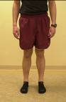 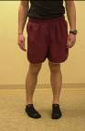

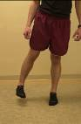

|  |
| --- |
| **B. Bridges**  **Choose one exercises per day**  ***1 set/ 20-30 repetitions / 3 x per week***  ***For each exercise, continue each repetition when able to hold stable AND no pain is felt.***  **Double leg bridge:** Lying on your back place rubber tubing around knees with hip and knees bent. Raise buttocks while keeping core stable then slowly lower.    **Single leg bridge:** Progress to single leg bridging.  **Bridge with shoulders on Ball:** Progress to laying with shoulders on ball and feet on floor then lowering and raising your buttocks.  **Bridge with single leg:** Progress to lifting one leg by extending the knee then perform with the other leg. Do not go up and down with the hips. |
|  |

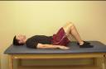 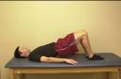

 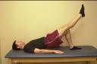

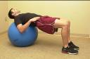 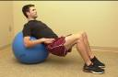

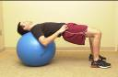 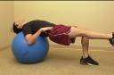

|  |
| --- |
| **C. Sidelying Glut Medius Clams:**  ***1 set/ 20-30 repetitions / 3 x week***  ***Please avoid sidelying straight leg raises as the joint reaction force is greater in this position (clams, as pictured, are okay to perform)***  **Neutral Hip Clams:**  Laying on your side, hips **straight** and knees bent to 90 degrees. Engage TA & squeeze glute to raise top knee without shifting pelvis, heels remain together throughout. Do not allow spine to collapse to table. |
|  |

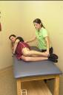 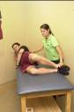

**Hip Extensions**: Keeping chest flat on table, engage TA, then squeeze glute and lift heel toward the ceiling, Keep hips touching table. Repeat twenty times.

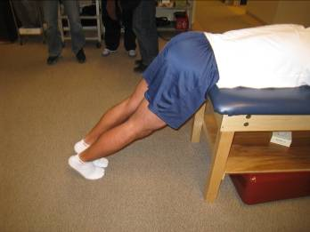 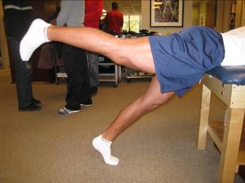

**Romanian Dead Lift:** Keeping knee straight, reach down toward the floor as you lift one leg toward the ceiling. With a flat back, reach down until feeling a light stretch in the hamstring, stand up tall to return to start position**.**

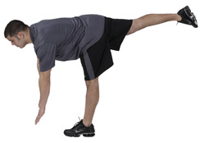

**Double Leg Squats:** Start standing with feet shoulder width apart, bend at the knees – sitting back as if into a chair, to 60°. Do not allow knees to go past toes**. 3 x 30**

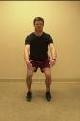 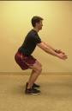

**Bridge with Ball (heels on ball)** Keep TA drawn in, slowly lift up hips and keep them even & controlled throughout motion. **Repeat for ten repetitions**

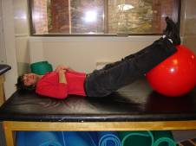 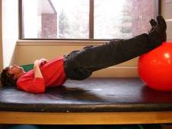

**Bridge with Ball to Hamstring Curl –** Dig heels into the ball and pull heels toward buttocks, keeping hips high and controlled. **Repeat for ten repetitions**

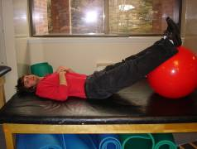 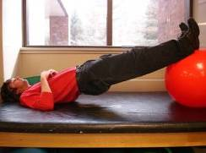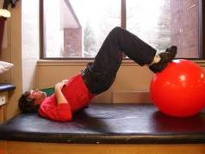

**Toe Bridges.** Keep TA drawn in, slowly lift up hips and keep them even & controlled throughout motion. **Repeat for ten repetitions**

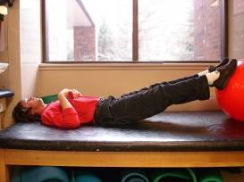 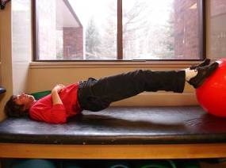

**Be well,**

Stay active – and keep moving!

# The Basics

### Hip Labral Tear

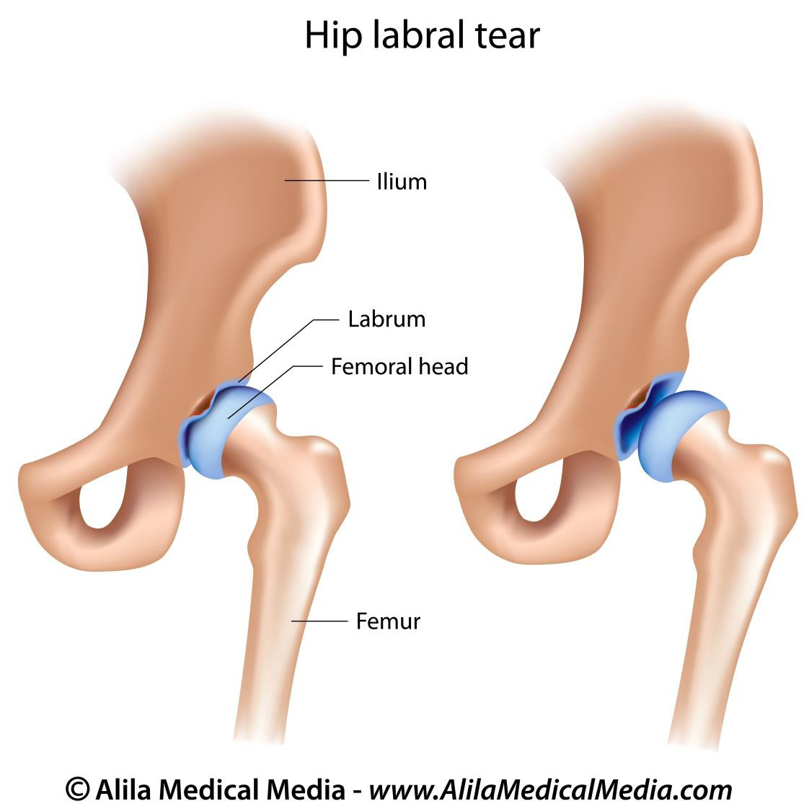

* The labrum, because of its function in distributing weight-bearing forces, is susceptible to injury from forces that occur with twisting, pivoting, and repetitive impact.
* Labral tears may result from femoroacetabular impingement (FAI), and may not be associated with a specific traumatic event.
* Due to its nerve innervation, an isolated labral tear can result in pain.
* Labral tears can cause micro-instability of the hip joint, leading to increased stresses between the femur (ball) and acetabulum (socket), which can lead to cartilage damage and progression of arthritis.

### CAM Impingement

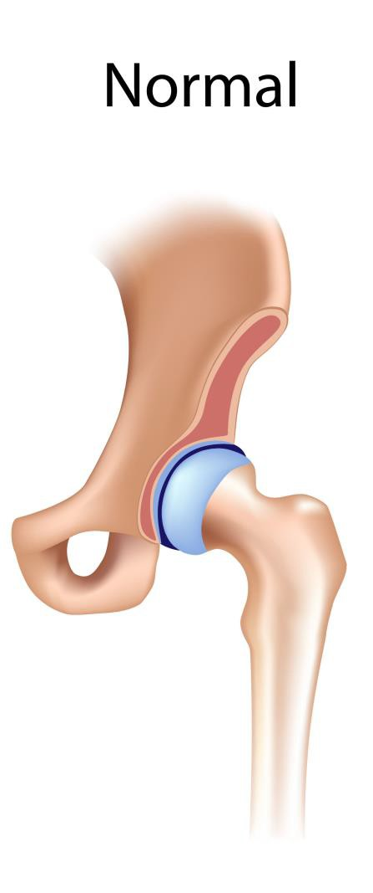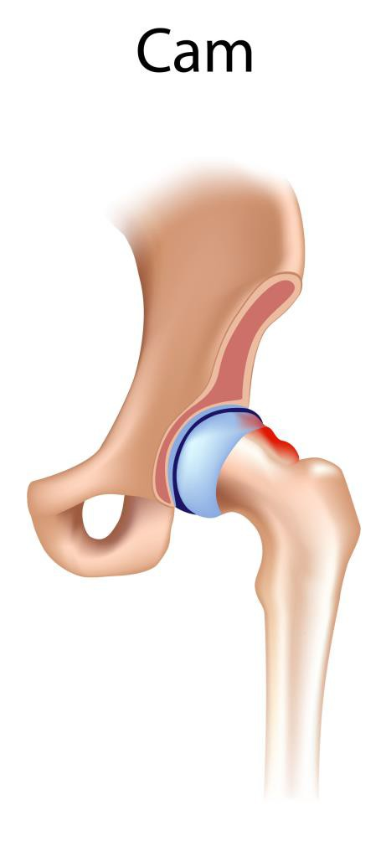

* Cam impingement occurs when the femoral head has an abnormally large radius, or an abnormal “bump” of extra bone, with a loss of the normally round shape of the femoral head.
* With a CAM lesion, the “ball” part of the “ball and socket” joint takes on more of an oval shape rather than a circle, and can cause impingement or pinching against the labrum.
* This may occur due to genetic factors or acquired factors, such as abnormal closure of the femoral head growth plate during adolescence, especially in youth athletes.
* This may lead to abnormal contact between the ball and socket, especially with certain ranges of motion, causing damage to the labrum and joint surface.
* With repetitive motion, CAM femoroacetabular impingement (FAI) may result in labral tears and articular cartilage injury.
* Cam impingement has approximately a 3-to-1 predilection for males over females.

### Pincer Impingement

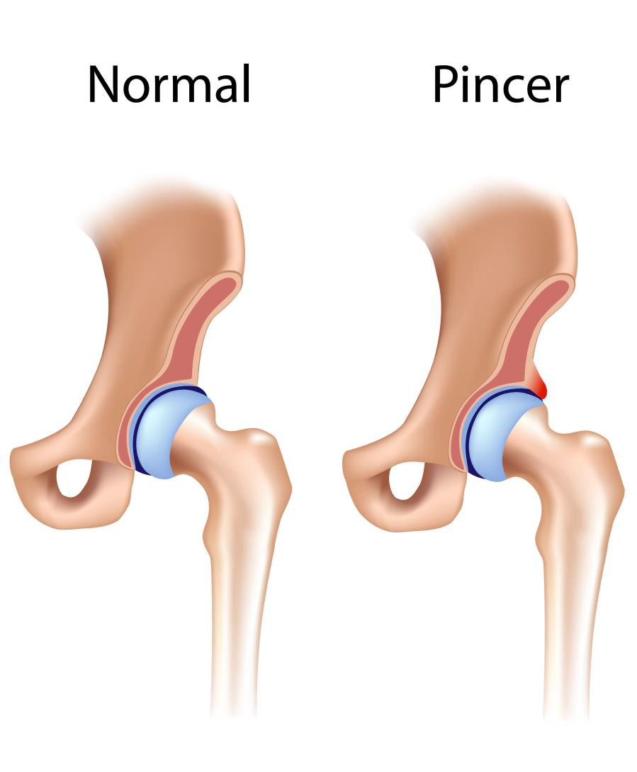

* A Pincer lesion refers to an abnormal acetabulum (socket) with increased overcoverage. Pincer impingement is caused by an abnormally deep or retroverted socket that bumps against a normal “ball” (femoral head/neck). This is opposed to CAM impingement, in which an abnormal “ball” (femoral head/neck) contacts a normal socket (acetabulum).
* Pincer lesions cause persistent impingement of the femoral head against the acetabular rim, and can be a cause of labral tears and cartilage damage.
* This can occur from overgrowth of the anterior edge, or retroversion of the acetabulum, which is a condition in which the face of the acetabulum tilts slightly backward instead of its normal forward position.
* Repetitive microtrauma against the edge of the socket leads to breakdown and tearing of the acetabular labrum.
* Pincer impingement occurs just about equally in males and females and more commonly starts to cause symptoms in middle age.