Hip Preservation
Rehabilitation and Physical Therapy Protocol

Dr. Michael B. Ellman, M.D.

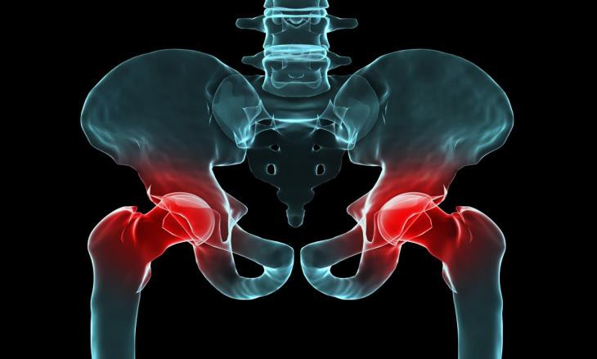

Physical Therapy
Hip Preservation

Dear Therapist,

Thank you for continuing the rehabilitation with Dr. Ellman’s patient following their hip arthroscopic surgery. The intent of this program is to provide guidelines for progression of rehabilitation. It provides the basic exercises and techniques you will need to guide the patient to return to normal function. At the 6-8 week follow-up and if appropriate for the patient, Dr. Ellman will determine whether the patient is ready to progress to an advanced functional training program for return to sport, a maintenance strength program, or to continue to work on “the basics” before progressing further.

- Utilize the rehab outline and exercise descriptions as a guide. This is a proven program in terms of exercises and treatment, but some patients may need to move slower.

- Utilize clinical decision making to adjust treatments if needed within given guidelines and precautions.

- Progression through each phase of rehabilitation is based on clinical criteria and patient progression, and the time frames are not strict. Please allow the patient and the hip to dictate the rehabilitation, not the timelines.

- Understand that the program should be tailored for the individual based on their ability to progress and respond to treatment. This concept should continually be emphasized to the patient. Advancing through the rehabilitation process involves an accurate assessment of joint function, strength, mobility and progressive overload based on the patient’s response.

- Primary goals at approx. 6 weeks out (non-mcfx) and 10 weeks out (McFx) are a normalized gait and good gluteal recruitment. We expect ROM restrictions at this time, especially External Rotation, Internal Rotation and Extension. Do not push through pain to achieve more, as these ranges will increase with a return to functional activity and not with overly aggressive stretching.

If you have any questions during the rehabilitation process, please feel free to contact Dr. Ellman at Panorama Orthopedics at 303-223-1223.

Sincerely,

Michael B. Ellman, MD
Email: mellman@panoramaortho.com
Hip Arthroscopy & Sports Medicine
Panorama Orthopedics

Table of Contents

- Rehabilitation Protocol
  - Phase I (Weeks 1-4)
  - Phase II (Weeks 5-10)
  - Phase III (Weeks 10 – Sport test)
  - Phase IV = Return to Sport
  - Cardiovascular Program
  - Functional Hip Sports Test
- Appendix I: PROM Definitions
- Appendix II: Rehabilitation Progressions
- Appendix III: Specific Exercise Photographs
- Appendix IV: Functional Hip Sports Test Instructions
- Appendix V: Beighton’s Criteria

Post Operative Hip Arthroscopy Rehabilitation Protocol

Dr. Michael B. Ellman

Labral Repair with or without FAI Component

- General Post-Operative PT Guidelines
  - Patient to be seen 1-3x/wk for 12-16 wks.
  - This protocol is written for the treating physical therapist and is not to substitute as a home exercise program for patients.
  - The post-operative rehabilitation is just as important as the surgery itself.
  - Please take a hands-on approach to the patient’s care utilizing manual therapy techniques to prevent and minimize post-operative scarring and tightness.
  - Please emphasize form and control when instructing patients in exercise to prevent compensation and soft tissue irritation from compensatory patterns.
  - This protocol serves as a guideline to patient care for the first 12-16 weeks of rehab.
  - Return to full activities / sport is generally achieved between 5 and 6 months postoperatively, but may take up to one year for some patients.
  - Patients may progress through the protocol at different rates, please always use clinical decision making to guide patient care and not strict timelines.
  - DO NOT PUSH THOUGH PAIN.

- Initial Precautions

Weight Bearing
- Non-microfracture procedures will remain Foot Flat Weight Bearing (20 pounds) for 3 weeks unless otherwise specified by Dr. Ellman.
- Microfracture procedures will remain FFWB for 6-7 weeks.

Initial ROM Restrictions for 2 weeks
- Flexion 120⁰ (Day 1-14)
- External Rotation 0⁰ with Flexion at 0⁰ (Day 1-14)
- Slight (<20 degrees) External Rotation ROM may be done gently at 90⁰ of hip Flexion by a therapist only (Days 7-14)
- Extension to 0⁰ (Day 1-14)
- Abduction to 45⁰ (2 weeks total)
- May progress to ROM as tolerated after 14 days

Other Comments / Restrictions
- Avoid hip flexor irritation; No hip flexor strengthening until indicated in the protocol (ie. Phase II)
- CPM: at least 4-6 hours daily for first 3 weeks.
  - Microfracture procedures will require use of CPM for 6-8 weeks for 6-8 hours per day.
- Hip brace for 3 weeks, settings 0-90⁰ flexion at neutral rotation and abduction/adduction
- Avoid impinging with flexion and FADIR ROM exercises

Phase 1 – Protection Phase (post-op weeks 1-4)
With Microfracture – post-op weeks 1-9

Goals:
  - Provide patient with education on initial joint protection to avoid joint and surrounding soft tissue irritation
  - Reduce swelling and pain
  - Begin initial passive range of motion within post operative restrictions
  - Initiate muscle activation and isometrics to prevent atrophy
  - Progress range of motion promoting active range of motion and stretching
  - Emphasize proximal neuromuscular control of hip and pelvis
  - Initiate return to weight bearing and crutch weaning
  - Normalize gait pattern and gradually increase weight bearing times for function

Precautions:
  - Avoid treadmill walking (this will not start until week 12)
  - Avoid irritation of the hip flexors, TFL, gluteus medius, ITB, and trochanteric bursa
  - Avoid anterior capsular pain and pinching with range of motion
  - Prevent low back pain and SIJ irritation from compensatory patterns
  - Manage scarring around portal sites and at the anterior and lateral hip
  - Do not push through pain with strengthening or range of motion

Pain and Swelling:
- PRICE – Protection, Rest, Ice, Compression, Elevation
- Use these items together to reduce pain and swelling
- At minimum, 5-6 times per day for 20-30 minute sessions
- There is no maximum!
- Icing is encouraged to be done in prone position to allow for mild stretching of the hip flexors
- Modalities as indicated - Ultrasound and Electric Stimulation
- Ankle Pumps – for swelling and DVT prevention

Range of Motion:
- Passive Range of Motion (week 1-6)
  - Partner-assisted ROM recommended 2-4 times per day, 20 minutes each episode
  - PROM Exercises
              - See Appendix I for Definitions of Exercises listed below:
              - Circumduction, Neutral Circumduction, Supine hip flexion / abduction / ER / IR, Side-lying flexion, Prone IR / ER / extension, press-ups, Supine abduction, Quadruped rocking, Half kneeling pelvic tilts
              - Maintain ROM restrictions for time periods as stated above
        - Manual Therapy Treatment Progressions (Weeks 1-6)
          - Scar massage x 5 minutes
              - Incision portals – begin post op day 2 – week 3
        - Soft tissue mobilization x 20 – 30 minutes
            - Begin POD 4 – wk 10-12
            - Begin with superficial techniques to target superficial fascia initially
            - Progress depth of soft tissue mobilization using techniques such as deep tissue massage, effleurage, pettrissage, strumming, perpendicular deformation, and release techniques
            - The use of mobilization with active and passive movement is very effective with this patient population (ART, functional mobilization etc.)
            - Soft tissue muscle groups and bony prominences
              - Anterior: Hip flexors (Psoas, Iliacus, and Iliopsoas tendon), TFL, Rectus femoris, sartorius
              - Lateral: ITB, Gluteus medius (all fibers, especially anterior), Iliac crest and ASIS
              - Medial: Adductor group, Medial hamstrings, Pelvic floor
              - Posterior: Piriformis, Gluteus medius/minimus/maximus, Deep hip ER’s (gemellus, quadratus femoris, and obturator internus), Proximal hamstrings, Sacral sulcus/PSIS/SIJ, Erector spinae, Quadratus lumborum
        - Joint Mobilizations (3-12 weeks)
            - Begin with gentle oscillations for pain grade 1-2
            - Caudal glide during flexion may begin week 3 and assist with minimizing pinching during range of motion
            - Begin posterior glides/inferior glides at week 4 to decrease posterior capsule tightness (may use belt mobilizations in supine and side lying)
            - Do not stress anterior capsule for 6 weeks post op with joint mobilizations
        - Active/Active Assist Range of Motion
  - Stationary Bike without resistance 20 minutes per day (No recumbent biking to avoid hip flexor contractures)
    - Add resistance in week 3
  - AAROM beginning at week 2
  - AROM beginning at week 2-3 as tolerated
      - Hydrotherapy
  - Aqua-jogging and ROM exercises are permitted when incisions have healed or stitches have been removed (~2weeks)

Gait:
- Crutches will be indicated for the first 3 weeks to keep excessive load off of the hip and protect healing structures. This will help to reduce swelling and pain.
Microfracture procedures must remain FFWB with crutches for 6-7 weeks.
- Weaning from crutches
  - Begin with weight shifting exercises
  - Load limited weight on 2 crutches
  - Single crutch walking
    - This will reduce weight on surgical leg by 25%
    - Be sure to place the crutch under the opposite arm
  - Walk small distances in home without crutches and take crutches for longer distances
  - Please do not come off crutches until the patient can walk without a limp!
        - Gait Exercises to promote normalized hip extension and lumbar stabilization
        - Hydrotherapy – water walking
  - Walk in water at shoulder level
  - Advance to walking at waist level
Strength:
- See Appendix II for Progressions
- Transverse Abdominus/Core isometrics in combination with all other isometric exercises
- Isometrics
  - Quad Sets (avoid SLR’s for 4-6 weeks to avoid hip flexor irritation)
  - Gluteal sets
  - Hamstring Sets
  - Ab/Adduction isometrics
  - External and Internal Rotation isometrics
- Open Chain Exercises (week 3)
  - Prone hip extension exercises
  - Glute Medius Exercises (sidelying or standing)
  - Quad and Hamstring dynamic strengthening in open chain

Proprioception and Neuromuscular Re-education:
- Begin open chain proprioception exercises
  - Prone IR/ER rhythmic stabilization exercise
- Light closed chain stability balance exercises (if pain free and weight bearing status permits)

Criteria for advancement to Phase 2
- Flexion to 120⁰
- Extension symmetrical to contralateral side
- 50% of FABER ROM as compared to contralateral side
- 75% of FADIR ROM as compared to contralateral side, without impinging
- No hip flexor contractures (otherwise remain in protective phase to decrease hip flexor tone and increase flexibility)
- Able to maintain full bridge position without compensations
- Mild deviations in gait with mild discomfort only

Phase 2 – Initial Strengthening (Post-operative weeks 5-10)
With Microfracture – Post-operative weeks 9-13

Goals:
- Eliminate Swelling
- Full active and passive ROM
- Normalize Gait
- Increase leg strength to allow for:
  - Walking 1 mile
  - Stair ascending/descending
  - Double knee bends without compensations
  - Singe knee bend to 70° without compensations
  - Resisted Side stepping without pain

Precautions:
    - Continue to avoid soft tissue irritation and flare ups that delay progression
    - Be aware of increasing activity and strengthening simultaneously to prevent compensation due to fatigue
    - Promote normal movement patterns and prevent compensations with higher level strengthening
    - Do not push through pain

Swelling:
- Continue PRICE’ing if residual swelling
- Modalities as indicated - Ultrasound and Electric Stimulation

Range of Motion:
- Motion Specific Stretching to eliminate ROM deficits
  - Thomas stretch
  - Low Load Duration Stretching for FABER and FADIR position (while avoiding impingement)
  - Single Knee to Chest stretches
  - ITB stretching
- Manual Therapy as indicated for any motion restrictions
- Continue to utilize manual therapy including soft tissue and joint mobilizations to treat patient specific range of motion limitations and joint tightness.
- Soft tissue mobilization should be continued to address continued to complaints of soft tissue stiffness at surgical sites especially for pinching in anterior hip
- Address any lumbar or pelvic dysfunction utilizing manual therapy when indicated

Strength:
- Please see Appendix II for Progressions of exercises listed below:
- Closed Chain Strength progression (Glutes and Quads)
  - Leg press with light weight and high repetitions
  - Mini Squats, 1/3 knee bends
  - Double knee bends to 90⁰
  - Single Knee Bends – advance to 70⁰ as tolerated
  - Light plyometrics on shuttle after week 10
- Abduction Exercises
  - Side Steps with thera-band
  - Lateral Agility Exercise with Sport cord - with and without diagonals
- Hamstring Specific Exercises
  - Carpet Drags
  - Hamstring Curls
  - Physio-ball bridging knee bends
- Cardio
  - Bike or spinning with resistance
  - Elliptical trainer (begin at week 6)
  - Swimming as tolerated (may begin aqua training at week 3)

Proprioception, Balance and Neuromuscular Re-education:
- Begin double leg stability exercises on balance board
- Single leg balance on stable/semi unstable (foam) surface
- Single leg balance on balance board
- Variations of balance exercises with perturbation training
- Variations of balance exercises during alternate activity (i.e. ball tossing)

Criteria for advancement to Phase 3
- No residual swelling present
- Full Active and Passive ROM
- Ascending and Descending stairs with involved leg without pain or compensation
- Gait without deviations or pain after 1 mile of walking on level surface
- At least 1 minute of double knee bends without compensations
- Single knee bends to 70° flexion without compensations

Phase 3 – Advanced Strengthening (Post-operative weeks 10-sport test completion)

Persons who do not participate in higher-level activities may not need to advance to phase 3. Activities that require advanced strengthening include: running, bounding sports, cutting sports and jumping sports, such as, skiing and snowboarding, golf, basketball, tennis and racquetball, soccer, football and hockey.

Goals:
- Restore multi-directional strength
- Restore ability to absorb impact on leg (plyometric strength)
- Pass sport test

Strength, Agility, Balance and Stability Training:
- Increase time on double knee bends with resistance
- Increase time on single knee bends. Add resistance as tolerated
- Forward backward jog exercises with sport cord
- Lateral Agility exercise with diagonals
- Jump-land training
- Advanced perturbation, balance and stability exercises
- Continue with cardio training

Criterion for advancement to Phase 4
- Pass sport test

Phase 4 – Return to Sport (passing of sport test – 6 months)

Goals:
- Safely and successfully return to sport

Strength and Agility
- Agility Drills
    - Chop-Downs
    - Back Pedals
    - W-Cuts
    - Z-Cuts
    - Cariocas
    - Cutting Drills
    - Sport Specific Drills
- Adjust Strength and Cardio Regimen to demands of sport
- Team Training Progression:
    - Begin training with team at 50% participation level
    - Advance to 100% participation
    - Athlete may begin competition at the discretion of surgeon and/or physical therapist
- Begin the following sports at the discretion of surgeon and/or physical therapist
    - Running, Basketball, Volleyball
    - Mountain biking
    - Golf
    - Soccer, football, tennis
    - Skiing and snowboarding

Return to Play
- Before return to play is contemplated, patient must have appropriate ROM, strength, flexibility and endurance
- Must pass Functional Sports test

Cardiovascular Program (Weeks 1-12)

- Stationary Bike (no resistance) x 20 minutes, 1-2/day x first 4 wks
  - Increase duration on bike by 5 minutes/wk beginning at wk 2.
- Aquatic PT Program
  - Begin aquatic PT program week 3 (incisions must be well healed)
- Elliptical trainer – Begin wk 6 p.o.- Start with 10 minutes and increase 5 minutes/ wk for next 6 wks)
- Combination program- begin alternating stationary bike and elliptical at wk. 8 for 20 minutes total time progressing as tolerated.
- Treadmill walking program may begin at week 12

Functional hip sports test

Functional hip sport test
Exercise | Goal | Points
Single knee bends | 3 min | 1 point for each 30 s completed
Lateral agility | 100s | 1 point earned for each 20 s completed
Diagonal agility | 100s | 1 point earned for each 20 s completed
Forward lunge on box | 2 min | 1 point earned for each 30 s completed
Wahoff, M, Ryan M. Rehabilitation After Hip Femoroacetabular Impingement Arthroscopy. J Orthop Sports Physical Therapy. 2006 36;503-515.

- See Appendix IV for instructions of all 4 exercises
- Single Knee Bend
  - Performed for 3 minutes at a pace of 1 second down and 1 second up without pelvic obliquity or knee valgus
  - One point for every 30 seconds successfully performed
  - Total of 6 points
- Lateral side-to-side
  - Performed with resistance cord attached to waist on involved side
  - Push off involved side against the resistance of the cord and return onto involved leg with good absorption
    - 30° of knee flexion progressing to 70° in a controlled manner
  - One point for every 20 seconds without compensation for 100 total seconds
  - Total of 5 points if performed correctly without pain
- Diagonal agility
  - Similar to Lateral test but performed at 45° angle forward and backward from frontal plane
  - One point for every 20 seconds without compensation for 100 total seconds
  - Total of 5 points if performed correctly without pain
- Forward box lunge (onto a box set at height of the patient’s knee)
  - It is performed for 2 minutes with cord resistance
  - 1 point for every 30 seconds performed without pain or compensation
  - Potential of 4 points
Scoring:
- >17 is passing
- High-level athletes are expected to score 20/20

Appendix I

Passive ROM Definitions

Circumduction: Flex hip to 70 degree and knee to 90 degrees. Slowly move thigh in small circular motion clockwise. Repeat in counter clockwise direction. Avoid rotating hip into ER and IR during the motion. Perform this motion for 5 minutes in each direction.

Neutral circumduction- with knee extended slowly abduct the hip to 20 degrees. Move the leg in small circles clockwise then repeat counter clockwise. Perform 30 reps in each direction.

Supine hip flexion – slowly flex the hip with the knee bent, avoiding any pinch in the anterior hip. You may provide a caudal glide to avoid pinch at 3 wks post op. Perform 30 reps of this motion.

Supine abduction- Abduct the hip maintaining the hip in neutral rotation and perform 30 reps of this motion.

Supine ER – Bring hip to 70 degrees of flexion with the knee flexed to 90 degrees. Slowly rotate the foot inward towards the other leg. Perform 30 reps of this motion.

Supine IR- Bring the hip to 70 degrees of flexion with the knee flexed to 90 degrees. Slowly rotate the foot outward. Avoid any pinch in the groin or back of hip. Perform 30 reps of this motion

Side lying Flexion- Have patient lie on uninvolved side. Support the leg by holding it above and below the knee. Slowly flex the knee towards the chest maintaining the hip in neutral rotation. Perform 30 reps of this motion.

Prone IR- In prone position, flex patients knee to 90 degrees and slowly move the foot to the outside. Perform 30 reps of this motion.

Prone ER- In prone position, flex patients knee to 90 degrees and slowly move the foot to the inside towards back of other knee. Avoid anterior hip pain. Perform 30 reps of this motion.

Prone extension- In prone, flex the patients knee to 90 degrees. Grasp the anterior aspect of the patient’s knee. Stabilize pelvis with opposite hand and slowly extend the hip. Perform 30 reps of this motion.

Prone on elbows or press ups- Have the patient lie prone and slowly extend the lumbar spine by propping on their elbows. The patient may progress to prone press-ups as tolerated to stretch the hip flexors. Perform 2 sets of 10 repetitions.

Quadruped rocking- The patient assumes a hands and knees position. Keeping pelvis level and back flat, slowly rock forward and backwards from hands back to knees. Once the range of motions restrictions are lifted, the patient may begin to rock backward bringing buttock to heels stretching the posterior hip capsule. Perform 2 sets of 30 repetitions.

Half kneeling pelvic tilts- The patients assumes a half kneeling position bearing weight through the involved leg. The patient slowly performs a posterior pelvic tilt gently stretching the front of the hip. Perform 2 sets of 20 repetitions.

Appendix II

Initial Isometrics

Gluteal sets- Have the patient lie on back or stomach and gently squeeze buttocks. Hold for 5-10 seconds and repeat sequentially up to 30 times.

Quad sets- Have the patient lie on back or stomach and gently tighten the muscle on the front of your thighs. Hold for 5-10 seconds and repeat sequentially up to 30 times.

TA isometrics with diaphragmatic breathing- Have the patient lie on back and place fingers 2 inches inside of pelvic bones on lower abdomen at waist- band. Instruct the patient to gently draw in until you feel tension under your fingers. You also may perform a kegal exercise prior to contraction. If you feel a bulge of stomach muscles and your fingers being pressed away you are squeezing to hard. Do not hold breath during contraction. Hold contraction for 5 slow breaths, relax, and repeat sequentially up to 10 times or at the therapist’s discretion.

Supine Progressions

Supine hook lying hip internal and external rotation
- Internal rotation- Have the patient assume hook-lying position with feet shoulder width apart slowly bring knees together and return back to neutral. Maintain a level pelvis throughout the motions. Repeat 30 times.
- External rotation – Assume hook-lying position and slowly rotate knees outward within the mid range of motion. Maintain a level pelvis throughout the motions. Repeat 30 times.

Pelvic clocks (12-6, 9-3, and diagonals)- Have patient assume a supine position with a bolster under the knees. The patient is instructed that they are lying on a clock face with 12 o clock being caudal and 6 being cephalad. Slowly move pelvis, so that the sacrum touches each number of the clock and returns to neutral. Perform clockwise and counterclockwise movements. Perform 10 repetitions each direction. Repeat 2-3 times/day.

Supine lower trunk rotations- Have patient assume a hook-lying position. Instruct the patient to slowly rotate their legs side to side. Initiate motion at hip joint and continue until pelvis and lumbar spine are off the bed. Rotate 30 times to each side. Repeat 2-3 times/day.

TA isometric with bent knee fall outs- Have patient lie supine with one knee flexed to 90 degrees and hip at 45 degrees and the other leg extended. Slowly rotate knee out to the side, maintaining a level pelvis and TA engaged. Perform 15 reps and repeat 2 sets both sides.

TA isometrics with marching- Have patient lie in hook-lying position. Perform a TA isometric maintaining a level pelvis. Slowly raise one foot off the support surface not moving the pelvis and isolating movement at the hip joint only. Repeat with the other leg on a marching type motion. Repeat 10-15 times with each leg and perform 2 sets. Avoid flexor irritation in early postoperative period (weeks 1-6).

Supine FABER slides with TA isometric- Do not start until at least POD 14. Have the patient place the heel of the involved leg at the medial malleolus of the opposite ankle. Slowly slide the heel and foot up the leg to the
knee. Slowly stretch the knee toward the table at the top into the FABER position. Maintain a level pelvis during the motion. Perform 10-15 reps and repeat 2 times.

Bridging Series

  - Double leg bridging- Have the patient assume a hook-lying position. Instruct the patient to slowly raise their pelvis off the support surface. Imagine moving one vertebrae off at a time from the sacrum to thoracic spine. Maintain a level pelvis during the entire movement. Perform 10-15 repetitions and repeat 2-3 times.

Progressions: Repeat all of the above instructions with…

  - Bridge with adduction isometric- Place a ball or pillow between the patients knees. Have the patient slowly squeeze the knees together while they slowly raise their pelvis off the support surface. Perform 10-15 repetitions and repeat 2-3 times.
  - Bridge with abduction- Place a thera band or pilates ring around the outside of patient’s knees. Instruct to begin by slowly press their knees into the band or ring. Perform 10-15 repetitions and repeat 2-3 times.
  - Bridge with single knee kicks- Slowly straighten your uninvolved knee maintaining a level pelvis during the movement. Return to the double leg position and repeat with other leg. Perform 10-15 repetitions and repeat 2 times.
  - Single leg bridge- Instruct the patient to cross their uninvolved knee over their involved knee in figure 4 position. Have the patient slowly raise their pelvis off the table keeping level at all times. Perform 10-15 repetitions and repeat 2 sets.

Side lying Progressions

Side lying pelvic A/P elevation and depression- Have the patient assume a sidelying position on uninvolved side. Flex the hips to 60 and knees to 90 degrees. Have the patient slowly bring the pelvis up and forward (elevation) keeping a neutral level spine posture. Have the patient then bring the pelvis down and back continuing to maintain a neutral spine. Avoid lumbar spine side bending and flexion and extension during the motion, isolate movement at the pelvis. Perform 10 reps and repeat 2 times.

Side lying clams- Have the patient assume a side lying position on the uninvolved side. Instruct the patient to depress the pelvis down and backward. Maintaining the pelvis in this position, slowly rotate the top knee away from the bottom knee keeping the feet together and maintaining a stable and neutral spine and pelvis. Perform 15 reps and repeat 2-3 sets; May add a thera band for resistance or pilates ring to perform isometric clams.

Side lying reverse clams- Have the patient assume a side lying position on the uninvolved side. Instruct the patient to depress the pelvis down and backward. Maintaining the pelvis in this position, slowly rotate the top foot away from the bottom foot keeping the knees together and maintaining a stable and neutral spine and pelvis. Perform 15 reps and repeat 2-3 sets.

Side plank progression

  - Half side plank taps- Have patient assume a side lying position on involved side with knees flexed to 90 degrees and hip at 0 degrees extension in line with shoulders. The patient’s bottom elbow in placed at 90 degrees directly under the bottom shoulder. Slowly push both knees into the table lifting the pelvis so its line with the shoulder, pause at the top for 3 seconds and return to the starting position. Repeat 15 times and do 2-3 sets.
  - Half side plank holds – Same as above but the position is held from 30 seconds to 3 minutes. Repeat 1-3 times.
  - Modified side plank holds- The patient assumes a half side plank position. The top knee is extended with the hip in neutral resting behind the bottom leg which is still flexed at 90 degrees. Slowly push the bottom knee into the table lifting the pelvis so its in line with the shoulder. The position is held for 30 seconds progressing to 3 minutes.
  - Full side planks- The patient assumes a side lying position the hips and knee extended and the pelvis level and spine in neutral. The bottom elbow in flexed to 90 degrees and shoulder is abducted to 90. Press the outside of the bottom foot into the table and lift the pelvis maintaining a neutral spine throughout the exercise. Hold for 30 seconds to 3 minutes as tolerated. Repeat 1-3 times.

Prone Progressions

Prone alternate knee flexion with TA isometric – Have the patient assume the prone position. Instruct the patient to perform a TA isometric maintaining a level pelvis. Slowly flex one knee at a time keeping the pelvis level and minimizing any movement during the motion with the legs. Repeat 10-15 reps with each leg and perform 2 sets.

Prone hip IR and ER – Have the patient assume a prone position with a level pelvis. Slowly rotate the involved leg into IR and ER maintaining a level pelvis and keeping the range of motion in med range. Repeat 15 reps each direction and perform 2 sets.

Prone hip extension with extended knee- Have the patient assume the prone position. Instruct the patient to perform a TA isometric to maintain a level pelvis and stable lumbar spine. Slowly have the patient extend the hip with the knee in extension using the buttock and minimizing hamstring activation during the movement. The patient should just raise the leg off the table and not move the pelvis or arch the low back during the motion. Repeat 15 times with each leg and perform 2 sets.

Prone hip extension w flexed knee- Slowly have the patient extend the hip with the knee flexed to 90 degrees using the buttock. Repeat 15 times with each leg and perform 2 sets

Prone alternate arm and leg extensions- Have the patient slowly extend the involved hip with the knee in extension and simultaneously raise the opposite arm off the surface, maintaining a neutral spine. Alternate movements with the other side. Repeat 15 times w each side and perform 2 sets.

Prone hip extension on exercise ball- Have the patient lie prone over a exercise ball so that the pelvis in supported and the spine is in neutral position. The hands are placed on the floor in a push up position and the legs are extended so that the patient is on the toes. The patient is instructed to slowly lift on leg at time keeping the low back relaxed and the pelvis still. Perform 15-20 reps with each leg. Perform 2-3 sets.

Prone alternate arm and leg extensions on exercise ball- Have the patient lie prone over an exercise ball so that the pelvis in supported and the spine is in neutral position. The hands are placed on the floor in a push up position and the legs are extended so that the patient is on the toes. The patient is instructed to slowly lift one arm leg and the opposite leg simultaneously keeping the mid and low back relaxed and the pelvis still. Perform 15-20 reps with each arm.
Perform 2-3 sets.

Prone plank progressions

  - Modified prone plank- Have the patient assume a position where they are on the knees and elbows. The forearms and hands are parallel. The spine and pelvis are in a neutral position. Instruct the patient to flex knees to 90 degrees maintaining a neutral spine and pelvis as they come onto the knees and elbows. Hold this position for 30 seconds to 60 seconds as tolerated. Perform 3 sets.
  - Half prone plank/Pillar bridge- Instruct the patient to assume a prone plank position on the elbows and toes. Maintain a neutral spine and pelvis at all times. Hold this position for 30 seconds to 2 minutes.
  - Full prone plank- Instruct the patient to assume a full prone plank position with the arms in a push up position. Maintain a neutral spine and pelvis during the exercise. Hold this position for 60 seconds to 3 minutes.
  - Full or Half prone plank on BOSU- Place the feet on either the soft or hard side of a BOSU. Maintain a neutral spine and pelvis during the exercise. Hold this position for 60 seconds to 3 minutes.
  - Full or Half prone plank with lateral slides- Place toes on a slide board and slowly abduct legs out to side maintaining a level pelvis and spine during the movement. Hold this position for 60 seconds to 3 minutes.

Quadruped Progressions

Quadruped anterior/posterior pelvic tilts- Have the patient assume a quadruped position with the hands positioned directly under the shoulder and knees under the hips. The spine and pelvis are in a neutral position. The patient is instructed to tilt the pelvis arching and rounding the low back during the movements. Perform 30 reps and perform 2 sets.

Quadruped arm lifts – Have the patient assume a quadruped position with the hands positioned directly under the shoulder and knees under the hips. The spine and pelvis are in a neutral position. The patient is instructed to lift one arm at a time keeping the trunk and pelvis still and relaxed. Perform 15- 20 reps with each arm. Perform 2-3 sets.

Quadruped hip extensions- Have the patient assume a quadruped position with the hands positioned directly under the shoulder and knees under the hips. The spine and pelvis are in a neutral position. The patient is instructed to lift one leg at a time keeping the trunk and pelvis still and relaxed. Perform 15- 20 reps with each arm. Perform 2-3 sets.

Quadruped alternate upper and lower extremity lifts- The patient is instructed to lift one arm and the opposite leg at a time keeping the trunk and pelvis still and relaxed. Perform 15- 20 reps with each arm. Perform 2-3 sets.
    - May add resistance with exercise band or perform movement with same sides to increase difficulty

½ Kneeling Progressions

½ kneeling pelvic clocks- The patient assumes a half kneeling position on the involved knee. The patient spine is in neutral and pelvis level. The patient is then instructed to slowly moving pelvis from 12-6 o’clock positions. Once control is established and range of motion is gained begin to move in opposite direction between numbers 1-7, 2, 8, 3-9, 4-10, 5-11. Repeat 20 times each direction in ranges that are tight. Perform 2-3 sets.
Repeat on uninvolved.

½ kneeling weight shifts- The patient assumes a half kneeling position on the involved knee. The patient’s spine is in neutral and the pelvis level. The patient is instructed to shift the body forward onto the front leg while maintaining a neutral spine and not letting the back arch or round. A gentle stretch should be felt in the front of the hip. Hold position for 15 seconds and repeat 10-15 times on each leg.

½ kneeling upper shoulder girdle strengthening- The patient assumes a half kneeling position on the involved knee. The patient is instructed to perform upper extremity strengthening exercises focusing on the shoulder girdle and trunk using Resistance bands, dumbbells, medicine balls, etc. upper extremity strengthening exercises are performed. The patient is instructed to always maintain a neutral spine and pelvis during the exercise.

½ kneeling trunk rotations- The patient assumes a half kneeling position on the involved knee. The arms are extended out in front with the hands together. The patient rotates the trunk and upper extremities side to side while maintaining a neutral spine and pelvis. The pelvis remains forward and in neutral during the exercise and the trunk is rotated from the top down. Repeat 10- 15 times to each side and perform 2-3 sets.

Gait Progression

Standing side to side weight shifts- Have the patient stand at the edge of table to chair and shift weight side to side, maintaining a level pelvis. Perform 2-3 sets for 30-90 seconds.

Standing anterior and posterior weight shifts- Have the patient in stagger stance position with the involved leg forward. The patient is instructed to shift the body weight to the front leg until the back toes lift off the floor. The pelvis and spine are maintained in a neutral position. Perform 2-3 sets for 30-90 seconds. Repeat with the uninvolved leg forward. Facilitation to the pelvis in diagonal directions is also beneficial for gait re- training.

Backward walking- Have the patient walk backward focusing on extension of involved hip and maintaining neutral spine and pelvis.

Side stepping- Have the patient side step with the knees slightly flexed and the spine and pelvis in neutral. Maintain a level pelvis and shoulders during the movement.

Side stepping with resistance band- Place a resistance band around the ankles. Have the patient assume a one third knee bend position, bending the knees to approximately 30 degrees of flexion and keeping the pelvis level. Have the patient slowly side step keeping the shoulder and pelvis level and avoiding any trunk motion. Do not let the feet come together, always maintain the feet shoulder width apart during the movements. The patient should perform the side stepping to both sides. Have the patient step 30 feet one direction and 30 feet the opposite direction. Repeat 2-3 laps.

Retro walking with resistance band- Place a resistance band around the ankles. Have the patient assume a one third knee bend position, bending the knees to approximately 30 degrees of flexion and keeping the pelvis level. Have the patient slowly step in a diagonal and backward direction. Bring the opposite foot to the step foot. Repeat to the other side. Have the patient step 30 feet one direction and 30 feet the opposite direction. Repeat 2-3 laps.

Closed Chain Squat Progression

Exercise ball wall sits- Have the patient stand with an exercise ball placed in the low back against a wall. Have the patient stand so that the feet are shoulder width apart and so that the knees do not go past the toes during a squat. Instruct the patient to slowly squat as if sitting in a chair. Have the patient maintain a neutral spine and slowly return to starting position. Have the patient perform 3 sets of 15-20 repetitions.

One third knee bends – Have the patient stand with the feet shoulder width apart and the feet slightly toed in. Instruct the patients to squat down as if they were going to sit in a chair only flexing the knees to 30 degrees. The spine is in neutral and pelvis level throughout the exercise. Repeat 20 times and perform 3 sets.

Double leg squats – Instruct the patient to slowly work on squat depth working towards to 70 degrees of flexion and the knees and hips maintaining a neutral spine.

Double leg squat with weight shifts- Instruct the patient to slowly shift weight side to side while maintaining a double leg squat. Perform 3 sets of 15-20 repetitions each side.

Balance squats- Have the patient place the uninvolved foot on a chair behind them using the foot only for balance. Have the patient begin with a one third knee bend on the involved and progressing to a squat position as tolerated. Instruct the patient to avoid pushing through the support leg. Perform 3 sets of 15-20 reps.

Single leg one third knee bends- Have the patient assume single leg stance on the involved leg while maintaining a level pelvis. Instruct the patient to slowly squat down to 30 degrees of knee flexion as if they were sitting in a chair. Avoid femoral valgus/IR on the squat leg and dropping the pelvis on the contralateral side. Perform 3 sets of 15- 20 reps

Single leg squats- Have the patient squat to 70 degrees of knee and hip flexion. Perform 3 sets of 15-20 reps

Balance squats with rotations- Have the patient slowly rotate trunk side to side with arms held together out in front of patient. May hold a medicine ball to increase difficulty. Perform 3 sets of 15-20 reps

Slide Board Exercises

Lateral slides - Have the patient assume a one third knee bend position. Slowly slide the involved foot outward extending the knee. The standing knee is maintained in a neutral position at 30 degrees of flexion. The pelvis stays level and spine in neutral. Repeat 20- 30 times and perform 2-3 sets. You can also have patient perform this moving the leg at a diagonal into extension as if skating.

Lateral lunge slides- Have the patient assume stand with knees extended and shoulder width apart with involved leg on slide board. Instruct the patient to slowly slide the involved foot outward squatting onto the uninvolved leg as if lunging. The standing knee is maintained in a neutral position during the movement. The pelvis stays level and spine in neutral. Repeat 20-30 times and perform 2-3 sets. You can also have patient perform this moving the leg at a diagonal into extension as if skating.

Hip split slides- Have the patient stand with both feet on the slide board with the outside foot resting against the edge of the board. Instruct the patient to slowly push off the outside foot sliding their body towards the opposite side but keeping their outside foot against the board. The pelvis should remain level at all times and the knees should be straight during the entire movement. Slowly bring the outside leg back to the starting position by pulling the leg in and returning to a standing position. Repeat this slide in both directions. Perform 15 repetitions and do 2-3 sets.

Reverse lunge slides- The patient assumes a staggered stance position, standing with the involved leg off the end of the slide board and the uninvolved foot on the board. The patient is instructed to slowly slide the uninvolved (back leg) backward bending the involved knee into a lunge position. Do not bring the knee past the toes and maintain a level pelvis and upright neutral spine during the movement. Slowly return to the starting position bring your involved knee to an extended position. Perform 15 repetitions and do 2-3 sets.

Lunge Progressions

Split lunge- Have the patient assume a staggered split stance position with the involved leg forward. Have the patient slowly lower the body toward the floor bending both knees so that the end position is lunge. Maintain a level pelvis and lumbar spine during the movement. Perform 3 sets of 15-20 reps

Forward lunge- Instruct the patient to slowly lunge forward onto involved leg. Maintain a neutral pelvis and trunk posture during the motion. Have the patient slowly absorb onto involved leg avoiding any compensation at the knee. Perform 3 sets of 15-20 reps. Repeat with the other leg.

Lateral lunge- Instruct the patient to slowly lunge to the involved side. Perform 3 sets of 15-20 reps

Reverse lunge- Instruct the patient to slowly perform a reverse lunge by stepping backward with the uninvolved leg. Perform 3 sets of 15-20 reps

Lunge with trunk rotations- Have the patient slowly rotate the trunk side to side with the arms out in front of them from any of the lunge positions. Perform 3 sets of 15-20 reps

Balance Progressions

Single leg balance- Have the patient shift weight to involved leg while maintaining a level pelvis and neutral spine. Have the patient hold the position for 30-60 seconds and repeat 3 times.
- May have the patient stand on altered surface to increase difficulty (Foam/BOSU/dynadisc)

Standing single leg hip hiking with ball- Have the patient stand on the involved leg with the opposite pelvis against an exercise ball that is resting on the wall (at hip height).
Have the patient bend the uninvolved knee (ball side). Instruct the patient to slowly hike the pelvis upward on the uninvolved side by squeezing the buttock. Instruct the patient to not use their back to hike their pelvis but focus on contracting the muscles of the buttock. Repeat 20 times and perform 2-3 sets.

Standing single leg balance with opposite hip abduction isometric- Have the patient stand on the involved leg with the opposite knee against an exercise ball that is resting on the wall at knee height. Have the patient, slightly bend both knees to 20 degrees of flexion. Then instruct the patient to bend the uninvolved knee to 90 degrees and press the outside of the knee into the ball keeping the pelvis level. If the patients uninvolved side pelvis begins to drop, instruct the patient to slowly hike the pelvis upward on the uninvolved side by squeezing the buttock. Instruct the patient to not use their back to hike their pelvis but focus on contracting the muscles of the buttock. Maintain a static hold on this position for 5-10 seconds and repeat 10-15 times.

Standing single leg balance with opposite hip isometric IR- Have the patient lean into the wall with both arms out in front as in a wall push up position. The patients body should be slightly angled toward the wall. Have the patient raise up onto the balls of both feet. Instruct the patient to flex the uninvolved hip and to 90 degrees of flexion. Manually resist internal rotation of the patients uninvolved leg while they maintain a level pelvis. Keep the spine in neutral position throughout the movement. Fatigue should be felt in the involved gluteus medius. Perform 10-15 resisted IR's and do 2-3 sets.

Standing gluteus medius isometric with FR in running position- Have the patient stand on the both legs with the uninvolved knee against a foam roller that is resting on the wall just above the knee. Have the patient shift their weight onto the balls of both feet. Instruct the patient to slightly bend both knees to 20 degrees of flexion as if they are bringing the knees over the toes (or stretching out ski boots). Have the patient slightly lean the trunk forward maintaining neutral spine and keeping the pelvis level. Then instruct the patient to bend the uninvolved knee to 90 degrees and press the outside of the knee into the foam roller while keeping the pelvis level. If the patients uninvolved side pelvis begins to drop, instruct the patient to slowly hike the pelvis upward on the uninvolved side by squeezing the buttock. Instruct the patient to not use their back to hike their pelvis but focus on contracting the muscles of the buttock. Maintain a static hold on this position for 5-10 seconds and repeat 10-15 times.

Appendix III

Exercises Week 0-2

Circumduction

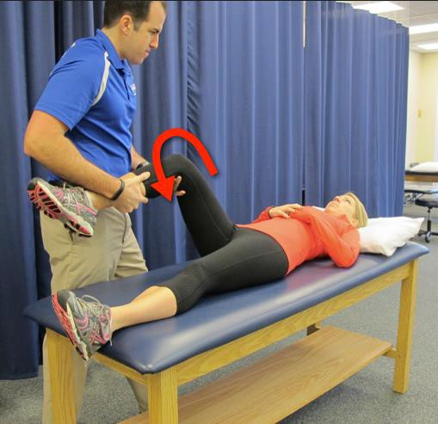
Log Roll- Internal

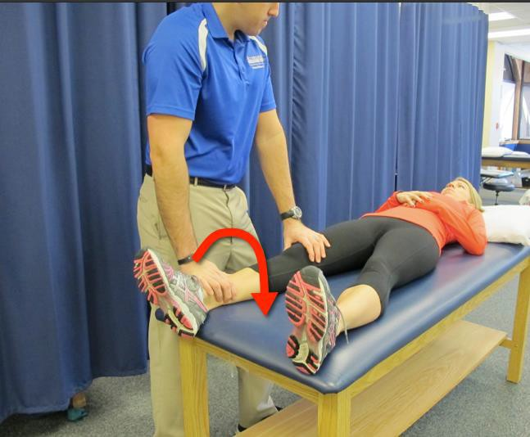

TA Bracing

PROM – Heel Slides

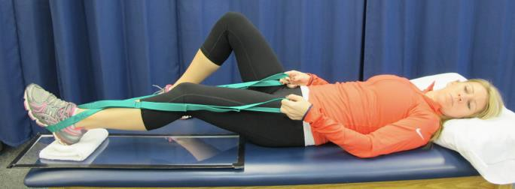

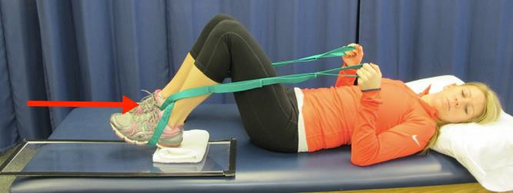

Glute Sets

Quad Sets

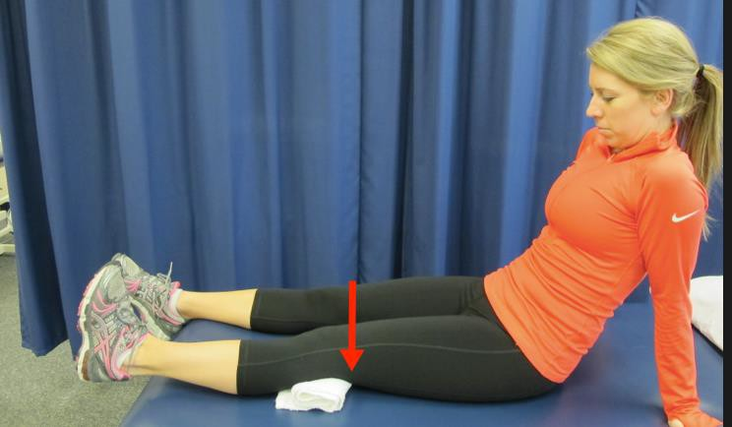

Quad Rocking

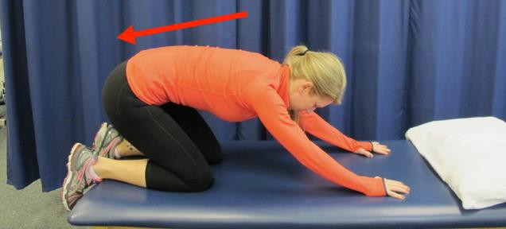

Hip Adduction Isometric

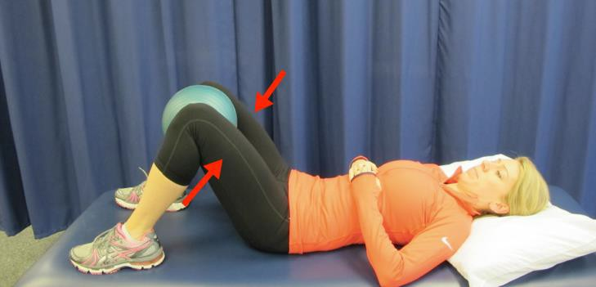

Hip Abduction Isometric

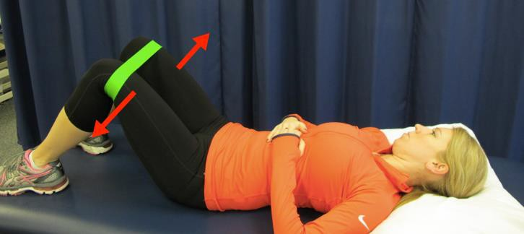

Hip Isometrics- Adduction

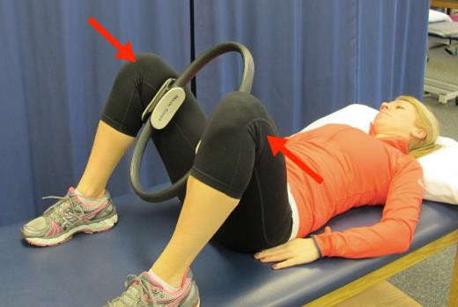

Hip Isometrics – Abduction

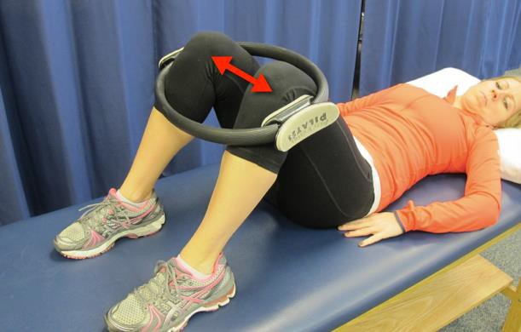

Double leg bridge

Cat Camel

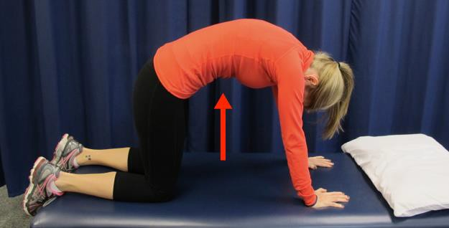

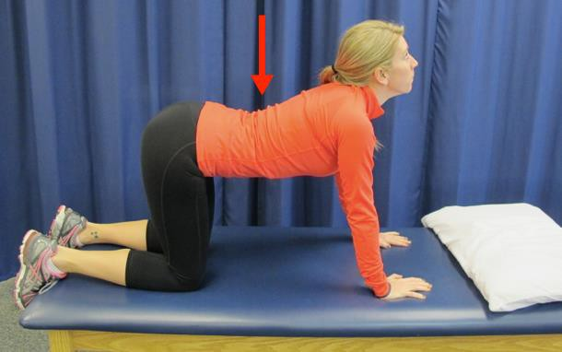

Bike

Week 2-4

Seated Hamstring Stretch

Piriformis Stretch

Stool Rotation Stretch- Neutral to ER

Stool Rotation Stretch- Neutral to IR

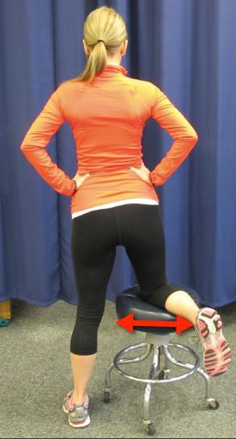

Assisted Hip Ab/Adduction Slide board

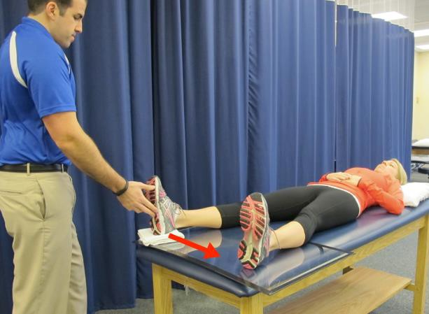

Standing Hip Abduction with IR

Bent Knee Fall- Out

Step Down

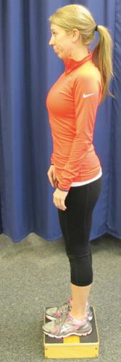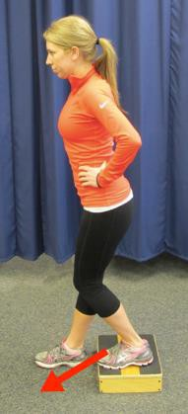

Lateral Step Up

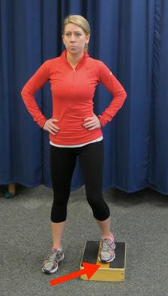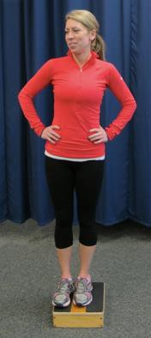

Clams

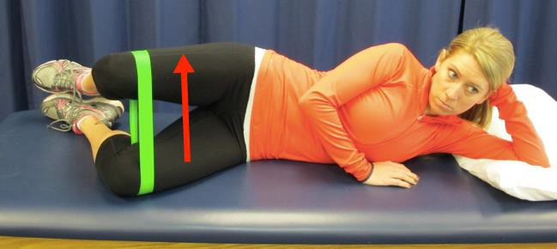

Figure “4” Slide

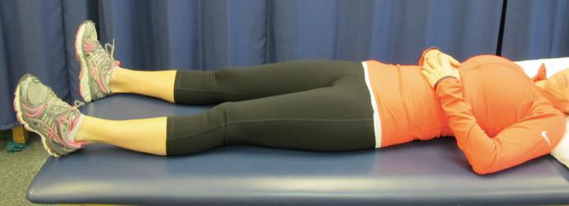

Fish Tails

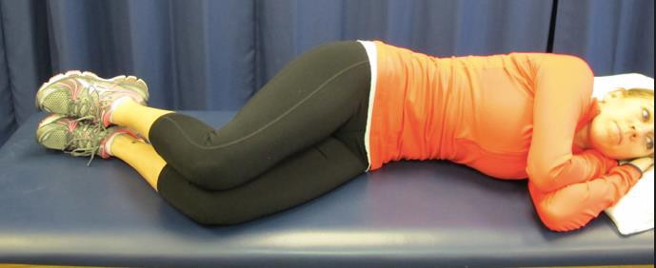

Hip Hiking

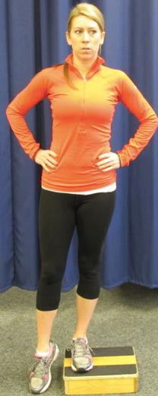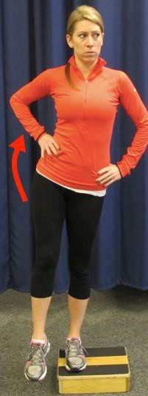

Balance Board

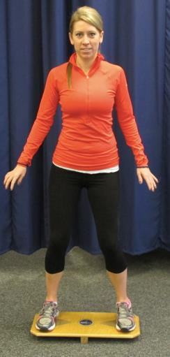

Standing Rotation Against Resistance

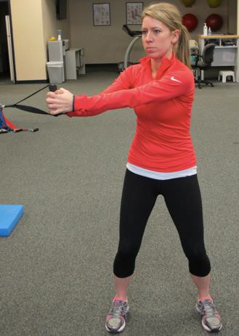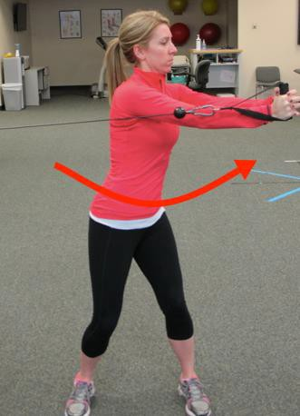

Single Leg Standing on Firm Surface

Ab Bracing with Marching

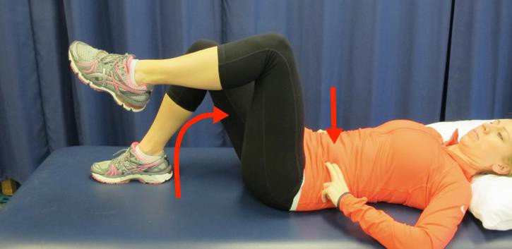

Weeks 4-8

Mobilization – Lateral with Rotation

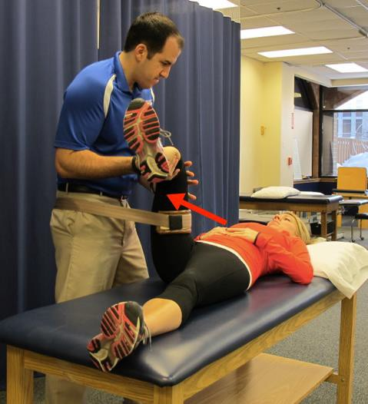

Mobilization – Inferior with Rotation

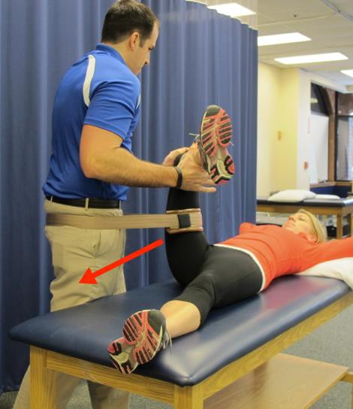

Standing Quad Stretch

Hip Flexor Stretch

Tall Kneeling

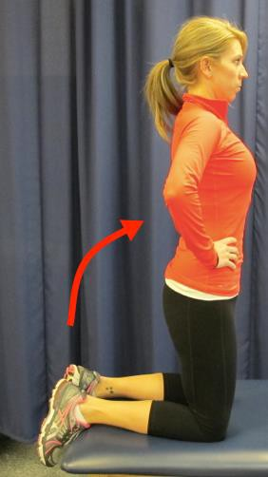

Multi-Plane Stepping

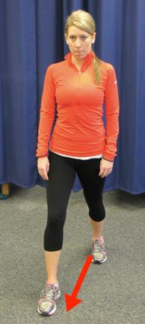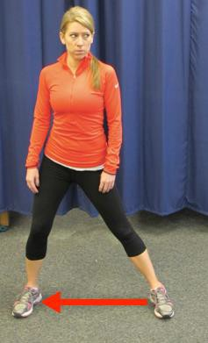

Single Leg Standing on Foam Surface

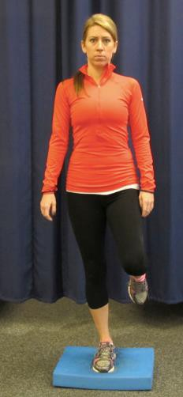

Double Leg Press

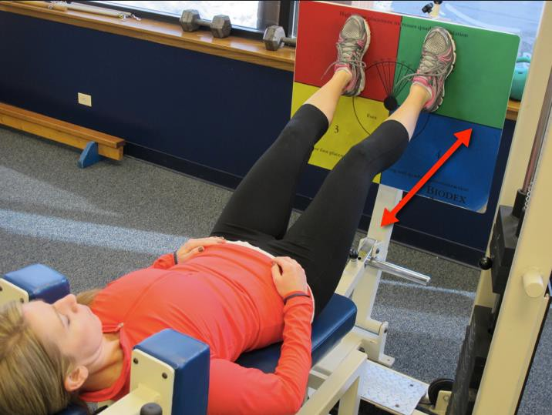

Single Leg Press

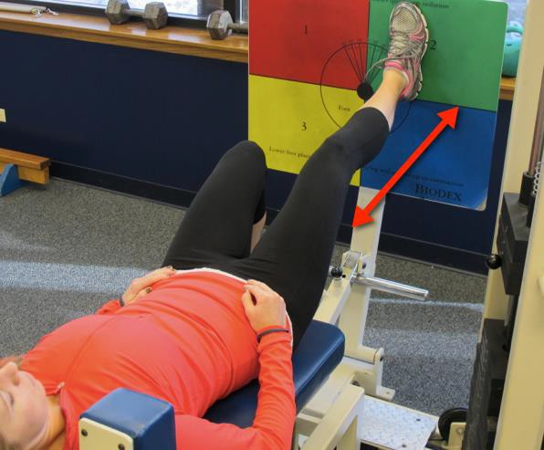

Core- Front Plank Progression

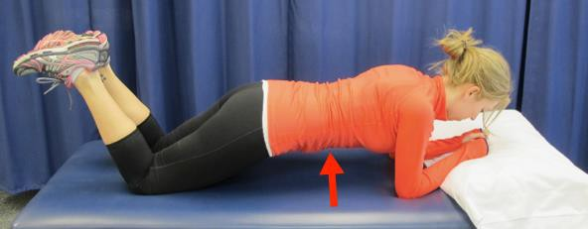

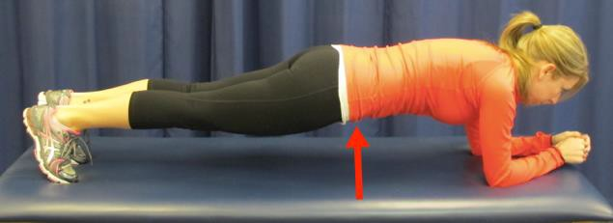

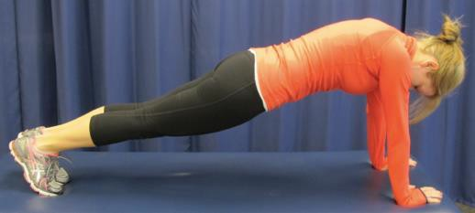

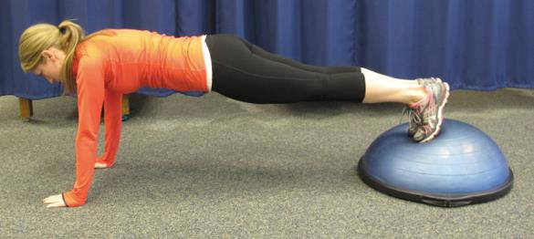

Td Side Step

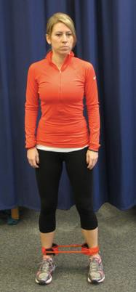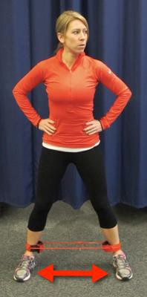

Quadruped Progression to Alternate Arm and Leg

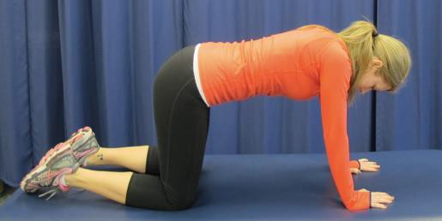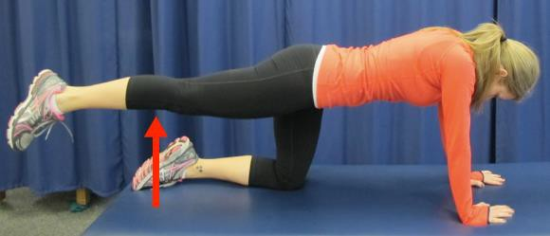

½ Kneeling Rotation

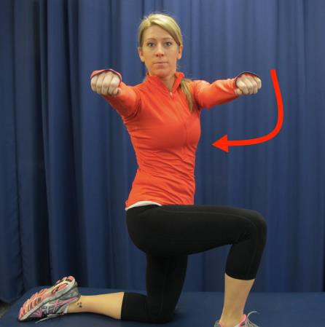

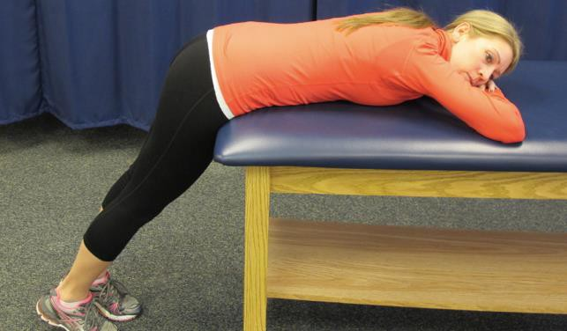
Prone Extension (Flexion to Neutral)

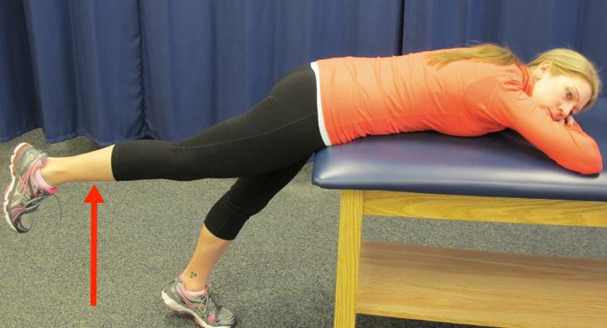
Week 8-12

Prone Alt Arm and Leg Ext

Tall Kneeling Against Resistance

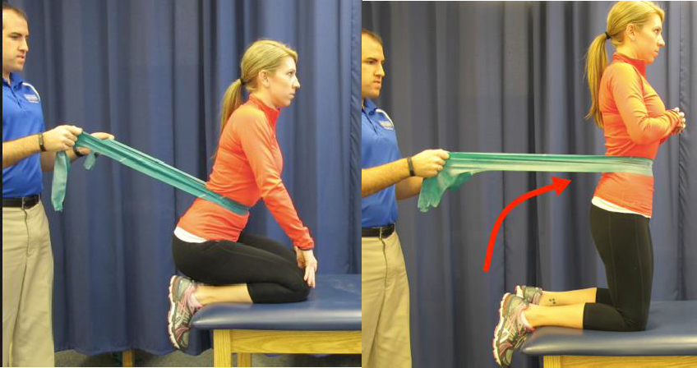

Forward Lunge

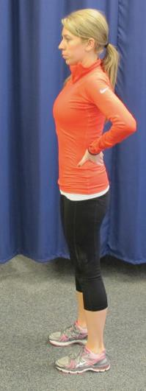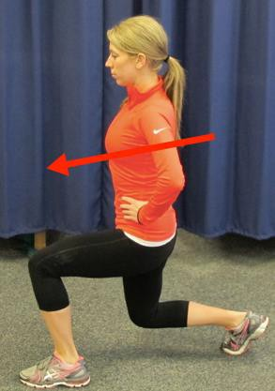

Body Weight Double Leg Squat

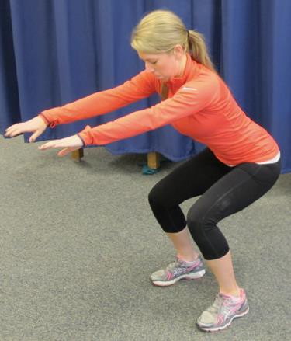

Single Leg Bridge

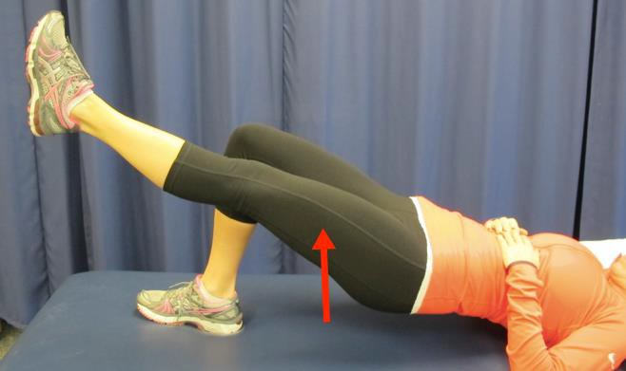

Monster Walks

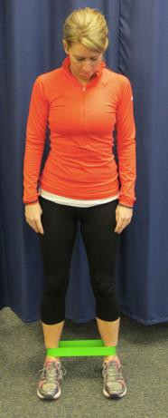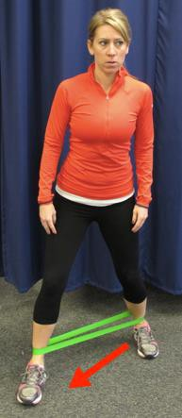

Bridge with Abduction

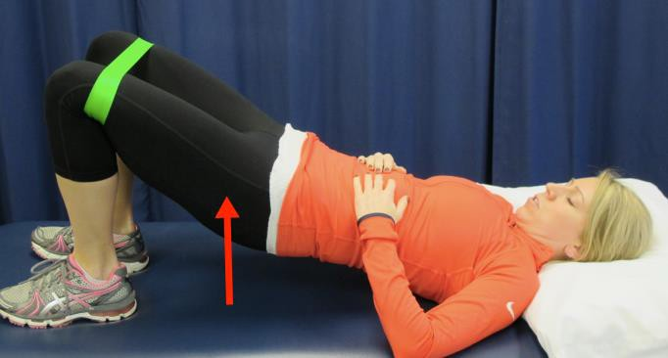

Wall Squats with Ball

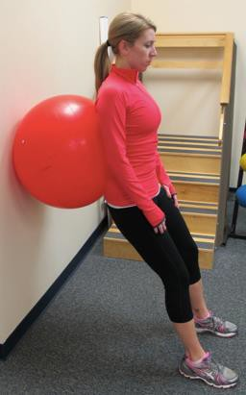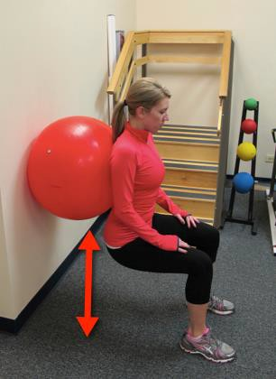

Standing Hip Abduction Maintaining Neutral Pelvis

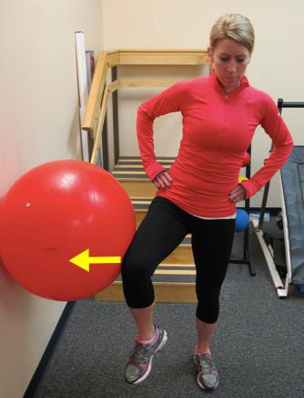

Mini Squat to HR

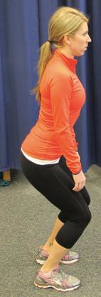

Single Leg Squat Maintaining Level Pelvis

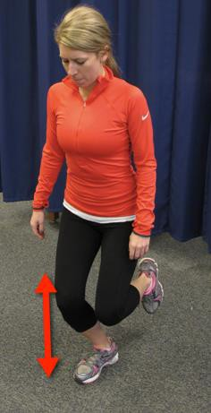

Core- Side Plank Progression

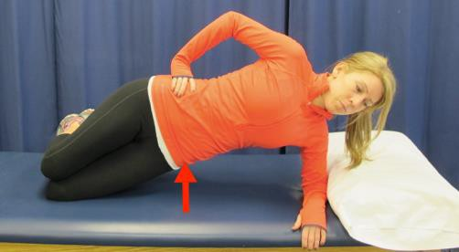

Core- Side Planks

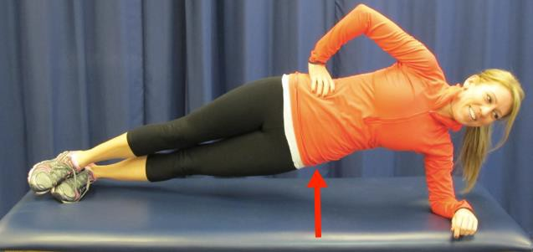

Core- Side Plank Progression

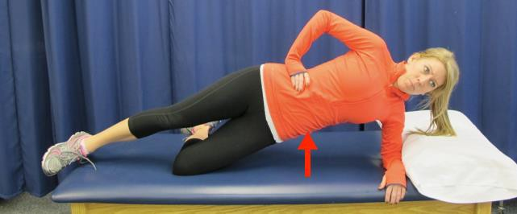

Ball Progression- Arm and Leg Extension

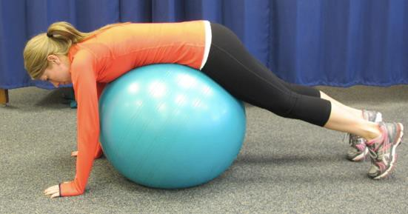

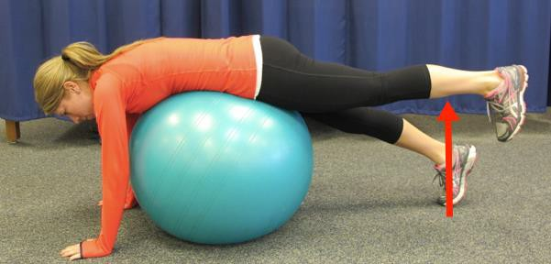

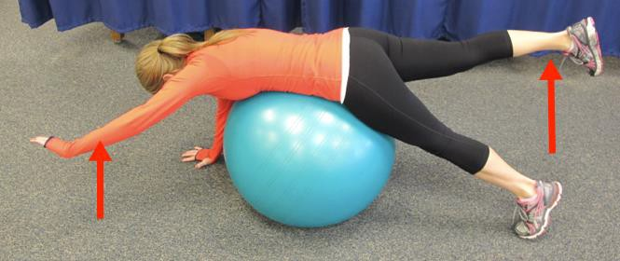

Lateral Lunge

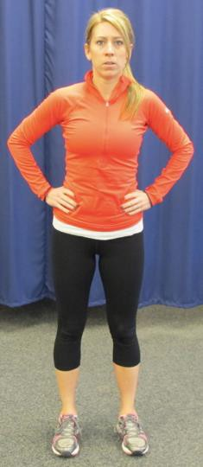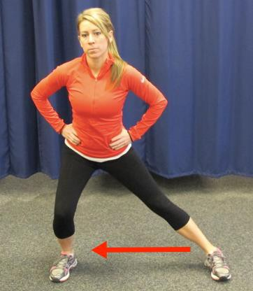

Appendix IV: Sports Test Instructions

Single Knee Bend

Purpose: To test single leg endurance strength and evaluate patellar tracking.

Supplies: Sport Cord (Topper Sports Medicine, black cord)
Goniometer
Stopwatch

Description: The Athlete will perform single knee bends with cord resistance to 60º at a cadence of 1 second up and 1 second down for a goal of 3 minutes. The movement is between 30º-60º of flexion with the knee never fully straightening past 30º throughout the 3 minutes. To cue the athlete the depth of 60º the buttocks can lightly touch the seat of a chair or object. Two fingers are allowed for balance on a chair back.

Setup: 1. With a goniometer, measure a 60º knee bend and place a chair in a position to allow the athlete's buttocks to lightly touch at that depth.
2. The athlete places the heel of the foot on the cord at a position so the D-ring of the handle is aligned with the knee joint line to remove slack from the cord.
3. Tension is set by pulling the cord handle to the waist line and holding. Having the athlete hook their thumb around their pant line is helpful in maintaining tension on the cord.
4. Two fingers of the opposite hand are allowed to lightly touch another chair back for balance

Technique: The athlete must perform each repetition of a single knee bend without the following:
- Trendelenburg sign (pelvis must remain level)
- the knee locking in full extension
- the knee "collapsing" into medial rotation / adduction
- the patella extending past the toe

Cuing should be provided when one of the following compensations are noted. If unable to correct STOP TEST.

Scoring: One point is earned for each 30-second increment completed with proper form for a total of 6 possible points.

Testing is stopped if and when:
- Form: once the subject is unable to complete single knee bends without compensation even with cuing.
- Pain: the patient has pain > 3/10 OR reproduces their pain
- Endurance: the athlete fatigues

Lateral Agility

Purpose: To test the ability of the leg to accept load (absorb) and push off in a lateral direction.

Supplies: Sport Cord (Topper Sports Medicine, black cord)
Stopwatch and Tape

Description: The athlete will hop laterally with cord resistance from their surgical leg, land momentarily on their non-surgical leg, only to return onto their surgical leg with the cord pulling them back to the starting position for a total test time of 100 seconds. Each repetition of 1 second includes exploding laterally off the surgical side, landing momentarily on the opposite leg, and then returning to the starting position with emphasis on absorbing by bending at the hip and knee with 30 degrees of knee excursion. Excursion is defined as the amount of absorption from knee flexion at landing to max knee flexion.

Setup: 1. Place the belt through the sport cord handles and then attach around the waist.
2. Attach the other end of the sport cord to the door jam or secure post.
3. Stand sideways with the involved leg toward the cord attachment.
4. Step away laterally until tension is reached where the athlete slightly compensates with leaning and place a line with tape on the lateral aspect of the involved foot.
5. Measure the distance from the greater trochanter to the floor.
6. Use this measured distance to place a second tape line parallel to the first.

Technique: The athlete must perform each lateral hop by landing on or inside the first tape line with the involved foot and on or outside the second tape line with the uninvolved foot. Only one foot should be on the ground at the same time and the athlete must absorb onto the involved leg without the following:
- Trendelenburg sign (pelvis must remain level)
- the knee "collapsing" into medial rotation / adduction
- the patella extending past the toe
- losing control or stability

Cuing should be provided when one of the following compensations are noted. If unable to correct STOP TEST.

Scoring: One point is earned for each 20 second increment completed with proper form for a total of 5 possible points.

Testing is stopped if and when:
- Form: once the subject is unable to complete single knee bends without compensation even with cuing.
- Pain: the patient has pain > 3/10 OR reproduces their pain
- Endurance: the athlete fatigues

Diagonal Lateral Agility

Purpose: To test the ability of the leg to accept load (absorb) and push off in a diagonal direction.

Supplies: Sport Cord (Topper Sports Medicine, black cord)
Stopwatch and Tape

Description: The athlete will hop diagonally forward at a 45º angle with cord resistance from their surgical leg, land momentarily on their non-surgical leg, only to return onto their surgical leg with the cord pulling them back to the starting position. The following repetition the athlete will hop diagonally backward at a 45º angle. The goal is 100 seconds total. Each repetition of 1 second includes exploding diagonally forward or backward at 45º angles off the surgical side, landing momentarily on the opposite leg, and then returning to the starting position with emphasis on absorbing by bending at the hip and knee with 30 degrees of knee excursion. Excursion is defined as the amount of absorption from knee flexion at landing to max knee flexion.

Setup: 1. Place the belt through the sport cord handles and then attach around the waist.
2. Attach the other end of the sport cord to the door jam or secure post.
3. Stand sideways with the involved leg toward the cord attachment.
4. Step away laterally until tension is reached where the athlete slightly compensates with leaning and place a line with tape on the lateral aspect of the involved foot.
5. Measure the distance from the greater trochanter to the floor.
6. Use this measured distance to place a second tape line at a 45º angle forward and a third tape line at a 45º backward to form a “V” if connecting the lines.

Technique: The athlete must perform each diagonal lateral hop by landing on or inside the first tape line with the involved foot and on or outside the second or third tape line with the uninvolved foot (Each foot should land parallel with each tape line). Only one foot should be on the ground at the same time and the athlete must absorb onto the involved leg without the following:
- Trendelenburg sign (pelvis must remain level)
- the knee "collapsing" into medial rotation / adduction
- the patella extending past the toe
- losing control or stability

Cuing should be provided when one of the following compensations are noted. If unable to correct STOP TEST.

Scoring: One point is earned for each 20-second increment completed with proper form for a total of 5 possible points.

Testing is stopped if and when:
- Form: once the subject is unable to complete single knee bends without compensation even with cuing.
- Pain: the patient has pain > 3/10 OR reproduces their pain
- Endurance: the athlete fatigues

Forward Box Lunges

Purpose: To test the lower extremity strength and endurance into extension.

Supplies: Sport Cord (Topper Sports Medicine, black cord)
Stopwatch and Tape

Description: The athlete will perform alternating forward lunges onto a box with cord resistance at a cadence of 2 seconds per lunge for a goal of 2 minutes. The movement is a forward lunge with maximum hip extension without compensation at the pelvis or spine throughout the 2 minutes.

Setup: 1. Place the belt through the sport cord handles and then attach around the waist.
2. Attach the other end of the sport cord to the door jam or secure post.
3. Stand facing away from the cord attachment.
4. Step forward until tension is reached where the athlete slightly compensates by leaning and tape a line in front of the feet.
5. Measure the distance from the greater trochanter to the floor.
6. Place a stable box or chair the height of the athlete’s knees in front of them at a distance equal to the measure of the greater trochanter to the floor.

Technique: The athlete must perform alternating forward lunges onto the box keeping their planted leg behind the line and extending the hip without the following:
- Trendelenburg sign (pelvis must remain level)
- Excessive lumbar hyperextension
- Pelvic rotation
Correct performance of this activity is through proper extension of the hip.

Scoring: One point is earned for each 30-second increment completed with proper form for a total of 4 possible points.

Testing is stopped if and when:
- Form: once the subject is unable to complete single knee bends without compensation even with cuing.
- Pain: the patient has pain > 3/10 OR reproduces their pain
- Endurance: the athlete fatigues

Appendix V: Beighton’s Scale

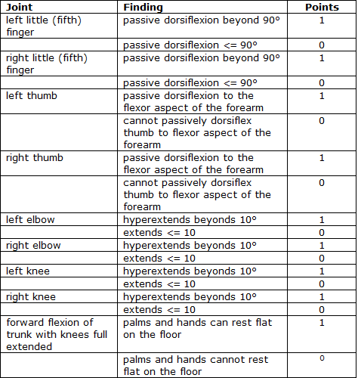
- A Beighton score of 5/9 or greater is considered significant. ⁶

References

- Martin, RL, Enseki, KR, et al. Acetabular Labral Tears of the Hip: Examination and Diagnostic Challenges. Journal of Orthopaedic & Sports Physical Therapy. 2006. 36:7:503-515.
- Lynch, ST, Terry MA, et al. Hip Arthroscopic Surgery: Patient Evaluation, Current Indications and Outcomes. AJSM. 2013.41:1174.
- Byrd JWT, Jones KS. Arthroscopic Management of Femoroacetabular Impingement in Athletes. AJSM. 2011; 39:7S-13S.
- Byrd JWT, Jones KS. Arthroscopic femoroplasty in the management of cam-type femoroacetabular impingement. Clin Orthop Rel Res. 2009;467:739-746.
- Austin AB, Souza RB et al. Identifiacation of Abnormal Hip Motion Associated With Acetabular Labral Pathology. JOSPT 2008. 38:558-565.
- Beighton P, Grahme R, Bird H. Hypermobility of Joints. London: Springer-Verlag, 1989: 149-170.

