Golden Physical Therapy Team

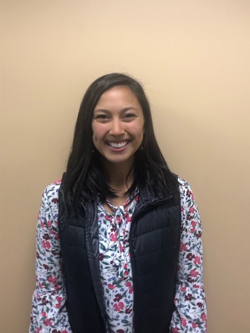
Abby Chris, PT, DPT - Abby earned her Doctorate of Physical Therapy degree from the University of Colorado, Anschutz Medical Campus in 2019. She earned her Bachelors of Science from Colorado State University-Pueblo. At CSU-Pueblo, she played soccer and found her passion for rehabilitation and return to sport training. She enjoys treating all orthopedic conditions, utilizing a holistic approach to care. Abby strives to provide the best care for her patient’s, incorporating individualized and functional strengthening to help her patient’s get back to what they enjoy! Outside of the clinic she loves everything outdoors, baking, exercising in any form, and spending time with friends and family.

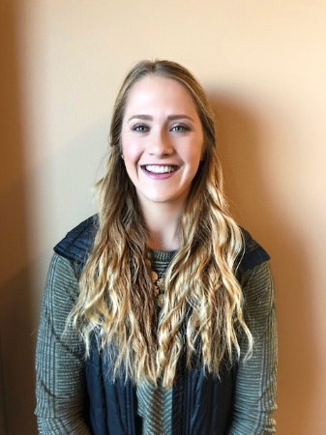
Beth Wood, PT, DPT - Elizabeth (Beth) received her Doctor of Physical Therapy from the University of Colorado, Anschutz Medical Campus in 2018. She earned her Bachelors of Science in Exercise Science from Colorado Mesa University in Grand Junction. Beth is certified in the Selective Functional Movement Assessment (SFMA) and utilizes this treatment approach to identify the cause of discomfort and address biomechanical and neuromuscular dysfunction in her patients. Beth also specializes in pre and post- operative total joint replacement rehab. She treats an array of orthopedic injuries and strives to develop a rapport with patients and make rehab a fun, positive process. Outside of work, Beth enjoys tennis, equestrian events, running, and spending time with friends and family.

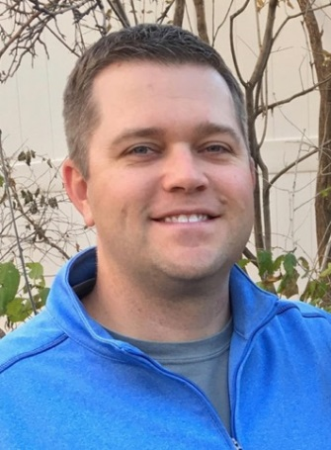
Brad Walters, PT, MSPT, OCS - Brad graduated in 2002 from the University of Colorado at Boulder, majoring in Kinesiology. He subsequently earned a Master of Science in Physical Therapy from the University Of Colorado Health Sciences Center in 2004. He has been a member of the American Physical Therapy Association and the Orthopedic Section for 15 years. He is a board-certified Orthopedic Clinical Specialist (OCS) since 2012. He was a game-day physical therapist for the NBA's Denver Nuggets for the 2012-2013 season. He was an APTA Orthopedic and Sports Residency Faculty Mentor for ATI Physical Therapy in Greenville, South Carolina from 2014-2017. He is certified in Functional Dry Needling Level 1 and 2 since 2016. He believes in coupling physical therapy with sports performance. He enjoys working within the broad spectrum of orthopedic and sports injuries. He strives to provide a personalized approach to assist each patient in establishing and achieving incremental goals. He combines hands on therapeutic treatment techniques with functional and evidence based exercises that are tailored to both the home and clinic environments. As a Colorado native, Brad enjoys following all his hometown teams, especially the Denver Broncos! He also enjoys golfing, fly-fishing, skiing, traveling and spending time with his wife, Rachael.

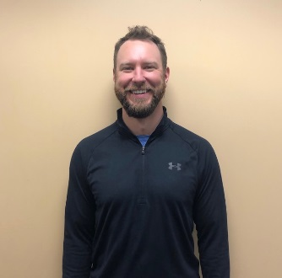
Chris Smith, PT, DPT – Christopher Smith was born and raised in Buffalo New York, where he dual majored in History and Exercise Science at the University of Buffalo before completing the Doctor of Therapy program at Daemen College. He then completed 2 years of travelling Physical Therapy working in Connecticut, Oregon, and Washington State. Prior to working with Panorama he worked at Howard Head Sports Medicine with a focus on US Ski and Snowboard teams, and specialization with US Climbing. He now lives in Denver, and is passionate about orthopedic rehab in the outpatient setting, though also works part time for the St. Anthony Hospital.

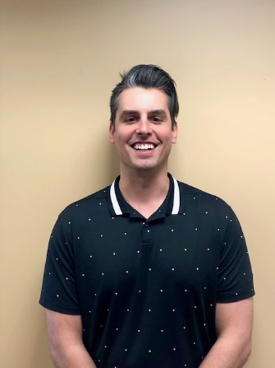
David Whitmore, PT, DPT – David graduated from Arizona State University’s Barrett Honors College and W.P. Carey School of business in 2014 with a BS in Business Management while also serving as a member of the men’s basketball team. He then attended Baylor University to earn his Doctorate of Physical Therapy in 2019. He enjoys working with a wide array of patient profiles. Whether it is an athlete returning to sport or a patient working to maintain highest functional levels to improve overall quality of life, he wants to be there to help patients meet their goals. He utilizes various manual techniques and evidence-based interventions to progress and improve patient’s functional abilities to return to, if not surpass, their prior level of function. When he is outside of the clinic he enjoys hiking and exploring all of the beauty Colorado has to offer with his wife and their dog Marley.

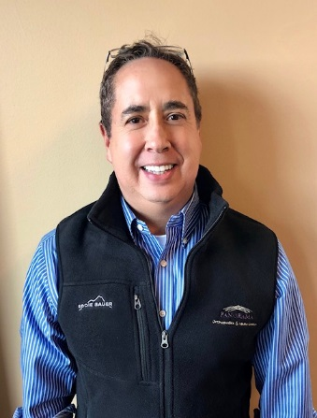
Emery Pino, PT, MSPT - Emery graduated from the University of Colorado Health Sciences Center Physical Therapy program in 2000. He previously was a System’s Engineer for 13 ½ years, much of the time with IBM. Emery’s engineering background helps him clearly explain pathology to his patients, while using critical thinking to determine the best rehabilitation for complicated patient pathologies and diagnoses. Emery’s interest in physical therapy is in outpatient orthopedics, and is also one of the vestibular and balance therapists at Panorama PT. He has a variety of certifications of continuing education to influence his knowledge and skill base in treating the orthopedic population.

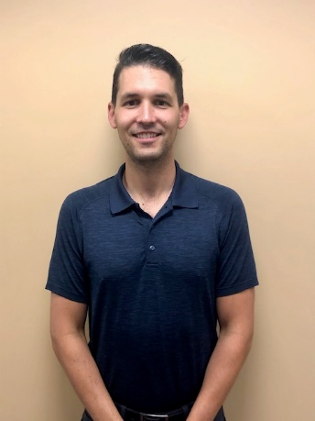
Jack Friesen, PT, DPT, CSCS – Jack graduated from East Carolina University with a Bachelor’s degree in Exercise Physiology. He then attended Duke University where he earned his Doctorate of Physical Therapy in 2016. Jack continued his education after Physical Therapy school, and pursed a Sports Residency Program with Howard Head Sports Rehab and Vail Health Hospital. Through this Residency, Jack gained sports experience working and traveling with the United States Moguls Ski Team. After his Sports Residency, Jack was accepted into a Sports Fellowship Program with the New England Patriots Football Club, where he gained acute experience working with professional athletes. Currently, he is certified in Functional Dry Needling Level 1, and holds his Certification in Strength & Conditioning. Jack believes in coupling physical therapy with sports performance. He combines hands on manual therapeutic treatment with corrective exercises to restore proper movement and strength in order to get his patients back to what they enjoy doing. Outside the clinic, Jack enjoys playing hockey, skiing, hiking, fishing, and traveling with his wife Lindsay.

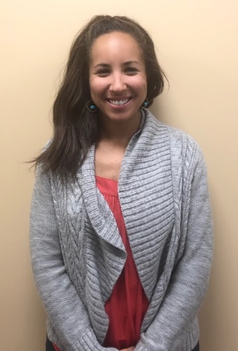
Jamie Ortiz, PT, DPT - Jamie earned her Doctorate of Physical Therapy from the University of New England in Portland, Maine in 2014. She received her undergraduate degree from Colorado State University where she majored in Health and Exercise Science with a concentration in Sports Medicine. Jamie has focused her PT career in outpatient orthopedics and has had the opportunity to work with a variety of injuries and patients of all ages. She enjoys educating patients regarding their injuries and uses the most up to date evidence based treatments to make sure her patients return to the activities they love as quickly as possible. In her free time, she loves to hike mountains, trail run, stand up paddleboard and camp with her husband, twin boys, and their dog, Duke.

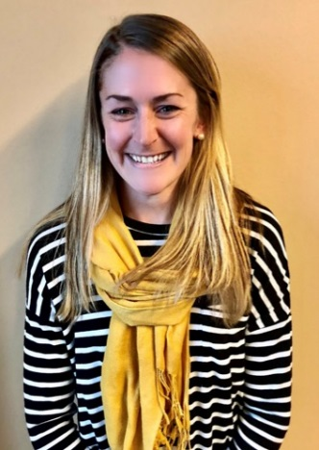
Katie Carbiener, PT, DPT - Katie received her DPT from the University of Colorado. Her undergraduate degree in Kinesiology and Biology was earned at Longwood University in Virginia where she also played DI lacrosse. Currently, she pursues her passion of running and enjoys the outdoor recreation CO has to offer from fly fishing, cycling, to mountaineering and climbing. Katie has special interests in gait analysis, sports med and other orthopedic conditions. Her primary philosophy is to empower her patients with the knowledge to better move and use their bodies to reach their personal goals. She is certified in Functional Dry Needling.

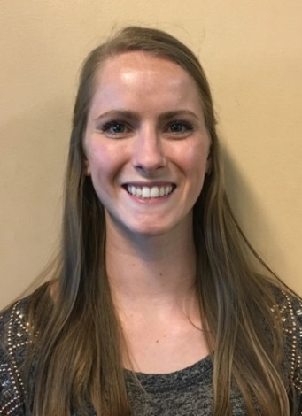
Kaitlin Thompson, PT, DPT - Kaitlin graduated from Boston University with a BS in Athletic Training in 2011 and Doctor of Physical Therapy in 2014. Kaitlin started her career in NYC doing outpatient orthopedics with an emphasis on sports/orthopedic rehab and is also a certified vestibular therapist. Her passion in PT lies in using specific exercises and education tailored to each patient to help get them back to what makes them happy. In addition to helping patients through PT, Kaitlin is has also been the PT clinic director at Golden since 2019 and enjoys helping her team grow and follow their own passions. Kaitlin’s happy place is on the volleyball court and up in the mountains. She played club volleyball at BU and continues to play competitively on grass, sand, and indoors.

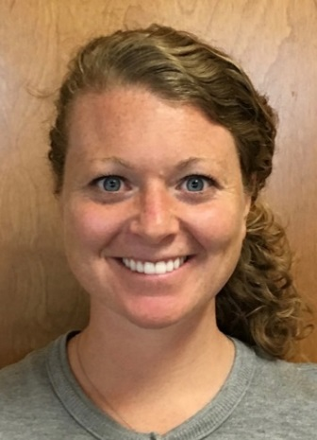
Kelly Powell, PT, DPT - Kelly graduated from Stony Brook University with her Doctorate of Physical Therapy in 2012 and completed her undergraduate degree from SUNY Oswego. She enjoys working with all orthopedic conditions and utilizes manual therapy and individualized exercise prescription to assist patients in their recovery. She believes in empowering the patient to reach their goals and prevent re-injury.

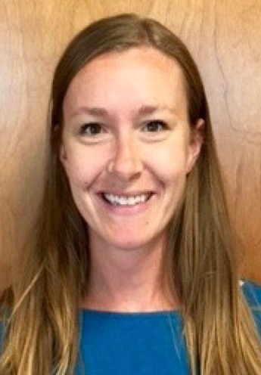
Keri Windels, PT, DPT, SCS - Keri went to The Pennsylvania State University where she majored in Kinesiology with a Exercise Science focus. After graduating, Keri moved to Denver and earned her Doctorate of Physical Therapy from University of Colorado Health Sciences Center in 2009. She then spent time on the East Coast, working at The Johns Hopkins Hospital. There, she was on faculty for the Orthopedic Physical Therapy Residency Program and also became a Sports Certified Specialist (SCS). Keri enjoys working with all orthopedic conditions, but specializes in lower extremity injuries in athletes.

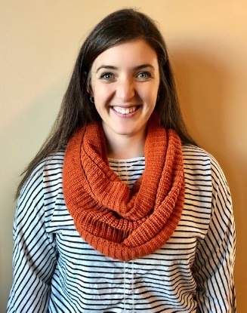
Lara Baum, PT, DPT, OCS - Lara graduated from University of Colorado in 2015 with her Doctorate of Physical Therapy, and has been a member of Panorama’s team since spring of 2018 and is a Board Certified Orthopedic Specialist. Lara enjoys working with all orthopedic conditions, but specializes in lower extremity injuries in athletes. She is certified in Functional Dry Needling and utilizes the Selective Functional Movement Assessment to identify biomechanical and neuromuscular dysfunctions in her patients.

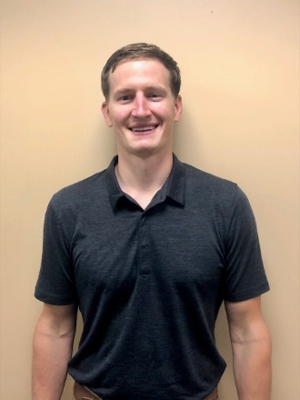
Luke Mueller, PT, DPT, CSCS - Luke graduated in 2011 from the University of Wisconsin-La Crosse with a degree in Exercise and Sport Science. He continued his education at UW-La Crosse to earn his Doctorate of Physical Therapy in 2014. He enjoys treating a variety of orthopedic and sport injury conditions as well as vestibular conditions. Evidence-based treatment with a holistic, individualized approach is what you can expect when working with Luke. He is a Certified Strength and Conditioning Specialist and believes in integrating rehabilitation with sport performance to maximize potential while reducing future injury risk. When not at work, Luke is likely in the outdoors with his fiancé, Arielle, enjoying a variety of outdoor recreation such as hiking, mountain biking, and snowboarding. He also enjoys traveling, trying out new recipes, and spending time with his dog and cat.

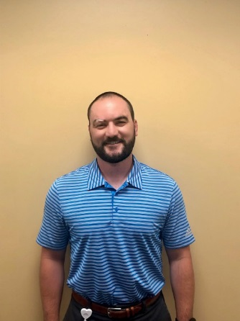
Matthew Hastings, PT, DPT - Matt graduated from New York Institute of Technology with his Doctorate of Physical Therapy, and completed his undergraduate degree at the University of Vermont. Matt believes that through an individualized approach to optimizing human performance and movement, he can help his patients maintain a balance of health and wellness. Matt enjoys working with a variety of sports and orthopedic conditions, and he has a passion for injury prevention in weekend warriors and athletes alike. In his free time, Matt enjoys skiing, golfing, hiking, mountain biking and lifting.

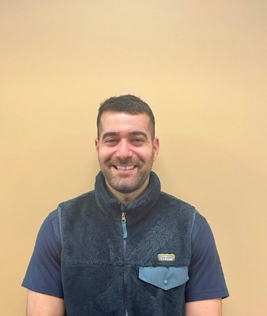
Ron Reznichky, PT, DPT – Ron earned his Doctor of Physical Therapy degree from nationally ranked University of Pittsburgh in 2020. Prior to obtaining a graduate degree, Ron played Division 1 soccer at Cal Poly San Luis Obispo where he graduated with a Bachelor’s Degree in Kinesiology. Ron’s primary interests and strengths lie within treatment of orthopedic conditions and helping patients return to their desired function. As a Doctor of Physical Therapy, Ron pays great heed to the individual tailoring and dosing of treatments, and ensuring patients are challenged and leave every appointment feeling accomplished. Ron’s patient care is built upon creating a therapeutic alliance with his patients, encouraging every individual to take an active role in their recovery, and including patients in the decision-making process of their care. Ron believes evidence-based practice, addressing patients’ goals, and a relationship of reciprocity between therapist and patient will help ensure successful outcomes. Personal growth and lifelong education define this therapist. Outside of work, Ron spends his free time reading, drinking good coffee, dabbling in photography, and exploring the mountains (through the means of travel, hiking and backpacking).

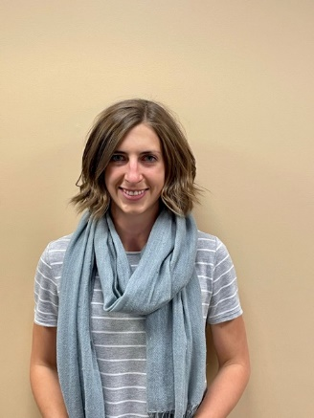
Sammie Lewis, PT, DPT – Sammie earned her Doctorate of Physical Therapy degree from the University of Colorado, Anschutz Medical Campus in 2020. She earned her Bachelors of Science in Biomedical Engineering from The Ohio State University while playing for the Women’s Soccer team, which included a NCAA Final Four appearance and multiple Big Ten Championships. Sammie now competitively races trail ultramarathons with mountain biking, ski mountaineering, and strength training playing integral roles in her training and passion for the outdoors. She has special interests in the treatment of runners including gait analysis, as well as adolescent sports medicine. Sammie’s philosophy centers around teaching patients to improve their movement patterns for long-term solutions, rather than quick fixes that don’t address the root of the issues, as well as giving her patients the tools to take control of their own health and wellness.

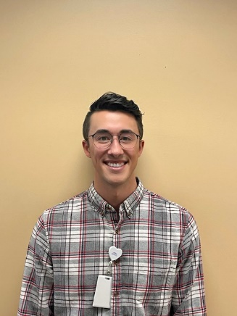
Steven Yao, PT – DPT – Steven graduated from California Polytechnic State University in San Luis Obispo, CA with his Bachelor’s Degree in Kinesiology. He moved to Colorado and continued his education at the University of Colorado, Anschutz Medical Campus where he received his Doctorate of Physical Therapy. Steven utilizes evidence-based treatment methods and is a huge advocate for patient-centered care because he believes each patient is truly unique and their care should be too. He wants to not only help people return to their prior level of function, but also to prevent future injury and maximize potential. Outside of physical therapy, Steven enjoys golfing, hiking, cooking, snowboarding, and pursuing top-tier movie recommendations.

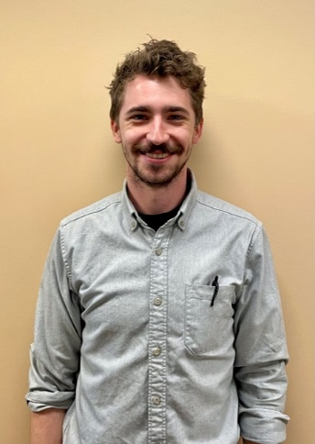
T.H. David, PT, DPT – T.H. graduated with a BA in Studio Art and Asian Studies from St. Olaf College, MN, and worked as a professional ceramic artist for 4 years before pursuing a career in physical therapy. He moved from Minneapolis to Denver with his wife and received his DPT degree through the University of Colorado at the Anschutz Medical Campus in 2020. T.H. strongly believes that movement is critical to living a life of independence and happiness. He enjoys working with all orthopedic populations, and utilizes evidence-based interventions, education, and laughter to help patients return to the activities they need and love to do. Outside of physical therapy, T.H. juggles too many hobbies, which often include adventuring with his wife and friends, bouldering, trail running, playing disc golf, making board games, and playing drums.

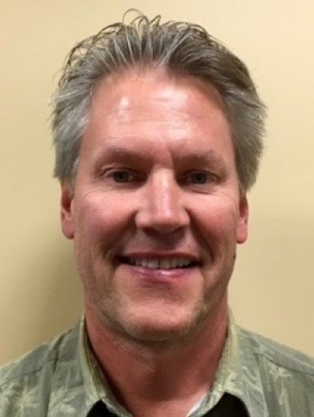
Tom Hermsen, PT, MSPT, CSCS - A 1983 graduate from the University of Wisconsin – Madison, Tom has been a practicing PT for over 30 years, 27 in outpatient orthopedics. He was a site coordinator and treating therapist at HealthSouth in Lakewood, CO from 1994- 2000. He was the clinic director and practicing PT for Physiotherapy Associates at Golden Ridge for seven years. In 2010, he joined the staff at Panorama Physical Therapy as a senior staff PT. Tom’s area of expertise included the treatment of shoulder and knee dysfunction, and foot and ankle disorders including the fabrication of custom orthotics. He has vast experience in lower extremity biomechanical evaluations. He is also a Certified Strength and Conditioning Specialist (CSCS).

HAND THERAPISTS
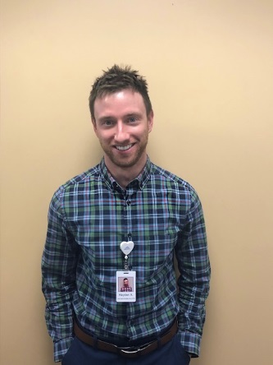
Hayden Alewine OT, MSOT, OTR/L - Hayden graduated from the College of Charleston in 2007 with a Bachelor’s in Biology. His desire to help others lead to his subsequent completion of the Master’s program in Occupational Therapy from the Medical University of South Carolina in 2017. His primary focus during graduate school was hand therapy and post-graduation he has continued this focus performing hand therapy while working in outpatient orthopedics in New York. Hayden’s approach to therapy includes helping patients regain functional use of the upper extremity through the use of patient education, exercise, modalities, and other various therapeutic interventions. He is currently in the process of studying to become a Certified Hand Therapist (CHT). In his free time, Hayden enjoys all things outdoors including hiking, biking, camping and fly-fishing.

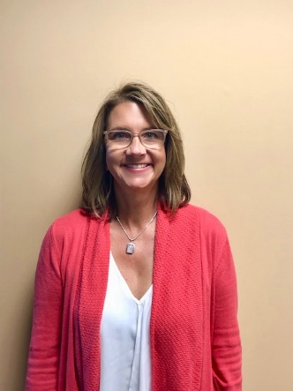
Lisa Condon, OT, MSOT, OTR, CHT - Lisa graduated from University of Wisconsin-Milwaukee in 1988 with a Bachelor’s in Occupational Therapy. After working 3 years in Inpatient Neurology, she moved to Colorado and pursued Outpatient Orthopedics. She received her Certification in Hand Therapy (CHT) in 1995 and her Master’s in Sports Medicine in 1996. Lisa has a strong passion for treating upper extremity trauma and has spent much of her career developing her manual skills and thoroughly understanding the anatomy of the hand, wrist, elbow and shoulder. She believes that educating the patient on their injury is imperative for a successful outcome and being an active member of the “Hand Team” (MD, Therapist and Patient).

