**Jessie McLaughlin PT, DPT**

**Clinic Director**

Jessie was born in Atlanta, Georgia and moved to Greenwood Village, Colorado in 1999. She attended school at Colorado Academy and then went to Gonzaga University where she played D1 soccer as a goalkeeper and received her BS in Exercise Science. She went on to physical therapy school at Duke University where she graduated with a Doctorate in Physical Therapy.

Jessie had a shoulder injury in high school that inspired her to go on to become a physical therapist. She specializes in sports medicine, ACL, foot/ankle, and return to sport therapy and works closely with Panorama physicians, physical therapists and performance trainers at The Institute to provide a full continuum of care for her patients. She greatly enjoys being a resource for her patients, staff, and anybody interested in pursuing a career in physical therapy.

Jessie loves the outdoors and in her spare time she enjoys training her horse, hiking, camping, and going on adventures with her husband and dogs. She is an avid football fan and regularly sports cowboy boots with her Atlanta Falcons jersey on casual Fridays.

Fun fact: Jessie can often be found on the dance floor at country bars perfecting her line dancing and country swing dance moves.

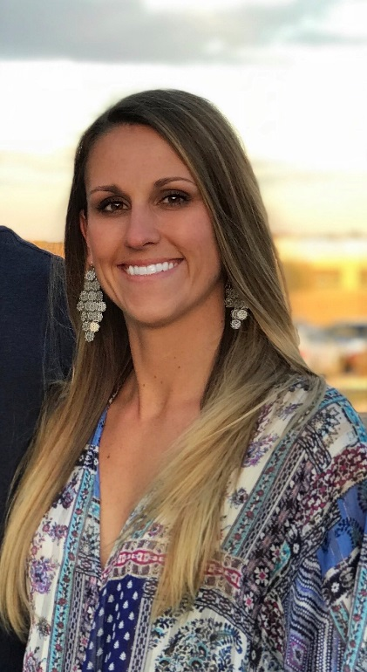

**Carrie Hamm PT, MPT**

Carrie is a Colorado native and graduated from University Of Shenandoah in 1998 and has been a member of Panoramas team since 2011. Carrie has continued to progress in her professional education and development receiving a level two Functional Dry Needling Certification in 2015. She also is certified in level two Selective Functional Movement Assessment to identify biomechanical and neuromuscular dysfunctions in her patients. Carrie specializes in a wide variety of orthopedic pathology and utilizes manual and evidence based practice treatment approaches to maximizing outcomes and recovery. Carrie is an avid mountain and road biker and played collegiate volleyball. She enjoys using her athletic background to challenge patients of all ages and athletic abilities reach their goals.



**Julie Huebner**

Julie is a 2003 graduate of the University of Colorado Health Sciences Center Physical Therapy program. She received a Master's Degree in Anatomy from Colorado State University and a Bachelor's Degree from Florida State University. She spent 2 years working as a Physical Therapist in Colorado's High Country before moving to practice in the Northwest for almost 10 years.  Now, she is happy to be back under the blue Colorado skies for the last several years. She uses manual techniques and individualized exercise programs to correct imbalances in the musculoskeletal system that lead to overuse syndromes, pain and injury in the spine, shoulders and lower body. She has extensive continuing education training for pre-operative, post-operative and non-operative shoulder, hip and spine rehabilitation as well as treatment for positional vertigo. She has her certification in Dry Needling.  When not at work, she enjoys being outside running,  riding her bicycle, competing in triathlons and spending time out in nature with her dogs and good friends.

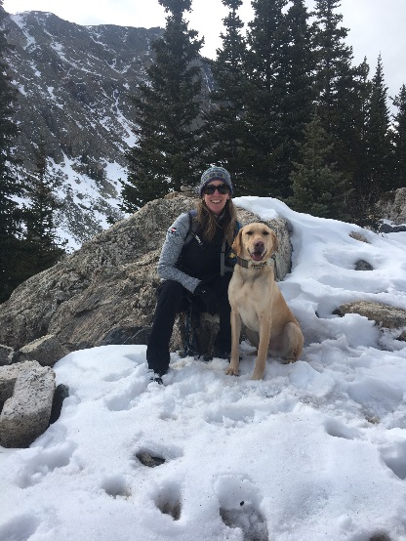

**Connor Longacre PT, DPT**

Connor earned his Doctorate of Physical Therapy from Regis University in 2018, after obtaining his Bachelors in Health and Exercise Science at Colorado State University. He has spent the last year working in the Rocky Mountains, focusing on orthopedic and outdoor-sports related injuries. Connor has had the pleasure of working with Olympic and Paralympic winter athletes, theatre actors, and weekend warriors alike. Connor’s personal passions for snowboarding, fly-fishing, hiking, and exercise have allowed him to help clients of all ages to achieve their goals and get back to enjoying beautiful Colorado.

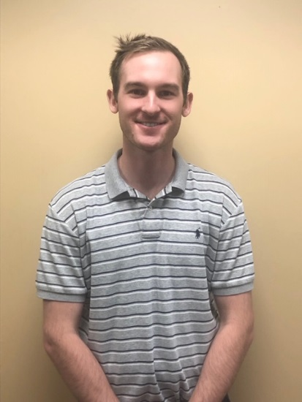

**Jamie Ortiz, PT, DPT**

Jamie earned her Doctorate of Physical Therapy from the University of New England in Portland, Maine in 2014. She received her undergraduate degree from Colorado State University where she majored in Health and Exercise Science with a concentration in Sports Medicine. Jamie has focused her PT career in outpatient orthopedics and has had the opportunity to work with a variety of injuries and patients of all ages. She enjoys educating patients regarding their injuries and uses the most up to date evidence based treatments to make sure her patients return to the activities they love as quickly as possible. In her free time, she loves to hike mountains, trail run, stand up paddleboard and camp with her husband, twin boys, and their dog, Duke.

