**Jessie McLaughlin PT, DPT**

**Clinic Director**

Jessie was born in Atlanta, Georgia and moved to Greenwood Village, Colorado in 1999. She attended school at Colorado Academy and then went to Gonzaga University where she played D1 soccer as a goalkeeper and received her BS in Exercise Science. She went on to physical therapy school at Duke University where she graduated with a Doctorate in Physical Therapy.

Jessie had a shoulder injury in high school that inspired her to go on to become a physical therapist. She specializes in sports medicine, ACL, foot/ankle, and return to sport therapy and works closely with Panorama physicians, physical therapists and performance trainers at The Institute to provide a full continuum of care for her patients. She greatly enjoys being a resource for her patients, staff, and anybody interested in pursuing a career in physical therapy.

Jessie loves the outdoors and in her spare time she enjoys training her horse, hiking, camping, and going on adventures with her husband and dogs. She is an avid football fan and regularly sports cowboy boots with her Atlanta Falcons jersey on casual Fridays.

Fun fact: Jessie can often be found on the dance floor at country bars perfecting her line dancing and country swing dance moves.

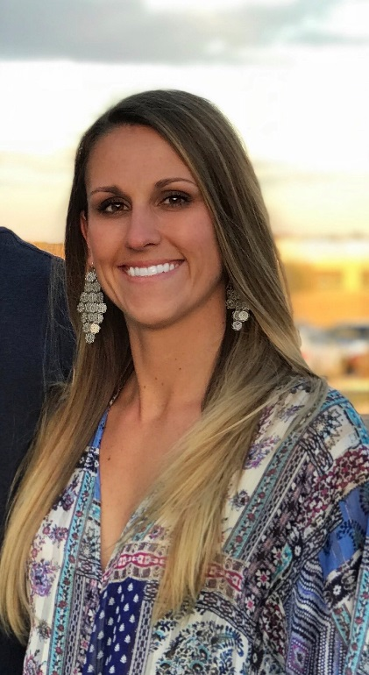

**Hannah Deveny PT, DPT, Cert DN**

Hannah grew up in Akron, OH and attended University of Cincinnati Conservatory of Music obtaining her BFA in ballet. She danced professionally for Charlottesville Ballet for 2 years before sustaining a back injury that led her to her second career as a Physical Therapist. Hannah graduated from Washington University in St. Louis with her DPT before joining the Panorama team. She uses the Movement System Impairment (MSI) syndrome approach to guide her treatment. She enjoys treating athletes including dancers. In her free time she enjoys spending time in the mountains skiing, biking, and hiking.

Fun Fact: Hannah was vegetarian for 10 years. She still enjoys cooking new vegetarian recipes and trying new restaurants in Denver.

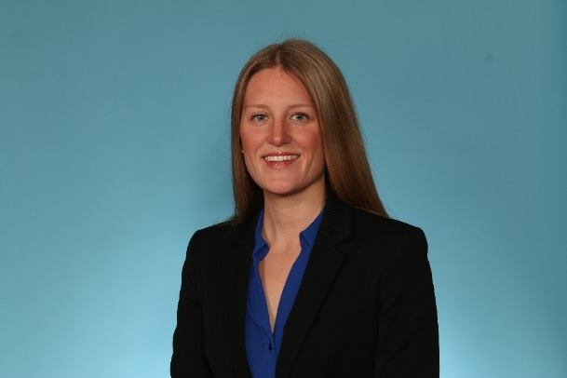

**Katie Franke PT, DPT, CSCS**

Katie Franke is originally from Chicago, IL.  She moved to the east coast to attend the University of Maryland, College Park, where she earned a Bachelor of Science in Neurobiology and Physiology and a Bachelor of Science in Psychology. Katie discovered her passion for physical therapy while volunteering at a school for disabled children in Cape Town, South Africa and decided to pursue a career in the exciting and rewarding field of physical therapy upon returning to the US. She attended the University of Miami, where she earned her Doctor of Physical Therapy degree. After Graduating from UM with her DPT, Katie spent the next 2 years treating in the outpatient sports setting at SPEAR Physical Therapy in NYC.

Katie’s clinical interests are rooted in orthopedics. Katie has treated a broad spectrum of patients in the outpatient orthopedic setting from pediatrics to geriatrics. In addition, Katie had the opportunity to treat Crossfit, NFL, and MLB athletes during the off-season; gaining exposure to advanced therapeutic exercise and strength and conditioning principles and their application to high-performing athletes and rehabilitation. Katie further supplemented this knowledge by becoming a Certified Strength and Conditioning Specialist (CSCS). Katie has also worked alongside surgeons and therapists from the world-renowned Paley Orthopedic and Spine institute where she treated adult and pediatric patients following limb lengthening, deformity correction, joint replacement, and other orthopedic surgical procedures.

In her spare time, you can find Katie traveling, hanging out with friends and family, and exploring different restaurants and craft breweries. Katie loves the outdoors and staying active. She enjoys hiking, running, racket sports, SCUBA diving, skiing, rock climbing, and adventure sports.

Fun Fact: Katie has lived on 4 different continents – North America, Europe, Africa, and Australia

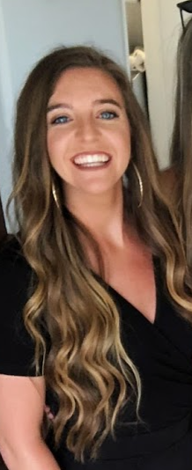

**Brandon Le Burkien PT, DPT**

Brandon Le Burkien’s biggest passion in life is to help people gain an understanding of their movement capabilities. He believes this drive stems from his years competing in gymnastics, rollerblading, and Olympic weightlifting. Each of these sports have challenged him to synchronize all of his moving parts into a technically proficient movement system. Taking those experiences and combining them with his journey through 18 years of personal training, 10 years coaching, an undergraduate degree in kinesiology and a Doctorate in Physical Therapy has helped him gain a greater understanding in how to better help people systematically build their understanding of how to use their body while reaching their movement potential.

In his free time he enjoys hanging out in the gym competing with and the comradery he shares with fellow Olympic weightlifters, followed by going for Chicago deep dish pizza and doughnuts.

Fun Fact: Brandon likes to draw, paint, build, and create prosthetics

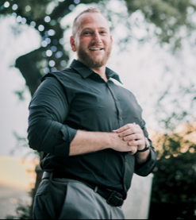

**Megan Lee PT, DPT, ATC, Cert DN**

Megan grew up in Southern California as a competitive tennis player. She completed her undergraduate and graduate studies at Boston University where she received her BS in Athletic Training and Doctorate in Physical Therapy. Megan has also worked as a personal trainer for 3 years. She received her certification in dry needling and seeks to integrate it into her daily practice to allow her patients every opportunity to return to doing what they love. She enjoys working with active populations of all ages particularly conditions that relate to head injury, concussion, vestibular pathologies, and spine. Her other passions include rock climbing, working out, hiking, traveling, cooking, reading, and camping.

Fun Fact: When she’s not at work, Megan can be found on the many beautiful Colorado hiking trails with her dog Monk.

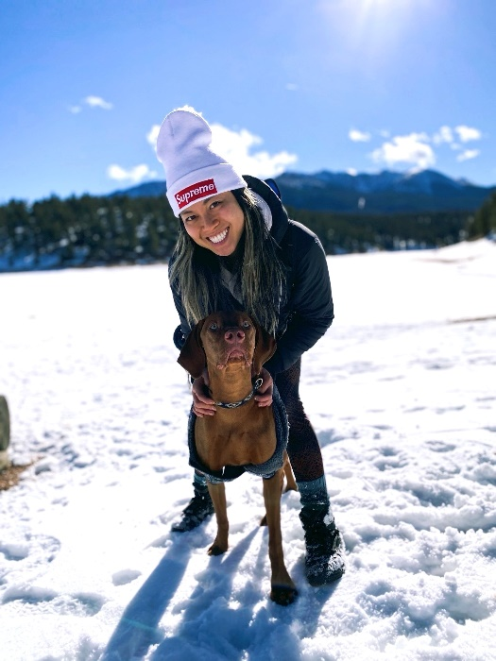

**Justin Meyer PT, DPT**

Justin completed his undergraduate education at Baylor University in Waco, TX with a degree in Marketing. From there, he transitioned into physical therapy school at The University of St. Augustine for Health Sciences in Austin, TX where he not only found his way to a degree, but also found his way to the love of his life – his wife, Logan!

Justin’s professional interests, include: manual therapy for a wide variety of orthopedic conditions, lower extremity pathologies involving the knee, and any situation where he can work to make a positive impact in the lives of his patients.

Justin’s hobbies include: hiking, fishing, hunting, exercise, hanging out with his wife, family, and friends.

Fun fact: Justin can be found binge watching college football on Saturdays (of course watching his Baylor Bears – Sic ‘em!!!)

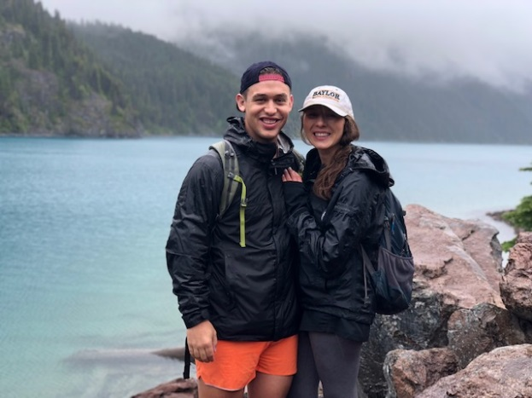

**Kristin Passaglia, PT, DPT**

Kristin grew up in a suburb of Chicago and attended Miami University of Ohio to receive her Bachelors in Exercise Physiology, she then went on to Belmont University in Nashville, where she received her Doctor of Physical Therapy. Kristin has lived in Denver for 13 years and has practiced at various outpatient orthopedic clinics. Kristin joined the Panorama team in 2015. She specializes in treating hip patients, specifically on our hip preservation team working with patients pre and post arthroscopic labral repairs. She lives with her husband, two children, and Yellow Labrador Retriever. In her spare time, Kristin enjoys working out, traveling with her family, watching her kids’ sporting event, and spending time with family and friends.

Fun fact: Kristin got to treat a famous singer while working in Nashville.

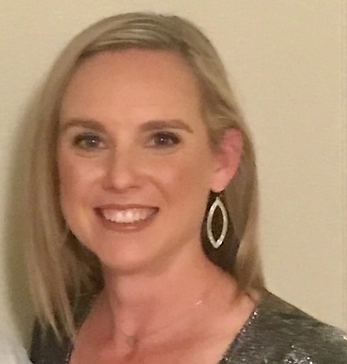

**Chad White PT, DPT, Cert DN**

Chad grew up in Suwanee, Georgia before heading to South Carolina to get his brain flooded with knowledge. In college, he played Division 1 baseball for the Blue Hose of Presbyterian College in Clinton, SC. Elbow problems landed him on an operating table undergoing Tommy John surgery, and ultimately in a physical therapy clinic where his passion for helping people get back to doing what they love began. After graduating from PC, he attended the Medical University of South Carolina in Charleston, SC for PT school. During his PT education, and from personal experience, he developed an interest in treating shoulder and elbow pathologies, specifically with athletes in overhead sports. Since graduation, he has continued work with upper extremity patients and has been certified in dry needling. Chad enjoys weight training, skiing, and spending time with his wife.

Fun Fact: Chad’s favorite animal is a lion, so he has two house “lions” named Rizzo and Honcho

