**Golden Physical Therapy Team**

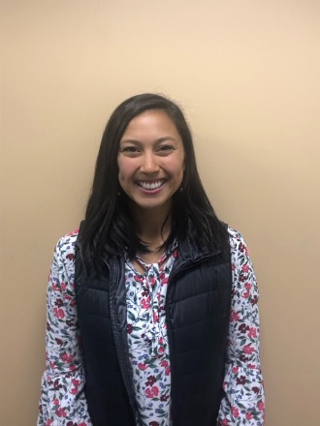**Abby Chris, PT, DPT** - Abby earned her Doctorate of Physical Therapy degree from the University of Colorado, Anschutz Medical Campus in 2019. She earned her Bachelors of Science from Colorado State University-Pueblo. At CSU-Pueblo, she played soccer and found her passion for rehabilitation and return to sport training. She enjoys treating all orthopedic conditions, utilizing a holistic approach to care. Abby strives to provide the best care for her patient’s, incorporating individualized and functional strengthening to help her patient’s get back to what they enjoy! Outside of the clinic she loves everything outdoors, baking, exercising in any form, and spending time with friends and family.

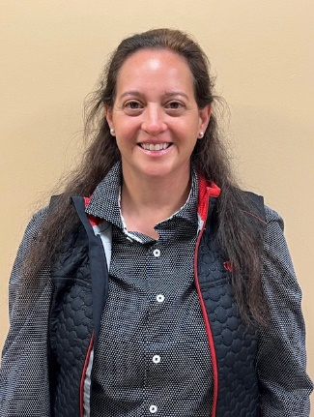**Ann Bizzano, PT, DPT, CSCS -** Ann earned her Doctor of Physical Therapy degree from the University of Montana, a master’s degree in Physiotherapy from Robert Gordon University, and her Bachelor of Science degree in Psychology from Virginia Tech. While at Virginia Tech she was a member of the Hokie Division 1 Swim team. As the daughter of a U.S. diplomat, Ann grew up overseas and jumped at the chance to go to school in Scotland. She loved Scotland so much she stayed and became a registered member of the Chartered Society of Physiotherapists. While in the U.K, she worked for a couple years for the National Health Service as well as the private health sector. In returning to the U.S., she got married and settled down and worked for a couple years for Health South. Ann has been an APTA member since 1998 and was the Director of Public Relations for the APTA of Maryland for many years. She also served as a research mentor for the Aberdeen Science and Math Academy for a couple years mentoring high school students for their year-long Capstone research projects involving physical-therapy-related subjects. Ann has a holistic approach to treatment and likes to help patients get through not only the physical and psychological challenges following a surgery or traumatic injury. Ann loves treating all types of orthopedic injuries, but her passion as a former fire-fighter and Paramedic and military wife and mother, is treating tactical athletes such as fire, police, military members and UFC, MMA, Brazilian Jujitsu fighters. Her hobbies include swimming, hiking, gardening, attending her children’s collegiate sporting events, and spending time with her husband exploring Colorado.

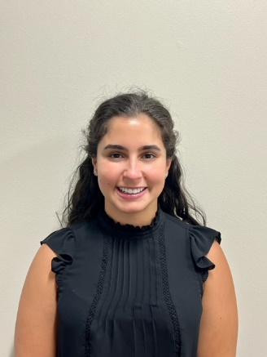**Andrea Bettini, PT, DPT, OCS -** Andrea was born and raised in Caracas, Venezuela. While in high school, she practiced sports including tennis, soccer, swimming and skiing. At the age of 15, her father suffered an ACL injury while skiing and while she watched him go through rehabilitation she discovered a strong interest in physical therapy. Andrea moved the USA when she was 18 yo to pursue her physical therapy degree, graduating from Texas A&M-Commerce with her B.S in biology and Long Island University - Brooklyn with her Doctor of Physical Therapy degree in 2017. Andrea lived in Brooklyn and worked in clinic that focus on sports and orthopedic conditions. Her goal as physical therapist is to provide patient-centered care to all individuals and help them return to doing all the things they love. Andrea recently moved to Colorado and enjoys spending time outdoors hiking and skiing, doing Crossfit, exploring the city for good ice cream shops and spending time with her partner Lee and black lab Bentley.

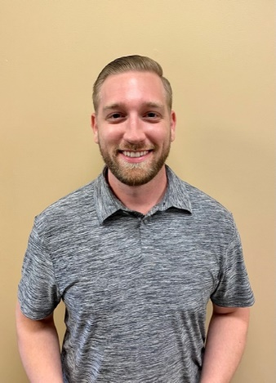**Austin Barkley, PT, DPT –** Austin is a Doctor of Physical therapy who graduated from Western University College of Health Sciences. He received his B.S. in Exercise Science from California State University, Northridge. He treats with an evidence based approach with an emphasis on returning his patients to their hobbies and activities they love. In his spare time he enjoys snowboarding, cooking, watching the UFC, and exploring the outdoor activities Colorado has to offer. He has a passion for treating concussion and neck injuries and has dreams of helping combat athletes return to the ring. He also enjoys asking random off the wall questions to help break his patients out of their shell and get to know them better, so be on your toes!

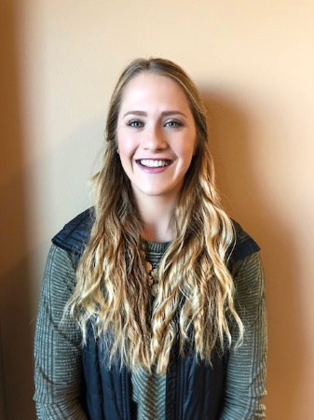**Beth Wood,** **PT, DPT** - Elizabeth (Beth) received her Doctor of Physical Therapy from the University of Colorado, Anschutz Medical Campus in 2018. She earned her Bachelors of Science in Exercise Science from Colorado Mesa University in Grand Junction. Beth is certified in the Selective Functional Movement Assessment (SFMA) and utilizes this treatment approach to identify the cause of discomfort and address biomechanical and neuromuscular dysfunction in her patients. Beth also specializes in pre and post- operative total joint replacement rehab. She treats an array of orthopedic injuries and strives to develop a rapport with patients and make rehab a fun, positive process. Outside of work, Beth enjoys tennis, equestrian events, running, and spending time with friends and family.

**Bo BabenkoPT, DPT, CSCS, Cert.DN, PN1, CFL3** *-* Bo has had a very non-traditional path through his Physical Therapy career. He has been involved in the fitness, nutrition, and medical space since 2001. His journey has included many roles including EMT, athletic trainer, personal trainer, nutritionist, and physical therapist. He has had experience opening a gym, serving as the private PT, and running his own business. Bo has thrived all over the world including Dubai, NYC, SoCal, and now here in Superior, CO. He utilizes a longevity and holistic treatment approach which often includes a focus on overall functional capacity and “fitness”; he plans to live to 120 years old with the ability to run around until his last day. Bo just had his first child, Rayaan, with his wife Maha who is a sex & relationship therapist. When Bo is not at work, he continues to suffer as a New York Jets fan, enjoys rock climbing, exploring all that CO has to offer, and lifting heavy things.

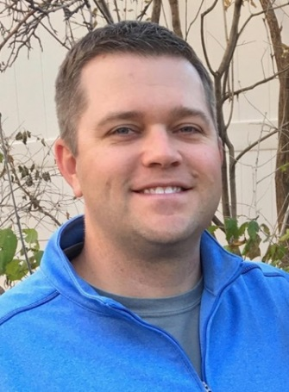**Brad Walters, PT, MSPT, OCS** - Brad graduated in 2002 from the University of Colorado at Boulder, majoring in Kinesiology. He subsequently earned a Master of Science in Physical Therapy from the University Of Colorado Health Sciences Center in 2004. He has been a member of the American Physical Therapy Association and the Orthopedic Section for 15 years. He is a board-certified Orthopedic Clinical Specialist (OCS) since 2012. He was a game-day physical therapist for the NBA's Denver Nuggets for the 2012-2013 season. He was an APTA Orthopedic and Sports Residency Faculty Mentor for ATI Physical Therapy in Greenville, South Carolina from 2014-2017. He is certified in Functional Dry Needling Level 1 and 2 since 2016. He believes in coupling physical therapy with sports performance. He enjoys working within the broad spectrum of orthopedic and sports injuries. He strives to provide a personalized approach to assist each patient in establishing and achieving incremental goals. He combines hands on therapeutic treatment techniques with functional and evidence based exercises that are tailored to both the home and clinic environments. As a Colorado native, Brad enjoys following all his hometown teams, especially the Denver Broncos! He also enjoys golfing, fly-fishing, skiing, traveling and spending time with his wife, Rachael.

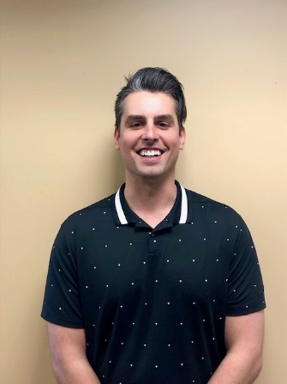**David Whitmore, PT, DPT –** David graduated from Arizona State University’s Barrett Honors College and W.P. Carey School of business in 2014 with a BS in Business Management while also serving as a member of the men’s basketball team. He then attended Baylor University to earn his Doctorate of Physical Therapy in 2019. He enjoys working with a wide array of patient profiles. Whether it is an athlete returning to sport or a patient working to maintain highest functional levels to improve overall quality of life, he wants to be there to help patients meet their goals. He utilizes various manual techniques and evidence-based interventions to progress and improve patient’s functional abilities to return to, if not surpass, their prior level of function. When he is outside of the clinic he enjoys hiking and exploring all of the beauty Colorado has to offer with his wife and their dog Marley.

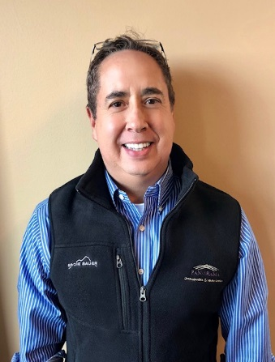

**Emery Pino, PT, MSPT** - Emery graduated from the University of Colorado Health Sciences Center Physical Therapy program in 2000. He previously was a System’s Engineer for 13 ½ years, much of the time with IBM. Emery’s engineering background helps him clearly explain pathology to his patients, while using critical thinking to determine the best rehabilitation for complicated patient pathologies and diagnoses. Emery’s interest in physical therapy is in outpatient orthopedics, and is also one of the vestibular and balance therapists at Panorama PT. He has a variety of certifications of continuing education to influence his knowledge and skill base in treating the orthopedic population.

**Fred Rooley, PT, DPT –** Fred earned his Doctoral of Physical Therapy from Northern Illinois University, NIU) in 2019.  His bachelor’s degree of General studies was received in 2005 from University of North Dakota, UND.  Fred’s approach to therapy is a holistic with a focus in evidence-based practice.  He enjoys working with a wide range of orthopedic conditions while working towards functional improvements and return to recreational activities for improved quality of life.  In his spare time Fred likes to camp, hike, fish, ski, exercise, yard work, and read a good book.

**Justin Lowder, PT, DPT –** Justin received his Doctorate of Physical Therapy from the University of Saint Augustine. He earned his Bachelors of Science in Sports Industry Operations from Metropolitan State University of Denver. Justin grew up in Oklahoma and moved to Colorado to play college soccer at MSUD. Justin is an avid soccer player, mountain biker, and snowboarder. Having been an athlete since childhood, he has had his share of injuries requiring rehabilitation and Physical Therapy which sparked his interest in the profession. Justin deeply understands the athlete’s mindset and the drive to achieve and maintain physical fitness for the demands patients put on their bodies. Justin thoroughly enjoys treating people with orthopedic conditions of all ages and abilities ranging from weekend warriors and active seniors to high-level athletes.

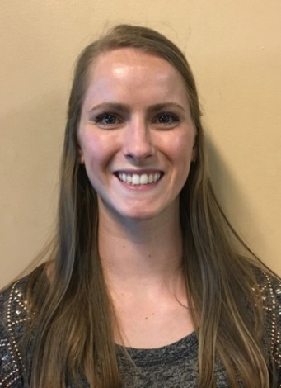

**Kaitlin Thompson, PT, DPT** - Kaitlin graduated from Boston University with a BS in Athletic Training in 2011 and Doctor of Physical Therapy in 2014. Kaitlin started her career in NYC doing outpatient orthopedics with an emphasis on sports/orthopedic rehab and is also a certified vestibular therapist. Her passion in PT lies in using specific exercises and education tailored to each patient to help get them back to what makes them happy. In addition to helping patients through PT, Kaitlin is also the clinic director at Golden PT and enjoys helping her team grow and follow their own passions. Kaitlin’s happy place is on the volleyball court and up in the mountains. She played club volleyball at BU and continues to play competitively on grass, sand, and indoors.

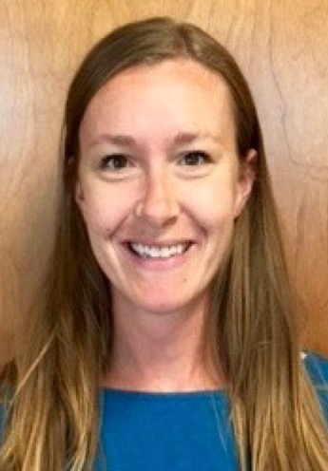

**Keri Windels, PT, DPT, SCS** - Keri went to The Pennsylvania State University where she majored in Kinesiology with a Exercise Science focus. After graduating, Keri moved to Denver and earned her Doctorate of Physical Therapy from University of Colorado Health Sciences Center in 2009. She then spent time on the East Coast, working at The Johns Hopkins Hospital. There, she was on faculty for the Orthopedic Physical Therapy Residency Program and also became a Sports Certified Specialist (SCS). Keri enjoys working with all orthopedic conditions, but specializes in lower extremity injuries in athletes.

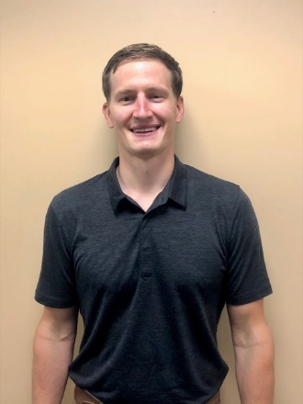**Luke Mueller, PT, DPT, CSCS** - Luke graduated in 2011 from the University of Wisconsin-La Crosse with a degree in Exercise and Sport Science. He continued his education at UW-La Crosse to earn his Doctorate of Physical Therapy in 2014. He enjoys treating a variety of orthopedic and sport injury conditions as well as vestibular conditions. Evidence-based treatment with a holistic, individualized approach is what you can expect when working with Luke. He is a Certified Strength and Conditioning Specialist and believes in integrating rehabilitation with sport performance to maximize potential while reducing future injury risk. When not at work, Luke is likely in the outdoors with his fiancé, Arielle, enjoying a variety of outdoor recreation such as hiking, mountain biking, and snowboarding. He also enjoys traveling, trying out new recipes, and spending time with his dog and cat.

**Matthew Hoffman, PT, DPT, CSMS-1-** Matt graduated from Grand Valley State with a Doctorate in Physical Therapy and a B.S. in Health Sciences and has worked in outpatient orthopedic practice for more than 15 years with an emphasis on Sports Medicine and shoulder rehabilitation. He has a passion for helping athletes of all ages and levels meet their goals and return to performing at their best. Matt uses a love for continuous learning and evidence-based practice to educate and guide his patients not only in recovery but also with prevention of reinjury. He also enjoys working with runners on gait evaluation, modification, and footwear choices. When not working, Matt is an avid cyclist, riding and racing on both the mountain bike and gravel bike several times per year. He also enjoys hiking and walking his two dogs on the many trails in and around Golden.

**Mitchell W. Parrish,** **PT, DPT Cert. DN** - Mitch received his Doctor of Physical Therapy from Regis University (Denver, CO) in 2021. Prior to this, Mitch earned his Bachelor of Science in Kinesiology from the University of Maryland, College Park. He worked with the Athletic Training Department at UMD for two years, where he developed a passion for Sports Medicine and orthopedics. Mitch has special interests in treating athletes of all skill levels, as well as concussion, hand-therapy, and endurance athletes. Mitchell believes that incorporating patient driven goals, using evidence-based medicine, and empowering his patients through meaningful education are crucial to the success of physical therapy. Outside of work, you can find Mitch in the mountains, camping, road cycling, mountain biking, hiking 14ers, skiing, climbing, and living life to the fullest.

**Nyita Hooper, PT, DPT -** Nyita earned her Doctorate of Physical Therapy from the University of Colorado, Anschutz Medical Campus in 2021. She received her Bachelors Of Science from the University of Colorado at Boulder. Nyita takes an evidence-based and holistic approach to treatment, working with the whole patient and the latest research to get her patients back to doing the things they love. Prior to starting her PT education she was a competitive rock climber at the national level, as well as a rock climbing coach for one of the country’s most competitive youth programs. Also, she loves to knit, craft, and bake, because, well, who doesn’t?

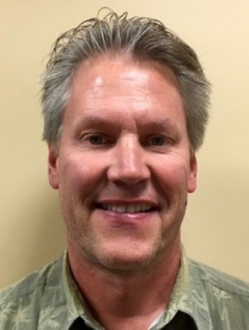**Tom Hermsen, PT, MSPT, CSCS** - A 1983 graduate from the University of Wisconsin – Madison, Tom has been a practicing PT for over 30 years, 27 in outpatient orthopedics. He was a site coordinator and treating therapist at HealthSouth in Lakewood, CO from 1994- 2000. He was the clinic director and practicing PT for Physiotherapy Associates at Golden Ridge for seven years. In 2010, he joined the staff at Panorama Physical Therapy as a senior staff PT. Tom’s area of expertise included the treatment of shoulder and knee dysfunction, and foot and ankle disorders including the fabrication of custom orthotics. He has vast experience in lower extremity biomechanical evaluations. He is also a Certified Strength and Conditioning Specialist (CSCS).

**HAND THERAPISTS**

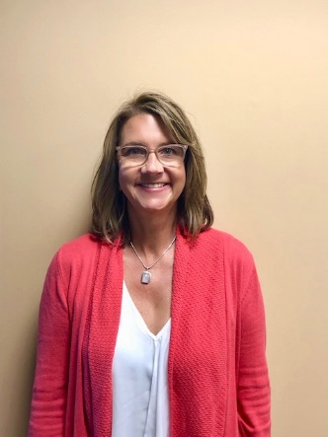**Lisa Condon, OT, MSOT, OTR, CHT** - Lisa graduated from University of Wisconsin-Milwaukee in 1988 with a Bachelor’s in Occupational Therapy. After working 3 years in Inpatient Neurology, she moved to Colorado and pursued Outpatient Orthopedics. She received her Certification in Hand Therapy (CHT) in 1995 and her Master’s in Sports Medicine in 1996. Lisa has a strong passion for treating upper extremity trauma and has spent much of her career developing her manual skills and thoroughly understanding the anatomy of the hand, wrist, elbow and shoulder. She believes that educating the patient on their injury is imperative for a successful outcome and being an active member of the “Hand Team” (MD, Therapist and Patient).