Bradburn Team
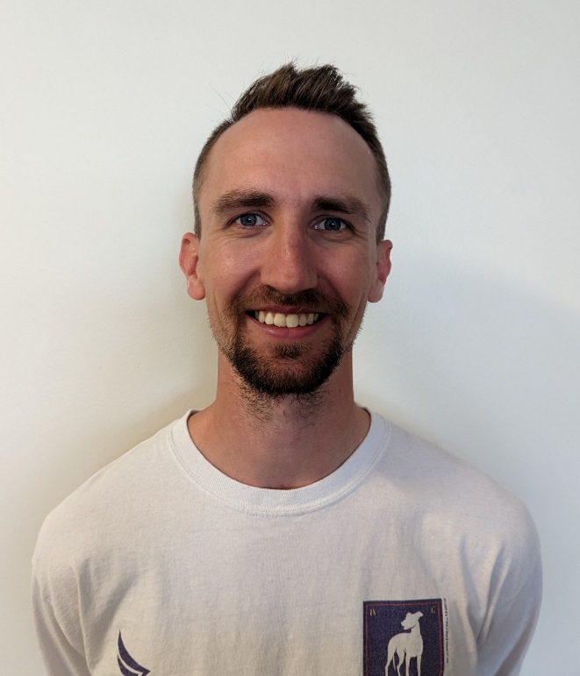
Creighton Thompson PT
Creighton is a South Dakota native who moved to Colorado 3 years ago to start his career with his significant other. Creighton grew up in Sioux Falls, SD. He attended the University of Nebraska-Lincoln for his bachelor's degree in Exercise, Nutrition, and Health Sciences. After completing undergraduate he returned to South Dakota to complete his Doctorate of Physical Therapy education at the University of South Dakota. In his free time he enjoys all that Colorado has to offer that Eastern South Dakota did not. His favorite hobbies include hiking, day trips to mountain towns, golf, and basketball. He currently lives with his significant other and their dog (Lasso) and cat (Hodor).
Creighton has been with Panorama for over a year now. In total he has 3 years of outpatient orthopedic experience. He thoroughly enjoys treating all orthopedic conditions and specializes with chronic pain and providing pain neuroscience education. In addition to general orthopedic conditions and post-operative cases he also treats vestibular conditions and sports specific recovery. He currently provides level 1 Functional Dry Needling interventions as well. Creighton promotes individualized treatment, designing each plan of care based on the patient’s functional goals. He strongly believes in a multi-faceted approach using a blend of therapeutic exercise, neurological reeducation, manual therapy, and modalities. If you are hoping to return to the activities you enjoy most, Creighton would love to help you get there.

Crickett Rippley PT
Crickett is a native of Colorado. She has a Bachelor’s of Arts degree in Kinesiology from the University of Colorado and completed her Master’s in Physical Therapy in 1996 from the University of Southern California. She enjoys treating a variety of diagnoses and helping her patients achieve their goals. In her spare time she loves spending time with her family, watching her daughter play soccer (who will be at the United States Air Force Academy), and playing with her two dogs.

Reba Havis PT
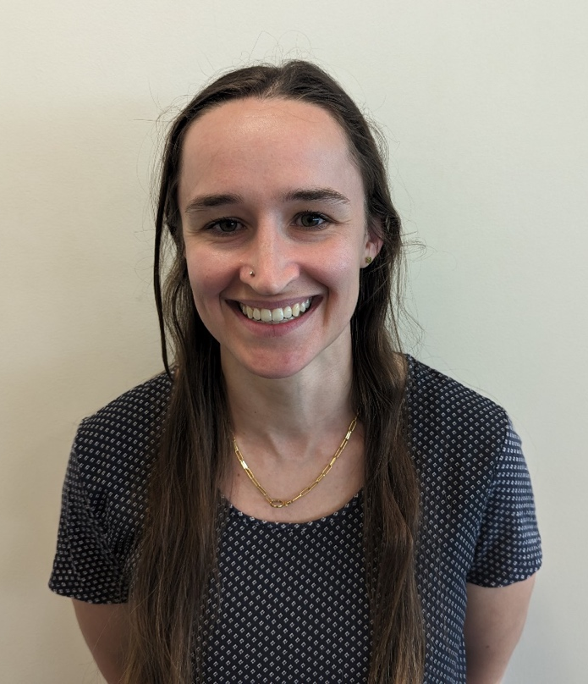
Reba Havis grew up in Fort Collins, CO and went to Poudre High School. She enjoys Colorado’s expansive outdoors by hiking with her dogs, rock climbing, and mountain biking. She went to the University of Florida for her undergraduate education and received her Doctorate of Physical Therapy from Northeastern University in Boston, MA. Reba joined the Panorama Team in 2021 following the completion of her education. She treats various conditions of the musculoskeletal system, but takes special interest in chronic pain, hip conditions, and pelvic health.

