Orchard Team
DeAnn German PT, CHT
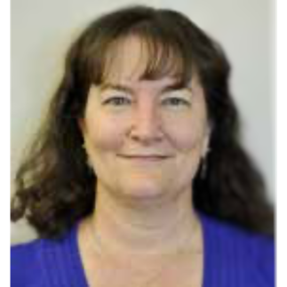
Part of the original physical therapy staff back in 2008 when Panorama Physical Therapy opened its doors, DeAnn German holds a BS in physical therapy from Mount St Mary’s College in Los Angeles (1991). After practicing for three years in California, DeAnn moved to Colorado in 1994. DeAnn relocated to Virginia in 2005 for a few years and then decided she did not want to live anywhere else and moved back to Colorado in 2008. She became a Certified Hand Therapist in 1999 and currently treats injuries of the shoulder, arm and hand, working closely with Panorama’s hand surgery service. DeAnn and her husband of 20+ years, Dave, live in their dream home just north of Denver. In her free time, DeAnn is a crazy horse lady who enjoys riding and working with a local equestrian vaulting team.
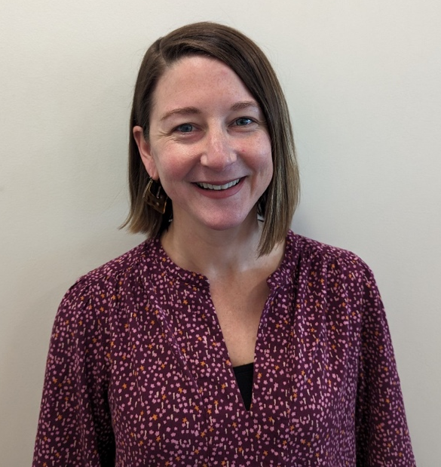
Jenna Neff, OT, CHT
Jenna was born in Lancaster, PA but relocated to Colorado from Washington, DC in 2022. She is an Occupational Therapist and Certified Hand and Upper Extremity Therapist. Continuing education and mentoring are of high priority; she has the mindset of a lifelong learner!
When not at work, Jenna enjoys all things outside, preferably in the sunshine. She continues to play competitive field hockey, though had to sit this season out as she and her husband are expecting their first child in July! Her 3-year-old dog, Zili is also very excited about this new development.

Courtney Luitjohan PT
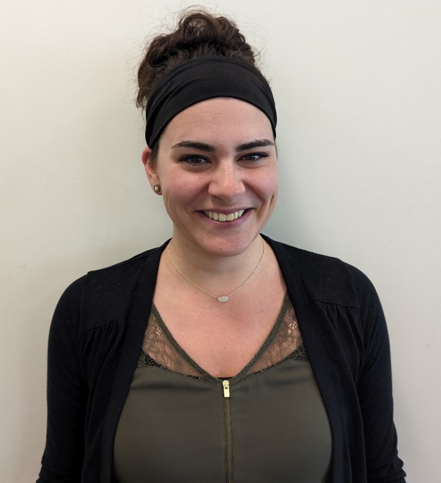
Courtney was born and raised in a small town in Missouri called Moscow Mills. She loves to ski, hike, bike, camp and enjoy anything outside with her two young children, Great Dane, and husband. Courtney attended Missouri State University for her Bachelor of Science in Athletic Training and her Doctorate in Physical Therapy, graduating in 2017. Courtney moved to Longmont, CO in 2017 to pursue a lifelong dream of living near the Rocky Mountains. Courtney joined the Panorama team in 2022 after leaving a management role to focus on her family and clinical care more.
Courtney has been practicing in the outpatient orthopedic setting for the past 6 years and is Certified Dry Needling Level I and a Certified Pelvic Floor Level I provider. Courtney is a member of the Panorama Hip Team and Pelvic Floor Special Interest Group. She treats every body part and enjoys treating a wide variety of diagnoses including sports injury recovery, post-operative patients, TMJ dysfunction, and post-partum patients. Courtney has been described as compassionate and driven. She strives to create individualized and enjoyable evaluations and therapy treatment sessions with patients.

Austin Lyons PT
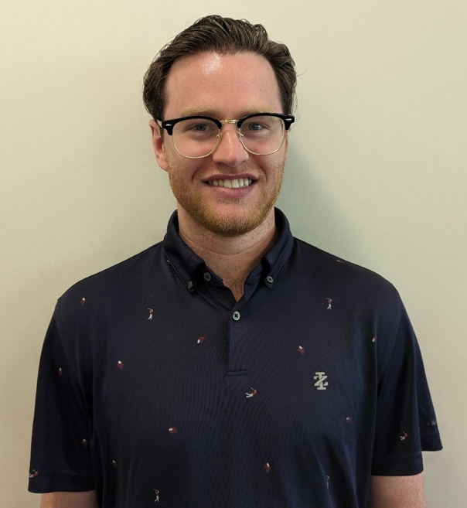
Born and raised in Eau Claire, Wisconsin, I have lived in Colorado for 4 years now. Over that time, I have adopted the Colorado lifestyle as I enjoy skiing, mountain biking, hiking, etc, although I am just as likely to be found enjoying the comforts of my living room. I attended the University of Kentucky for my undergraduate studies. I then transitioned to Colorado to receive my Doctorate of Physical Therapy in 2022 at Regis University. I have always had an interest in the orthopedic setting which has led me to joining the Panorama team in the Fall of 2022. I enjoy getting to manage all varieties of patient presentations from head to toe. I am a Certified Dry Needling Specialist which allows me to better treat musculoskeletal impairments. I will work with my patients to find a successful plan of care that can improve their quality of life, ultimately returning them to the activities they love.

Morgan Wilcox PT
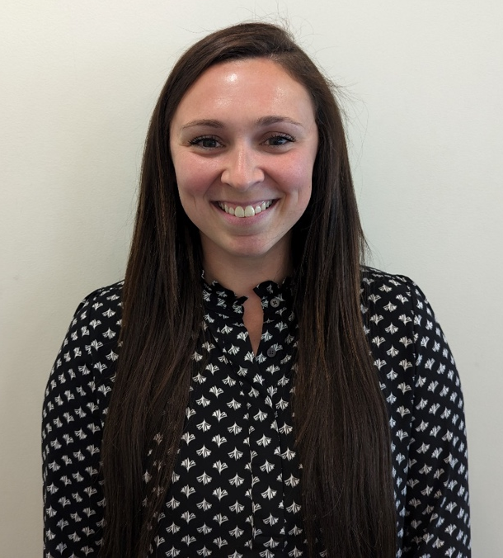
Morgan grew up in Northern Colorado and received her Bachelor of Science in Exercise Science and was a collegiate softball player at Colorado Mesa University in Grand Junction. Morgan earned her Doctor of Physical Therapy degree from the University of Colorado, Anschutz Medical Campus in 2020.
Morgan has been practicing in the orthopedic setting for the past 3 years and most recently became certified in Functional Dry Needling Level 1. While she likes utilizing her sports background for return to sport rehabilitation in athletes, she enjoys seeing and treating all orthopedic conditions and strives to provide patient-centered care to every individual in order to help them reach their goals and return to doing the things they love.
Following PT school Morgan married her high school sweetheart, bought a home, and became a dog mom to a sweet Rottweiler named Riggs! In her free time, she enjoys exercising in any form (most recently running half marathons) and spending time with her friends and family.

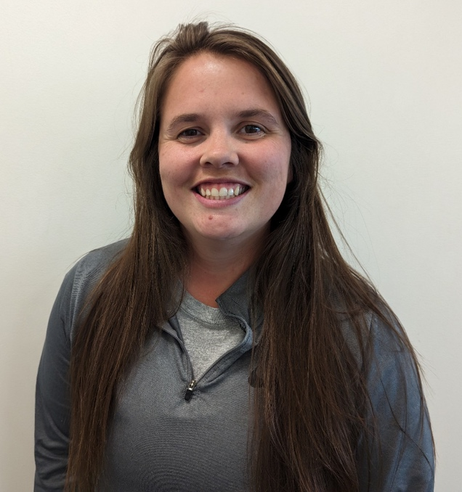
Brook Hughes PT
Brook was born in Thatcher, Arizona, but with her dad being in the military, she moved all over, including living in England. She returned to Arizona to finish her undergrad in Exercise and Wellness at Arizona State University, and then continued at A.T Still University to receive her Doctorate in Physical Therapy. Brook moved to Denver quickly after graduating and started her career as a PT. Since graduating Brook has worked primarily in the hospital setting, working with patients with neurological deficits as well as COVID recovery patients. She wanted to explore outpatient, as this is where she found her love for PT when she was a tech before PT school, and joined Panorama in September 2022. Brook enjoys getting to know her patients and taking a teamwork-like approach to her treatment sessions, allowing patients to be actively involved in their care to help them reach their goals. Brook tries to make each session fun and often you’ll hear Brook and her patient laughing and joking around, all while getting work done.
When not at work Brook enjoys everything Colorado has to offer, including hiking, brewery hopping, camping, and taking her dogs to the dog park as much as she can. She also plays in a competitive flag football league and many Sundays are spent at the field or traveling to different tournaments.

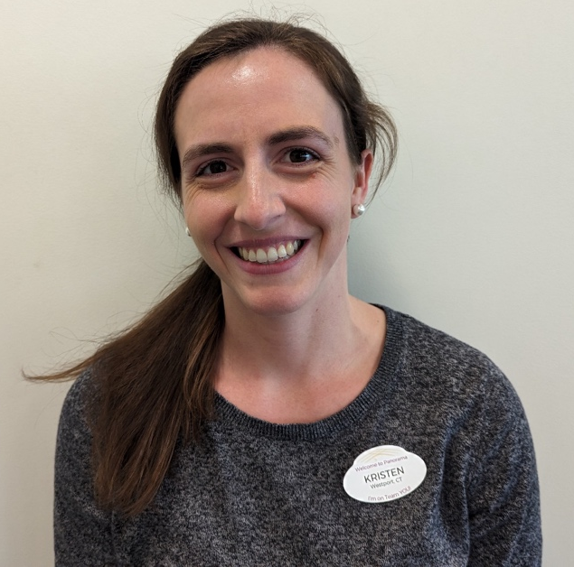
Kristen Weiler PT
Kristen comes from Westport, CT, where she grew up playing soccer, volleyball, and running indoor and outdoor track. She completed her undergraduate degree in psychology at Villanova University where she joined club running and participated in and led several community service activities, including a service trip to Kingston, Jamaica, as well as Habitat for Humanity trips to North and South Carolinas.
Kristen completed her doctorate degree at MGH Institute of Health Professions in Boston, MA, where she continued her passion for helping others by participating in PT Day of Service, as well as a community service trip to Guatemala where pro-bono PT services were administered.
Kristen enjoys working with all types of injuries but has a particular interest in foot and ankle. Kristen moved to Colorado with her fiancé in 2021 and has been enjoying hiking and running with her dog, Arya in the warm seasons, and snowboarding in the winter.

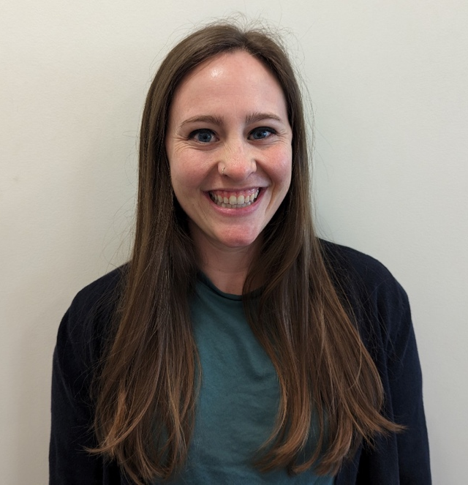
Madi Kaufman PT
Madi was born and raised in Southern California where she quickly realized she was not cut out for beach life. For a change of scenery, she moved north to Eugene to attend the University of Oregon (go Ducks) where her appreciation of nature and sports continued to grow. Madi then made her way to the East coast to attend Boston University, where she graduated with her Doctor of Physical Therapy in 2021. Following her last clinical rotation in Aurora, CO, Madi decided to stay and make Denver her home.
Madi has been with Panorama since September of 2021 and has since become certified in Functional Dry Needling Level 1 and has joined the Panorama Pain Neuroscience Team. Madi’s relaxed style helps her patients feel comfortable during treatments and she strives to build personal connections with each patient while helping them work towards their goals.
Outside of work Madi enjoys exploring Colorado with friends, attempting to learn to ski, and a healthy dose of reality TV.

Reba Havis PT
Reba Havis grew up in Fort Collins, CO and went to Poudre High School. She enjoys Colorado’s expansive outdoors by hiking with her dogs, rock climbing, and mountain biking. She went to the University of Florida for her undergraduate education and received her Doctorate of Physical Therapy from Northeastern University in Boston, MA. Reba joined the Panorama Team in 2021 following the completion of her education. She treats various conditions of the musculoskeletal system, but takes special interest in chronic pain, hip conditions, and pelvic health.

