**Highlands Ranch Town Center Physical Therapy**

**Adam Bahnson, PT, DPT, ATC, certDN**

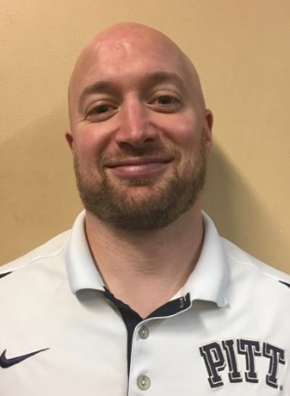Adam graduated from nationally top ranked University of Pittsburgh with a BS and an Athletic Training Certification (ATC) in 2004 and a Doctor of Physical Therapy (DPT) in 2007 both with honors. Adam has also continued to progress in his professional education and development receiving a level two Dry Needling Certification in 2011. Adam specializes in a wide variety of orthopedic pathology and utilizes manual and evidence based practice treatment approaches to maximizing outcomes and recovery.

**Alyssa Jean Rachubka Dickerson, PT, DPT, certDN**

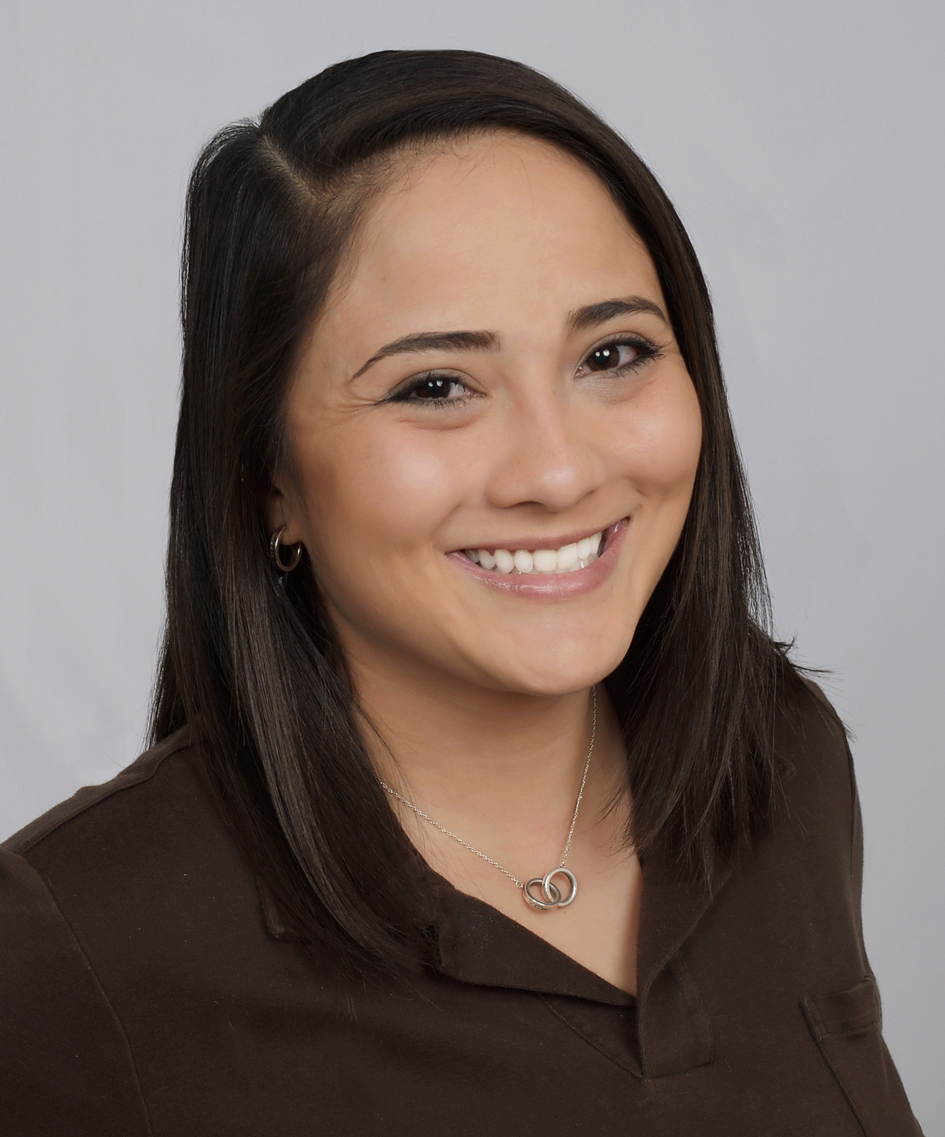

Alyssa was born and raised in Virginia where she attended James Madison University for undergrad. She earned her DPT from University of Hartford in 2016 and has had the opportunity to gain clinical experience in Connecticut, Louisiana, Missouri, and Maryland at Walter Reed National Military Medical Center. Alyssa specializes in a wide variety of outpatient conditions, enjoys treating post-op ACL reconstruction or joint replacements and working with the military population. Certifications include Dry Needling (Level 1 & 2 via BRI), Sportsmetrics (via Cincinnati Sports Medicine), and Pilates (Gateway Level 1 Mat via Polestar Pilates). Hobbies and interests include going to concerts and lives shows, traveling, arts and crafts, yoga, hiking, roller skating and DISCO (her dog). Red Rocks is her happy place – day or night and rain/snow or shine! Alyssa has been with Panorama since September of 2018.

**Annika Morrison PT, DPT**

Annika graduated from Ithaca College in 2021 with her Doctorate in Physical Therapy, and also earned her B.S. in Clinical Health Studies with a minor in Nutrition Promotion in 2019. She is a native of Storrs, CT - go Huskies! - and grew up as a mid-distance runner. Several running injuries landed her in PT and opened up the world of rehab from there.

Annika has clinical experience in pre- and post-operative orthopedic and acute care rehab and enjoys working with lower extremity patients across the lifespan. She is passionate about educating patients to increase independent self-management of their condition for the long run.

In her free time, Annika enjoys tackling new hikes in the mountains, baking, dog watching, hobby jogging, lifting, and cheering on the Avalanche.

**Logan Meyer, PT, DPT, CSCS, Cert. DN**

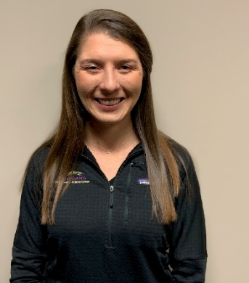As a native of Charlottesville, Virginia, Logan is a born-and-raised Virginia Cavaliers fan. Logan split her allegiances by attending James Madison University, receiving her Bachelors of Science in Kinesiology. While at JMU, Logan worked with the university’s strength and conditioning program, ultimately inspiring her to become a Certified Strength and Conditioning Specialist (CSCS). After earning her doctorate in physical therapy from the University of St. Augustine for Health Sciences in Austin, Texas, Logan moved to Denver. Over the years, Logan has developed a passion for treating all orthopedic injuries, especially those of the knee and hip. Logan and her husband enjoy hiking, skiing, and spoiling their dog, Breck.

**Max Langevin, PT, DPT**

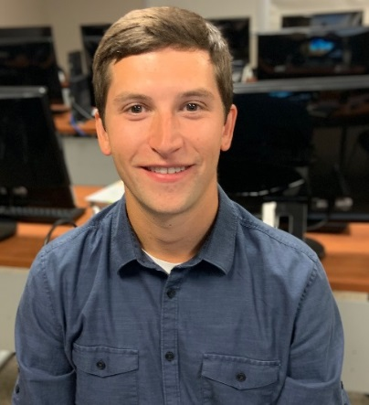Max Langevin grew up in Connecticut and completed his undergraduate degree in psychology at Boston University. After earning his DPT at Georgia Southern University in Savannah, Max moved to Colorado to begin his career in physical therapy. Max has been with Panorama since September of 2019 and in his free time enjoys playing ultimate, hiking, playing golf, and snowboarding.

**Steve Medberry PT, DPT**

Steve is a Colorado native, and loves nothing more than exploring the mountains, practicing archery, and spending time with friends and family.  Having worked with a PT who served as his mentor in high school, Steve set out to become a PT himself and attended CSU to study Health and Exercise Science.  He began his career in personal training and group fitness instruction, going on to become the fitness department student manager at the CSU Rec Center and teaching the ACE personal training certification course each semester.  Steve achieved his doctorate in physical therapy at Regis University in 2016 and has been practicing in outpatient orthopedics ever since.  Before joining Panorama’s team in 2022, he has worked exclusively in the private practice setting, developing a comprehensive treatment approach that incorporates manual therapy and exercise to focus on patient specific goals.

Steve has gone on to attain his certification in dry needling, and also specializes in the treatment of vestibular rehabilitation and balance training.  He has a passion for teaching and mentorship, and believes strongly in investing in others to empower them to help themselves and others.

Steve volunteers extensively with Colorado’s outdoor community serving on the board of directors of Outdoor Buddies, a local non-profit organization focused on making outdoor activities accessible to individuals with physical limitations.

**Maria Kalasountas, PT, DPT**

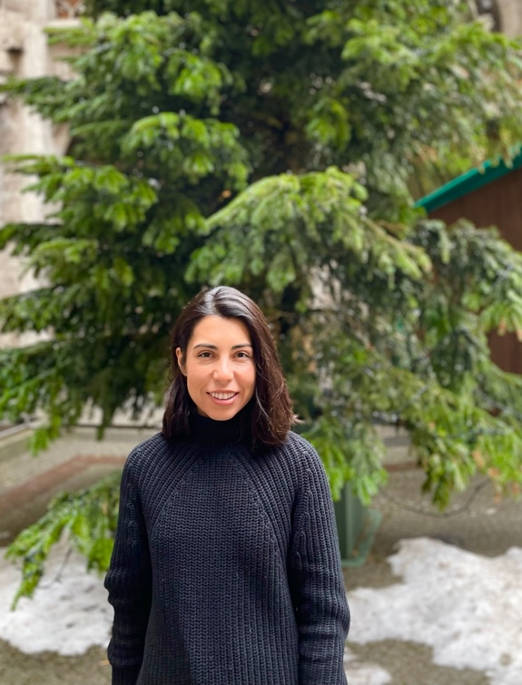

Maria was born and raised in Denver, Colorado. She received her Doctorate of Physical Therapy from Emory University in Atlanta, Georgia. Maria's passion for Physical Therapy began after an ankle injury and surgery. Maria enjoys working with patients of all ages and orthopedic conditions, especially related to lower extremity injury and post-operative rehabilitation. Maria is a compassionate listener and strives to help each patient achieve his/her functional and recreational goals. When she is not in the clinic, Maria can be found trying new restaurants, running outside, spending time with her family, and travelling.

Fun fact: Maria's first language was Greek.

**Kristen Joyce PT, DPT, OCS**

Kristen graduated from California State University, Long Beach with her B.S. in Kinesiology specializing in exercise science in 2010 and a master’s in physical therapy in 2012. In 2016, she received her board certification in orthopedic physical therapy and then went on to complete her doctorate in physical therapy at A.T. Still University of Health Sciences in 2020. She believes that everything is connected which led her to take course work in pelvic floor physical therapy from Herman and Wallace Pelvic Rehabilitation Institute. Additionally, she has experience working with patients undergoing cancer treatment and has become a PORi-Certified Oncology Rehabilitation Specialist. To provide quality care to her patients, she obtained her certification in dry needling from the American Academy of Manipulative Therapy in 2022.

When she is not working, she enjoys spending time with her family, cooking, or going for long walks with her dog.

**Kayla Stolfa PT, DPT**

Kayla is from the Chicago suburbs (Batavia, IL) and graduated from Eastern Illinois University with her Bachelors of Science in Biological Sciences. During her undergraduate studies, she played DI soccer for the university as well. She then went on to graduate school at University of Iowa where she received her Doctorate of Physical Therapy in 2021. Kayla completed internships during school that were largely focused on pediatrics, neurological rehabilitation (such as stroke and spinal cord injuries), and orthopedics. In her free time, Kayla enjoys playing soccer, hiking, being outside, spending time with family and friends, and trying out new restaurants.

**Savannah Sprague OTR/L, MSOT**

Savannah received her Bachelor's degree from the University of Missouri in Columbia, Missouri with a major in Pre-Occupational Therapy, Health Sciences. She then received a Master of Science in Occupational Therapy from Allen College- Unity Point Health Hospital in Waterloo Iowa. Savannah is a hand therapist who specializes in orthopedic injuries of the elbow, wrist, and hand. Savannah enjoys spending her free time outside hiking or skiing and rooting on her home town KC Chiefs!

**Sarah Shivley, OTR/L, MOT, WCC**

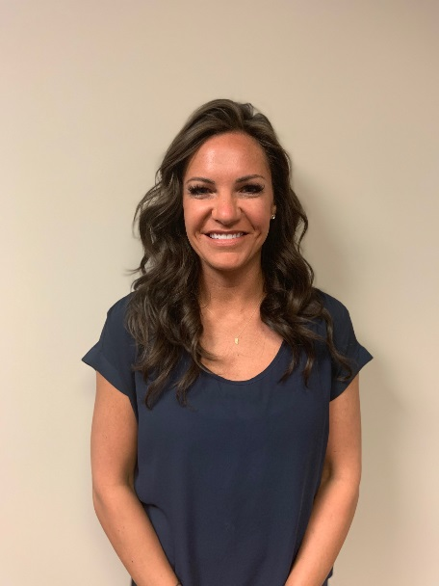Sarah received her Bachelor’s degree from Olivet Nazarene University in Bourbonnais, Illinois and her Masters of Occupational Therapy from Midwestern University in 2013. Sarah was with Northwestern Medicine in Chicago, Illinois and worked alongside six hand and upper extremity surgeons since graduating and she specializes in orthopedic injuries of the elbow, wrist and hand and is Wound Care Certified. Sarah has been with Panorama since June of 2019.

**Annelise Adolph, PT**

Annelise was born and raised in Colorado and completed her B.S. in Health and Exercise Science with a Concentration in Sports Medicine at Colorado State University as a part of the University Honors Program. She earned her DPT from Regis University in 2023 where she got to experience clinicals in a wide variety of areas including orthopedics, pediatric rehabilitation, neurologic rehabilitation, and inpatient rehabilitation. Ultimately, she decided to return to the clinic where she shadowed and began her physical therapy journey because of the exceptional patient care, supportive team, and close patient-clinician relationships.

As a Colorado native, she loves anything outdoors including hiking, going to lakes, going to Broncos games, line dancing, and playing pickleball.

**Jess McLaughlin PT, DPT, Cert. DN**

**Clinic Director**

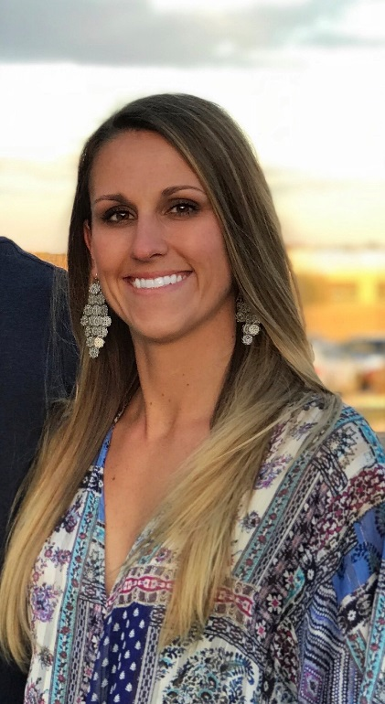

Jessie was born in Atlanta, Georgia and moved to Greenwood Village, Colorado in 1999. She attended school at Colorado Academy and then went to Gonzaga University where she played D1 soccer as a goalkeeper and received her BS in Exercise Science. She went on to physical therapy school at Duke University where she graduated with a Doctorate in Physical Therapy.

Jessie had a shoulder injury in high school that inspired her to go on to become a physical therapist. She specializes in sports medicine, hip preservation, ACL, foot/ankle, and return to sport therapy and works closely with Panorama physicians, physical therapists and performance trainers at The Institute to provide a full continuum of care for her patients. Since obtaining her certification in dry needling, Jessie incorporates this skillset to further assist her patients recover from their injuries. She greatly enjoys being a resource for her patients, staff, and anybody interested in pursuing a career in physical therapy.

Jessie loves the outdoors and in her spare time she enjoys training her horses, hiking, camping, and going on adventures with her husband and dogs. She is an avid football fan and regularly sports cowboy boots with her Atlanta Falcons jersey on casual Fridays.

Fun fact: Jessie can often be found on the dance floor at country bars perfecting her line dancing and country swing dance moves