**Golden Physical Therapy Team**

**Abigail Weber, PT, DPT -** Abigail (Abby) is from Northern Virginia where she was born and raised. In high school she participated in soccer and cross country. She earned her Doctorate of Physical Therapy degree from Shenandoah University in August 2023 and moved out to Colorado with her fiancé and dog in September 2023. She earned her Bachelors of Science from James Madison University in Harrisonburg, VA. While at JMU, she was involved with Special Olympics and volunteered with the SPCA shelter. As a therapist, Abby’s goal is to help patients return to their prior level of function stronger and better than before focusing on a patient-centered approach, as well as provide a positive impact on patients. She enjoys treating a variety of patients and encourages an active lifestyle with her patients. Outside of clinic you will find Abby outside whether that’s hiking, paddle boarding, swimming, playing pickleball, and traveling to new places. She is also a football fan and will be cheering on the Green Bay Packers.

**Andrea Bettini, PT, DPT, OCS -** Andrea was born and raised in Caracas, Venezuela. While in high school, she practiced sports including tennis, soccer, swimming and skiing. At the age of 15, her father suffered an ACL injury while skiing and while she watched him go through rehabilitation she discovered a strong interest in physical therapy. Andrea moved the USA when she was 18 yo to pursue her physical therapy degree, graduating from Texas A&M-Commerce with her B.S in biology and Long Island University - Brooklyn with her Doctor of Physical Therapy degree in 2017. Andrea lived in Brooklyn and worked in clinic that focus on sports and orthopedic conditions. Her goal as physical therapist is to provide patient-centered care to all individuals and help them return to doing all the things they love. Andrea recently moved to Colorado and enjoys spending time outdoors hiking and skiing, doing Crossfit, exploring the city for good ice cream shops and spending time with her partner Lee and black lab Bentley.

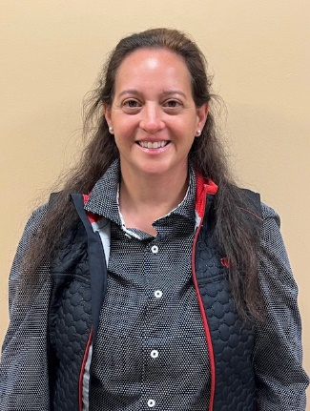**Ann Bizzano, PT, DPT, CSCS -** Ann earned her Doctor of Physical Therapy degree from the University of Montana, a master’s degree in Physiotherapy from Robert Gordon University, and her Bachelor of Science degree in Psychology from Virginia Tech. While at Virginia Tech she was a member of the Hokie Division 1 Swim team. As the daughter of a U.S. diplomat, Ann grew up overseas and jumped at the chance to go to school in Scotland. She loved Scotland so much she stayed and became a registered member of the Chartered Society of Physiotherapists. While in the U.K, she worked for a couple years for the National Health Service as well as the private health sector. In returning to the U.S., she got married and settled down and worked for a couple years for Health South. Ann has been an APTA member since 1998 and was the Director of Public Relations for the APTA of Maryland for many years. She also served as a research mentor for the Aberdeen Science and Math Academy for a couple years mentoring high school students for their year-long Capstone research projects involving physical-therapy-related subjects. Ann has a holistic approach to treatment and likes to help patients get through not only the physical and psychological challenges following a surgery or traumatic injury. Ann loves treating all types of orthopedic injuries, but her passion as a former fire-fighter and Paramedic and military wife and mother, is treating tactical athletes such as fire, police, military members and UFC, MMA, Brazilian Jujitsu fighters. Her hobbies include swimming, hiking, gardening, attending her children’s collegiate sporting events, and spending time with her husband exploring Colorado.

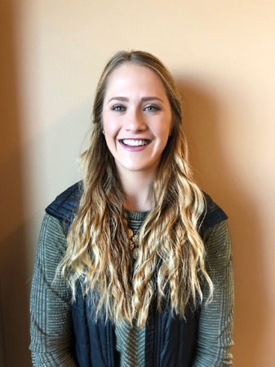**Beth Wood,** **PT, DPT** - Elizabeth (Beth) received her Doctor of Physical Therapy from the University of Colorado, Anschutz Medical Campus in 2018. She earned her Bachelors of Science in Exercise Science from Colorado Mesa University in Grand Junction. Beth is certified in the Selective Functional Movement Assessment (SFMA) and utilizes this treatment approach to identify the cause of discomfort and address biomechanical and neuromuscular dysfunction in her patients. Beth also specializes in pre and post- operative total joint replacement rehab. She treats an array of orthopedic injuries and strives to develop a rapport with patients and make rehab a fun, positive process. Outside of work, Beth enjoys tennis, equestrian events, running, and spending time with friends and family.

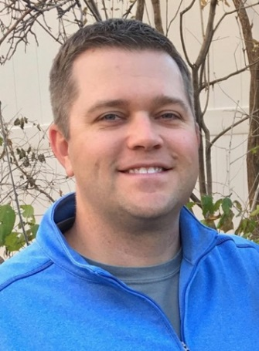**Brad Walters, PT, MSPT, OCS** - Brad graduated in 2002 from the University of Colorado at Boulder, majoring in Kinesiology. He subsequently earned a Master of Science in Physical Therapy from the University Of Colorado Health Sciences Center in 2004. He has been a member of the American Physical Therapy Association and the Orthopedic Section for 15 years. He is a board-certified Orthopedic Clinical Specialist (OCS) since 2012. He was a game-day physical therapist for the NBA's Denver Nuggets for the 2012-2013 season. He was an APTA Orthopedic and Sports Residency Faculty Mentor for ATI Physical Therapy in Greenville, South Carolina from 2014-2017. He is certified in Functional Dry Needling Level 1 and 2 since 2016. He believes in coupling physical therapy with sports performance. He enjoys working within the broad spectrum of orthopedic and sports injuries. He strives to provide a personalized approach to assist each patient in establishing and achieving incremental goals. He combines hands on therapeutic treatment techniques with functional and evidence based exercises that are tailored to both the home and clinic environments. As a Colorado native, Brad enjoys following all his hometown teams, especially the Denver Broncos! He also enjoys golfing, fly-fishing, skiing, traveling and spending time with his wife, Rachael.

**Brock Kraemer, PT, DPT –** Brock graduated with this B.S. in Athletic Training from UConn before getting his octorate of Physical Therapy from University of Vermont (UVM). Growing up in southeast Connecticut he was always on the move, whether traveling across New England for soccer tournaments, performing on stage in musicals/choral concerts, or financially ruining his parents with his reading habits. His goal as a physical therapist is to provide holistic and patient-centered care to all his patients so that they can get back to their passions safely and with confidence. He is a recent transplant to Colorado and enjoys hiking, reading fantasy/sci-fi novels, playing soccer, and exploring his new home with his bernedoodle, Bowen.

**Carson Fonner, PT, DPT**- Carson is a Doctor of Physical Therapy who graduated from Maryville University of Saint Louis in 2022. Carson has always had a passion for staying active and incorporating movement into her every day routine. During her time at Maryville, Carson competed on the University’s inaugural STUNT team, a new sport for female athletes. This experience reinforced her passion for not only strength and conditioning, but her love of trying new things and being spontaneous. The opportunity to be a part of this group of athletes solidified her love for physical therapy as she competed throughout her time at Maryville. In her free time, Carson also enjoys hiking, traveling, weightlifting, and baking. Another hobby of Carson’s is running half marathons, with a few races planned in the next year! As a therapist, Carson’s goal is to encourage and educate patients to reach their full potential, and allow them to feel confident in managing their movement dysfunctions, resulting in every patient being able to attain optimal movement through her care. As a new resident to the Denver area, Carson is eager to explore the scenery, restaurants, and adventures Colorado has to offer. She is excited to meet and make connections with all of her new patients here at Panorama!

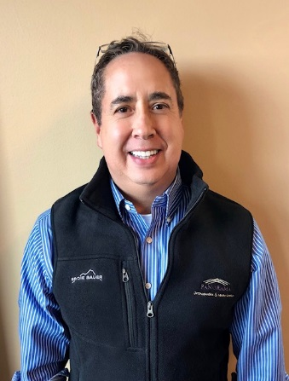

**Emery Pino, PT, MSPT** - Emery graduated from the University of Colorado Health Sciences Center Physical Therapy program in 2000. He previously was a System’s Engineer for 13 ½ years, much of the time with IBM. Emery’s engineering background helps him clearly explain pathology to his patients, while using critical thinking to determine the best rehabilitation for complicated patient pathologies and diagnoses. Emery’s interest in physical therapy is in outpatient orthopedics, and is also one of the vestibular and balance therapists at Panorama PT. He has a variety of certifications of continuing education to influence his knowledge and skill base in treating the orthopedic population.

**Evan Hockenberry, PT, DPT –** Evan obtained his Doctor of Physical Therapy degree from Slippery Rock University of Pennsylvania in May of 2022. Afterwards he moved to Colorado chasing after the culture of health, physical activity, and wellness that he felt has been cultivated well in the Denver area. Upon moving to the Denver area, Evan started his work as a physical therapist attempting to develop and expand his own individual treatment approaches and rehabilitative ideologies. He enjoys working with active populations, athletes, and shows increasing interest into vestibular rehabilitation. Evan has obtained his dry needling certification and is working towards being credentialed as a dry needling specialist. Since his youth, Evan has been participating regularly in sports and physical activity, playing soccer, volleyball, running, swimming, biking, and more recently improving his ability to play basketball and golf. When he is not working as a physical therapist you can find Evan in the gym, playing sports, or exploring different restaurants/attractions that Denver has to offer.

**Fred Rooley, PT, DPT –** Fred earned his Doctoral of Physical Therapy from Northern Illinois University, NIU) in 2019.  His bachelor’s degree of General studies was received in 2005 from University of North Dakota, UND.  Fred’s approach to therapy is a holistic with a focus in evidence-based practice.  He enjoys working with a wide range of orthopedic conditions while working towards functional improvements and return to recreational activities for improved quality of life.  In his spare time Fred likes to camp, hike, fish, ski, exercise, yard work, and read a good book.

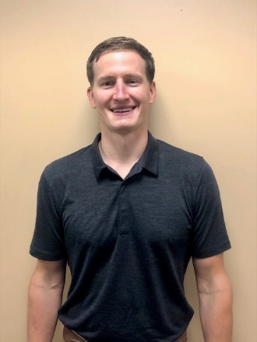**Luke Mueller, PT, DPT, CSCS** - Luke graduated in 2011 from the University of Wisconsin-La Crosse with a degree in Exercise and Sport Science. He continued his education at UW-La Crosse to earn his Doctorate of Physical Therapy in 2014. He enjoys treating a variety of orthopedic and sport injury conditions as well as vestibular conditions. Evidence-based treatment with a holistic, individualized approach is what you can expect when working with Luke. He is a Certified Strength and Conditioning Specialist and believes in integrating rehabilitation with sport performance to maximize potential while reducing future injury risk. When not at work, Luke is likely in the outdoors with his fiancé, Arielle, enjoying a variety of outdoor recreation such as hiking, mountain biking, and snowboarding. He also enjoys traveling, trying out new recipes, and spending time with his dog and cat.

**Megan Murphy, PT, DPT -** Megan (Meg) received her Doctorate of Physical Therapy from the Medical University of South Carolina in Charleston, SC. She grew up in Highlands Ranch, Colorado and moved to Washington to play college volleyball. Having been on the patient side of physical therapy, Meg understands the physical and mental toll an injury can take on someone and is passionate about getting people back to the things that they love to do. Meg takes a holistic approach to treating her patients and focuses on educating her patients about their body and how they move. She enjoys treating patients of every age and wants to encourage movement at every level. When she is not in the clinic, Meg can be found mountain biking or hiking with her husband and her dog. She also enjoys cooking, video games, and traveling.

**Mitchell W. Parrish,** **PT, DPT Cert. DN** - Mitch received his Doctor of Physical Therapy from Regis University (Denver, CO) in 2021. Prior to this, Mitch earned his Bachelor of Science in Kinesiology from the University of Maryland, College Park. He worked with the Athletic Training Department at UMD for two years, where he developed a passion for Sports Medicine and orthopedics. Mitch has special interests in treating athletes of all skill levels, as well as concussion, hand-therapy, and endurance athletes. Mitchell believes that incorporating patient driven goals, using evidence-based medicine, and empowering his patients through meaningful education are crucial to the success of physical therapy. Outside of work, you can find Mitch in the mountains, camping, road cycling, mountain biking, hiking 14ers, skiing, climbing, and living life to the fullest.

**Nyita Hooper, PT, DPT -** Nyita earned her Doctorate of Physical Therapy from the University of Colorado, Anschutz Medical Campus in 2021. She received her Bachelors Of Science from the University of Colorado at Boulder. Nyita takes an evidence-based and holistic approach to treatment, working with the whole patient and the latest research to get her patients back to doing the things they love. Prior to starting her PT education she was a competitive rock climber at the national level, as well as a rock climbing coach for one of the country’s most competitive youth programs. Also, she loves to knit, craft, and bake, because, well, who doesn’t?

**PJ Calvo, PT, DPT** - PJ was born and raised in Guam. As a former member of Guam's national rugby team, he is no stranger to aches and pains. His positive experience with physical therapists as an injured athlete inspired PJ to pursue a B.S. in Kinesiology from Notre Dame de Namur in Belmont California and graduated in 2017. PJ worked as a personal trainer at Stanford's recreation center until his acceptance into Regis University's Doctor of Physical Therapy program in 2020. PJ graduated in 2023 and is passionate about providing patient-centered, evidence-based care to help patients return the activities that they love. Outside of work, PJ enjoys spending time outdoors, weightlifting, cooking, and spending time with his fiancée and cat.

**Rusty Batykefer, PT, DPT -** Rusty completed his Doctorate of Physical Therapy degree from George Fox University in the spring of 2023. Prior to completing his DPT degree, Rusty attended Eastern University where he obtained his Bachelors in Exercise Science in 2019. During both his undergraduate and graduate studies, he competed collegiately in cross country and track and field. Rusty’s approach to care is evidence based and person centered as places priority of the patient’s goals and desire to return them to full function. Outside of PT, Rusty is still passionate about running now as he spends his free time training on the roads, track, and trails. Rusty also enjoys cooking, playing boardgames, and going on hiking/camping adventures with his wife.

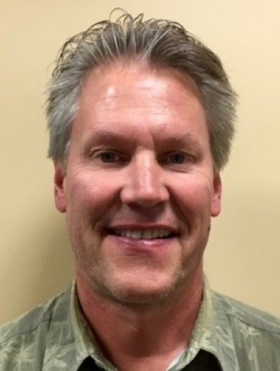**Tom Hermsen, PT, MSPT, CSCS** - A 1983 graduate from the University of Wisconsin – Madison, Tom has been a practicing PT for over 30 years, 27 in outpatient orthopedics. He was a site coordinator and treating therapist at HealthSouth in Lakewood, CO from 1994- 2000. He was the clinic director and practicing PT for Physiotherapy Associates at Golden Ridge for seven years. In 2010, he joined the staff at Panorama Physical Therapy as a senior staff PT. Tom’s area of expertise included the treatment of shoulder and knee dysfunction, and foot and ankle disorders including the fabrication of custom orthotics. He has vast experience in lower extremity biomechanical evaluations. He is also a Certified Strength and Conditioning Specialist (CSCS).

**Wellsley Brown,** **PT, DPT** – Wellsley received her Doctor of Physical Therapy from Emory University in 2023. Prior to becoming a physical therapist, she worked as a marine biologist after earning a dual degree in Marine Science and Biology from the University of Miami in 2017 in her home state of Florida. Although she still loves all things ocean-related, Wellsley decided to become a physical therapist due to her interest in the connection between physical and mental health. She is passionate about helping her patients optimize their movement abilities to allow them to do what they love! She has experience working with neurologic and orthopedic conditions and believes in patient-centered and holistic treatment plans. Outside of the clinic, she has traded the beach for the mountains and loves spending time outdoors. She enjoys running, hiking, climbing, and eating (restaurant recommendations welcome!), all with company of friends and family.

**Zach Zebarth, PT, DPT, OCS** - Zach is a Colorado native starting from growing up in Littleton, going to Lakewood High School, and attending University of Colorado for his undergraduate studies. Zach completed his PT school education at the University of Illinois at Chicago, graduating in 2016 with his Doctor of Physical Therapy. Following PT school, Zach moved to Indianapolis before moving back to Colorado in the summer of 2020 and joining the Panorama team. Zach has been practicing in the orthopedic setting for the past 5 years and is a Certified Dry Needling Specialist. While foot and ankle is his specialty, Zach treats every joint in the body and enjoys treating a wide variety of diagnoses including vestibular/concussion rehab, sports injury recovery, post-operative rehab, temporomandibular dysfunction, and much more. Every patient Zach sees receives a highly specialized plan of care, personalized to get them back as quickly as possible to whatever it is they love to do. In addition to helping patients through PT, Zach is also the clinic director at Golden PT and enjoys helping his team grow and follow their own passions. Zach is also recently married and is a proud pet parent to an adorable old corgi named Paxton; be prepared to see plenty of pictures if you end up on his schedule!

**HAND THERAPISTS**

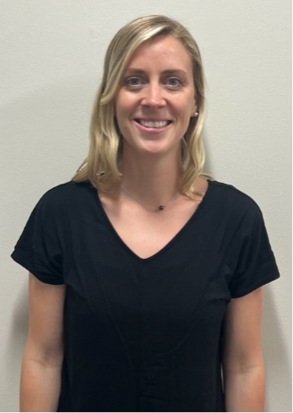

**Ella Coker, OT, MSOT, OTR** - Ella earned her master’s degree in Occupational Therapy (OT) in Rhode Island. Prior to gaining her master’s degree she worked as an occupational therapy assistant treating children. Ella completed her OT clinical fieldwork rotation in an orthopedic hand therapy setting and immediately fell in love with hand therapy, as our hands are how we explore the world every day. She worked in an orthopedic outpatient facility in Rhode Island and moved to Colorado to continue this work and enjoy the outdoors. She is currently working towards becoming a certified hand therapist, and focuses her treatments on a holistic approach with an individualized treatment plan to get her patients back to their everyday activities and desired hobbies. In her free time, you can find Ella playing with her chocolate lab, snowboarding, rock climbing, hiking or doing any other outdoor activities.

**Jenna Neff, OT, MSOT, OTR, CHT**

Jenna was born in Lancaster, PA but relocated to Colorado from Washington, DC in 2022. She is an Occupational Therapist and Certified Hand and Upper Extremity Therapist. Continuing education and mentoring are of high priority; she has the mindset of a lifelong learner! When not at work, Jenna enjoys all things outside, preferably in the sunshine. She continues to play competitive field hockey. She has a newborn as of July 2023 and her 3-year-old dog, Zili is also very excited about this new development.

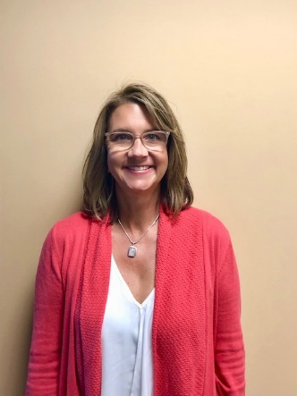**Lisa Condon, OT, MSOT, OTR, CHT** - Lisa graduated from University of Wisconsin-Milwaukee in 1988 with a Bachelor’s in Occupational Therapy. After working 3 years in Inpatient Neurology, she moved to Colorado and pursued Outpatient Orthopedics. She received her Certification in Hand Therapy (CHT) in 1995 and her Master’s in Sports Medicine in 1996. Lisa has a strong passion for treating upper extremity trauma and has spent much of her career developing her manual skills and thoroughly understanding the anatomy of the hand, wrist, elbow and shoulder. She believes that educating the patient on their injury is imperative for a successful outcome and being an active member of the “Hand Team” (MD, Therapist and Patient).

**Chad Brinkman** - Chad’s academic journey began at a small school in PA called Allegheny college where he earned a bachelor's degree in biology while playing football. He continued on for his Doctor of Physical Therapy degree at Duke University and graduated in 2018. He moved to Denver after graduation and has been working in mainly orthopedic clinics since. He earned his Orthopedic Specialist Certification(OCS) in 2020, and has continued to focus on treating all kinds of musculoskeletal aches and pains. He loves to treat holistically and help people get back to the activities they love. When he is not in the clinic you can find him with his wife in the mountains somewhere, playing music, reading a book, or doing some handiwork around their house.