Centennial Physical Therapy

Chad Brinkman, PT, DPT, OCS, SFMA, Cert FDN
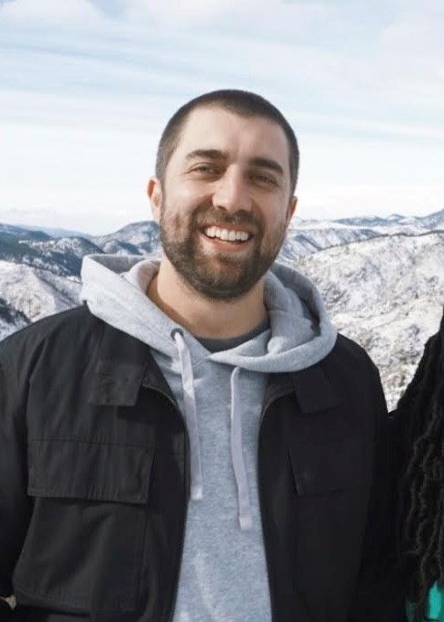
Chad’s academic journey began at a small school in PA called Allegheny college where he earned a bachelor's degree in biology while playing football. He continued on for his Doctor of Physical Therapy degree at Duke University and graduated in 2018. He moved to Denver after graduation and has been working in mainly orthopedic clinics since. He earned his Orthopedic Specialist Certification(OCS) in 2020, and has continued to focus on treating all kinds of musculoskeletal aches and pains. He loves to treat holistically and help people get back to the activities they love. When he is not in the clinic you can find him with his wife in the mountains somewhere, playing music, reading a book, or doing some handiwork around their house

Connor Longacre, PT, DPT
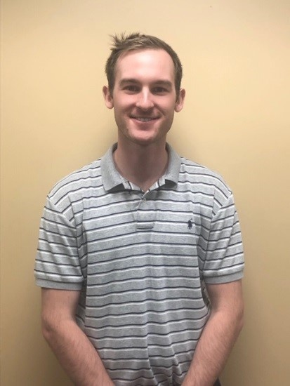
Connor studied Health and Exercise Science at Colorado State University, and achieved his Doctor of Physical Therapy from Regis University in Denver, CO in 2018. For two years, Connor worked in Silverthorne, CO, treating avid skiers, mountain bikers, and hikers, helping to rehabilitate anything from traumatic injuries to joint replacement surgeries. Connor is Level 1 Dry Needling certified, and utilizes manual therapy and exercise to achieve optimal results. On the weekends, he enjoys playing disc golf, basketball, and snowboarding on fresh powder.

Paulo Falcao, PT, Cert FDN, Cert FCE
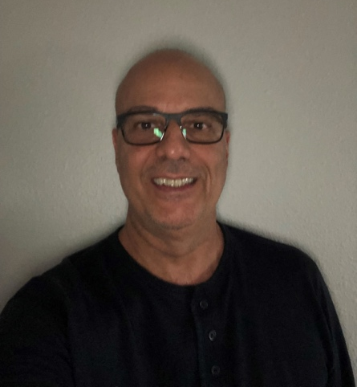
With over 10 years of experience in the field of physical therapy, Paulo Falcao has established himself as a trusted expert in post-operative rehabilitation and Sports Medicine. He has successfully treated numerous patients, helping them return to their peak performance and normal daily activities. Paulo's approach is rooted in evidence-based practices, ensuring each patient receives the best possible care. On a personal note, Paulo is an avid mountain biker, volleyball player, and paddle boarder understanding firsthand the challenges and rewards of pushing one's physical limits. He's passionate about helping his patients achieve their goals, whether it's running a marathon or simply enjoying a pain-free walk in the park.

Christie Peck, PT, DPT

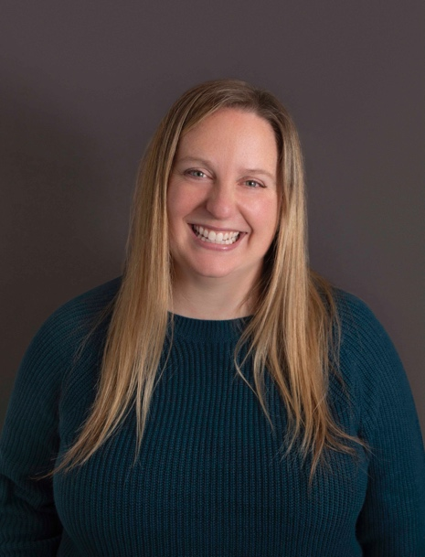
Christie first became interested in physical therapy while in high school after having knee surgery due to a soccer injury. She earned her Bachelor of Arts in Spanish, with minors in Health Ecology and Mathematics, from University of Nevada, Reno in 2007. Following this, Christie attended Eastern Washington University in Spokane and graduated with her Doctor of Physical Therapy degree in 2010. Christie and her family recently moved to Colorado after working for thirteen years in various outpatient orthopedics clinics in western Washington and Montana.

Christie is a board-certified Orthopaedic Clinical Specialist and is also a Certified Integrated Manual Therapist through Great Lakes Seminars. Her professional interests include treating patients with all types of orthopedic injuries, vestibular and concussion rehabilitation, and injured worker case management. Christie loves collaborating with her patients and designing individualized treatment plans that will help them achieve their goals, and she loves empowering her patients by teaching them ways to help manage their conditions on their own.

In her spare time, Christie enjoys spending time with her husband, daughter, and dog Blanca. She enjoys hiking, traveling, gardening, and photography.

Fun Fact: Christie’s right pinkie is shorter than her left pinkie!

