Littleton Physical Therapy

Chad Brinkman, PT, DPT, OCS, SFMA, Cert FDN
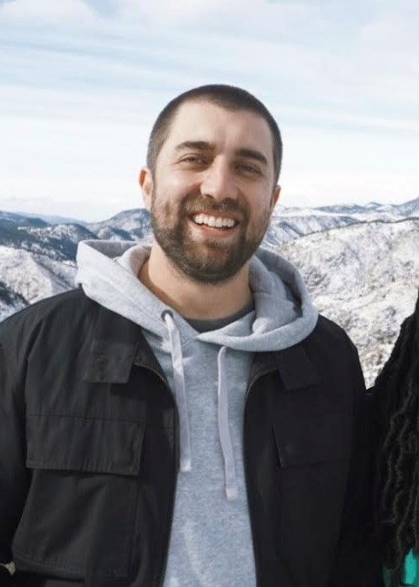
Chad’s academic journey began at a small school in PA called Allegheny college where he earned a bachelor's degree in biology while playing football. He continued on for his Doctor of Physical Therapy degree at Duke University and graduated in 2018. He moved to Denver after graduation and has been working in mainly orthopedic clinics since. He earned his Orthopedic Specialist Certification(OCS) in 2020, and has continued to focus on treating all kinds of musculoskeletal aches and pains. He loves to treat holistically and help people get back to the activities they love. When he is not in the clinic you can find him with his wife in the mountains somewhere, playing music, reading a book, or doing some handiwork around their house.

Matt Jones, PT, DPT
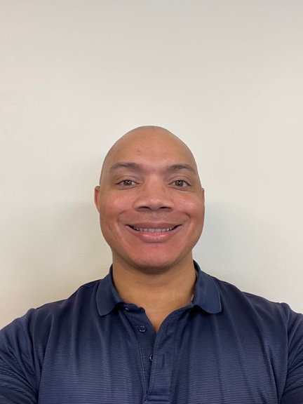
Matt studied Psychology in undergrad at CU Boulder and went on to earn a Doctor of Physical Therapy from CU Anschutz Medical Campus, class of 2019. Matt began working as an outpatient Physical Therapist in the Spring of 2020 and has continued in this environment to this day. He treats a wide range of ailments from total knee replacements to general low back pain. Matt is a recreational powerlifter who regularly deadlifts 500 pounds off the floor and loves helping people overcome back pain.

Krista Graham, PT, DPT
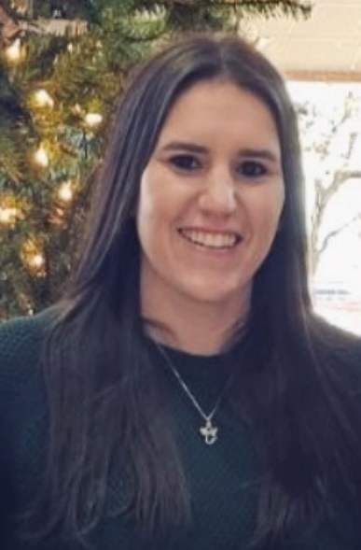
Krista grew up in Missouri however she achieved her Bachelors in Behavioral Science: Exercise Science at Hardin-Simmons University while living in Texas. She then went back to her home state where she achieved her Doctor of Physical Therapy degree from Southwest Baptist University in Bolivar Missouri in 2021. Krista has been treating outpatient orthopedics in Littleton, CO for the past 2 years where she has utilized her manual therapy and exercise skills to treat an array of joint replacements and orthopedic injuries. Krista has a true talent for connecting with her patients and has a passion for rehabilitating patients back to their hobbies and daily lives. Outside of work she enjoys spending time with her teenage daughter and fiancé, playing soccer, and hiking. Fun fact, she was born on a major holiday and shares a birthday with the man upstairs.

Macy Liles, PT, DPT
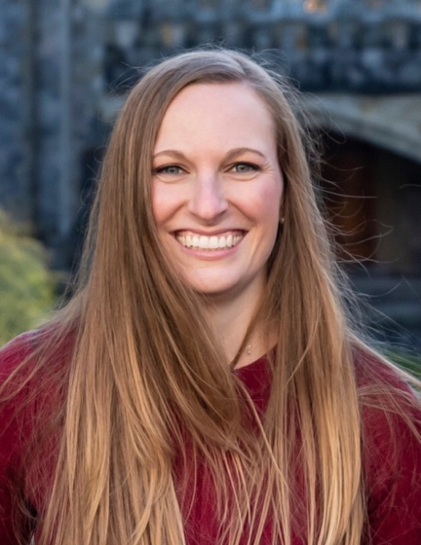
Macy Liles, PT, DPT graduated from Texas A&M University with a B.S. in Kinesiology and a minor in Psychology. She attended University of North Texas Health Science Center in Fort Worth where she graduated with honors and received her Doctorate in Physical Therapy in 2021. After working in an outpatient clinic in Fort Worth, Texas for two years Macy and her husband moved to Littleton, Colorado to get closer to the mountains. Macy is very passionate about the orthopedic setting and helping others achieve their goals through movement and exercise science. In her free time Macy enjoys running, hiking, and cooking.

Emily Hoyt, PT, DPT, CMP, Cert DN
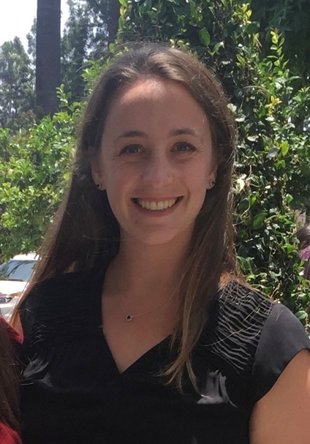
Emily grew up in Moraga California and completed her undergraduate degree at California Polytechnic State University where she received a Bachelor of Science in Kinesiology. She went to Azusa Pacific University for graduate school and received her Doctorate of Physical Therapy in 2017. Emily practiced in California before moving to Colorado in 2021. She enjoys hiking and skiing in her free time.

Robin Peterson, PT
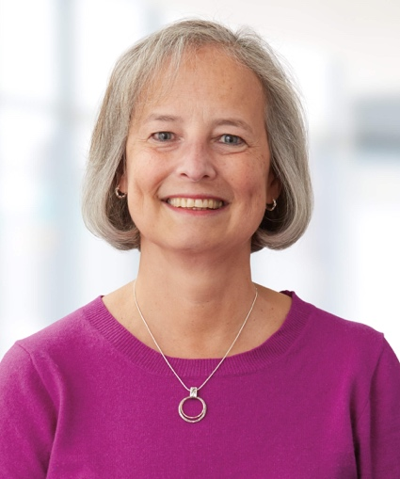
Growing up in MN and being active in gymnastics in high school and college grew my interest in Physical Therapy to help prevent and treat injuries. I attended college in a small town in MN, Gustavus Adolphus College, and graduated with majors in Distributive Sciences and Psychology. I immediately entered Physical Therapy school at the University of MN and graduated in 1985. Since then, I’ve pursued my passion to treat Spine, orthopedics and to help prevent and treat injured workers. I’ve also held leadership positions during my 38-year career, but with a recent move to beautiful Colorado I intentionally returned to my original passion of solely treating patients. I would describe myself as a lifetime learner.

My husband and I have deep roots to Colorado due to family and have really enjoyed spending more time with my siblings, children, their significant others and our first grandchild who live in Colorado! We love being outdoors whether that’s in the Colorado mountains, the North Shore of Lake Superior or the Boundary Waters Wilderness Canoe Area.

As a patient who receives care from me, you can expect a thorough understanding of your condition, a collaborative plan for treatment and several tools to help you self-manage your condition. I look forward to working with you!

