**Jess McLaughlin PT, DPT, Cert. DN**

**Clinic Director**

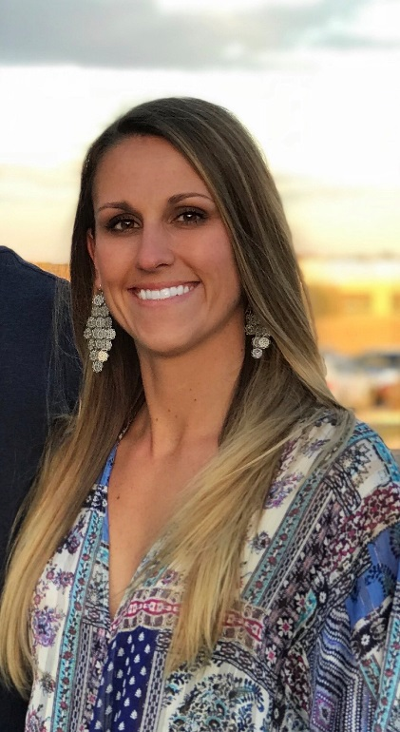Jessie was born in Atlanta, Georgia and moved to Greenwood Village, Colorado in 1999. She attended school at Colorado Academy and then went to Gonzaga University where she played D1 soccer as a goalkeeper and received her BS in Exercise Science. She went on to physical therapy school at Duke University where she graduated with a Doctorate in Physical Therapy.

Jessie had a shoulder injury in high school that inspired her to go on to become a physical therapist. She specializes in sports medicine, hip preservation, ACL, foot/ankle, and return to sport therapy and works closely with Panorama physicians, physical therapists and performance trainers at The Institute to provide a full continuum of care for her patients. Since obtaining her certification in dry needling, Jessie incorporates this skillset to further assist her patients recover from their injuries. She greatly enjoys being a resource for her patients, staff, and anybody interested in pursuing a career in physical therapy. Jessie loves the outdoors and in her spare time she enjoys training her horses, hiking, camping, and going on adventures with her husband and dogs. She is an avid football fan and regularly sports cowboy boots with her Atlanta Falcons jersey on casual Fridays.

Fun fact: Jessie can often be found on the dance floor at country bars perfecting her line dancing and country swing dance moves.

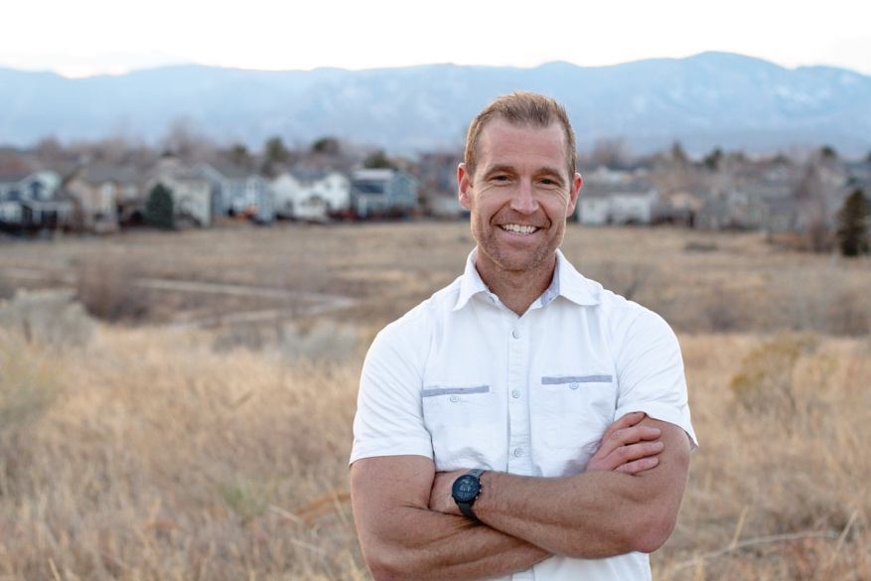**Aaron Jansen, PT, DPT, CSCS, SMTC**

Aaron is originally from Grand Rapids, MI and moved to Colorado in 2021. Aaron went to Calvin University in Michigan and earned his BS in Exercise Science while playing soccer for 1 year and club ultimate frisbee. After undergrad he spent 6 years as a personal trainer primarily in Washington state before returning to school. Aaron went to Chapman University in Orange, CA to earn his Doctorate in Physical Therapy in 2013.

Aaron is passionate about helping others to improve their function and being able to live life better. His knowledge of the body and tools he has developed through his experiences as a physical therapist and personal trainer have enabled him to help a wide variety of patients. Aaron is especially interested in injury prevention and screening of athletes, ACL recovery, and running and cycling related injuries. He has done advanced training in running gait analysis and bike fitting to reduce repetitive stress and associated pain. Aaron loves working with a variety of diagnoses and really enjoys problem solving as a PT and in life.

Aaron is a father for 3 lovely little girls and has been married to his amazing wife since 2007. His interests include being outdoors, camping with his family, trail running, mountain biking, obstacle course racing, playing any sport that he can and trying to keep up with his kids.

Fun Fact: Aaron would love to be on American Ninja Warrior one day

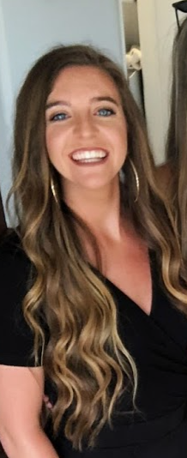**Katie Franke PT, DPT, CSCS**

Katie Franke is originally from Chicago, IL.  She moved to the east coast to attend the University of Maryland, College Park, where she earned a Bachelor of Science in Neurobiology and Physiology and a Bachelor of Science in Psychology. Katie discovered her passion for physical therapy while volunteering at a school for disabled children in Cape Town, South Africa and decided to pursue a career in the exciting and rewarding field of physical therapy upon returning to the US. She attended the University of Miami, where she earned her Doctor of Physical Therapy degree. After Graduating from UM with her DPT, Katie spent the next 2 years treating in the outpatient sports setting at SPEAR Physical Therapy in NYC.

Katie’s clinical interests are rooted in orthopedics. Katie has treated a broad spectrum of patients in the outpatient orthopedic setting from pediatrics to geriatrics. In addition, Katie had the opportunity to treat Crossfit, NFL, and MLB athletes during the off-season; gaining exposure to advanced therapeutic exercise and strength and conditioning principles and their application to high-performing athletes and rehabilitation. Katie further supplemented this knowledge by becoming a Certified Strength and Conditioning Specialist (CSCS). Katie has also worked alongside surgeons and therapists from the world-renowned Paley Orthopedic and Spine institute where she treated adult and pediatric patients following limb lengthening, deformity correction, joint replacement, and other orthopedic surgical procedures.

In her spare time, you can find Katie traveling, hanging out with friends and family, and exploring different restaurants and craft breweries. Katie loves the outdoors and staying active. She enjoys hiking, running, racket sports, SCUBA diving, skiing, rock climbing, and adventure sports.

Fun Fact: Katie has lived on 4 different continents – North America, Europe, Africa, and Australia

**Mackenzie Gloven PT, DPT, MTP, CFC**

Mackenzie was born in San Diego, California where she grew up surfing, open water swimming and kayaking. She attended school at Columbia University in New York City where she received her BS in Psychology. During school, Mackenzie played Division I lacrosse and participated in Columbia’s triathlon club. She went to the University of St. Augustine for Health Sciences in San Marcos, CA, where she graduated with a doctorate in physical therapy.

Mackenzie was inspired to pursue physical therapy after rupturing her ACL and meniscus downhill skateboarding. She was only 12 years old at the time, so surgery was delayed until she was a senior in high school. As a physical therapist, Mackenzie specializes in manual therapy and dry needling, but also a functional movement approach. She craves learning and enjoys continuing education opportunities.

Mackenzie loves the outdoors and can often be found mountain biking, camping, paddle boarding and skiing. She is a member of CO’s largest female mountain bike club and hopes to someday “bikepack” the entire CO trail with the help of friends and family along the way.

Fun fact: Mackenzie is a major dog lover and hopes to soon adopt a “trail dog” to accompany her on future mountain adventures.

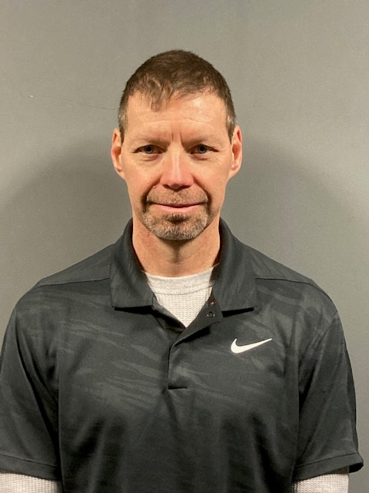**John Guido PT, tDPT, SCS**

John A. Guido, Jr., PT, tDPT, SCS has been practicing as a physical therapist for over 34 years in the fields of orthopedics and sports medicine. He is a 1988 graduate of Quinnipiac University in Hamden, CT. He obtained his Sports Clinical Specialist certification from the American Physical Therapy Association in 1994, and was recertified in 2003 and again in 2013. He has continued his education by obtaining his Master's in Health Science degree at the University of Indianapolis, and completed his transitional doctorate in physical therapy with Arcadia University, in Glenside, PA in 2011.

He is the recipient of the New Horizon and the Lynn Wallace Clinical Educator of the Year awards given by the Sports Physical Therapy Section of the APTA.

John has authored several book chapters and published several research studies. He is currently an active reviewer for the International Journal of Sports Physical Therapy. His main focus in research has been on the kinematics and kinetics of the overhand athlete. He recently joined Panorama Physical Therapy in Highlands Ranch, CO and his responsibilities include direct patient care, clinical education and mentorship.

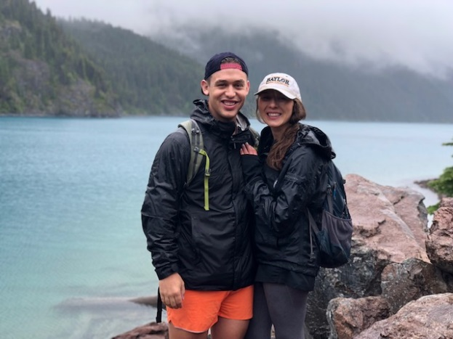**Justin Meyer PT, DPT**

Justin completed his undergraduate education at Baylor University in Waco, TX with a degree in Marketing. From there, he transitioned into physical therapy school at The University of St. Augustine for Health Sciences in Austin, TX where he not only found his way to a degree, but also found his way to the love of his life – his wife, Logan!

Justin’s professional interests, include: rehabilitation of various sport injuries including ACL and meniscus pathologies, labral tears, ankle instability.

Recently, Justin has taken a position with the University of Denver Athletic Department assisting the training staff in the treatment and rehabilitation of their athletes. Furthermore, Justin is a member of the Hip Preservation and Arthroscopy team focusing on the rehabilitation of arthroscopic labral repairs/reconstructions, as well as various other pathologies and procedures performed focused on preserving the well-being of the hip joint.

Justin’s hobbies include: hiking, skiing, and spending time with his wife, family, friends and of course, his dog Breck.

Fun fact: Justin can be found binge watching college football on Saturdays (of course watching his Baylor Bears – Sic ‘em!!!)

**Chris Kolodzek, PT, MSPT**

Chris is originally from Milwaukee, WI and moved to Colorado in 2023. He attended the University of Wisconsin-Lacrosse for both undergraduate and physical therapy school. He has worked in sports medicine since graduating in 2006. He has treated athletes throughout a wide range of ages and abilities, including at the college and professional level, but has a passion for the overhead athlete. Chris specializes in shoulder and elbow injuries as it pertains to throwers, tennis players, volleyball players and swimmers as well as treating those with surgical interventions. He also enjoys working with individuals with ACL reconstructions as he has recovered from this injury himself.

Chris is a father of 2 lovely children and has been married since 2014. When not treating patients, Chris enjoys exploring the beautiful Colorado landscape, keeping up on Wisconsin sports and playing with his kids.

**Annelise Adolph, PT**

Annelise was born and raised in Colorado and completed her B.S. in Health and Exercise Science with a Concentration in Sports Medicine at Colorado State University as a part of the University Honors Program. She earned her DPT from Regis University in 2023 where she got to experience clinicals in a wide variety of areas including orthopedics, pediatric rehabilitation, neurologic rehabilitation, and inpatient rehabilitation. Ultimately, she decided to return to the clinic where she shadowed and began her physical therapy journey because of the exceptional patient care, supportive team, and close patient-clinician relationships.

As a Colorado native, she loves anything outdoors including hiking, going to lakes, going to Broncos games, line dancing, and playing pickleball.

**Jacob Barker, PT, DPT, CSCS**

Jacob is a Colorado native and grew up in the southeastern part of the state on his family’s small farm. He received his Bachelor of Science in Health & Exercise Science from Regis University where he also was a member of the NCAA men’s soccer team. He continued his education at the University of Iowa Carver College of Medicine to obtain his Doctor of Physical Therapy degree.

Prior to becoming a physical therapist, Jacob had a career as a Certified Strength and Conditioning Specialist working in the Denver area at Landow Performance. This work included being a coach on the NFL Combine team preparing collegiate athletes for the NFL. He has also worked with a wide variety of individuals including soccer, hockey, golf, volleyball, UFC/MMA, boxing, and law enforcement/tactical athletes.

Jacob’s commitment to being strong in principles yet flexible in his methods when delivering evidence-based and patient-centered care led him to becoming a Doctor of Physical Therapy. His goal is to improve the efficiency and effectiveness of the movement system to help individuals live the best version of their lives.

Outside of the clinic, Jacob loves hunting, fishing, and being in the outdoors with his friends and family. Jacob enjoys meeting new people, learning their stories, and discovering how he can help them achieve their personal goals.