**Highlands Ranch Town Center Physical Therapy**

**Adam Bahnson, PT, DPT, ATC, certDN**

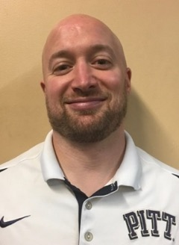Adam graduated from nationally top ranked University of Pittsburgh with a BS and an Athletic Training Certification (ATC) in 2004 and a Doctor of Physical Therapy (DPT) in 2007 both with honors. Adam has also continued to progress in his professional education and development receiving a level two Dry Needling Certification in 2011. Adam specializes in a wide variety of orthopedic pathology and utilizes manual and evidence based practice treatment approaches to maximizing outcomes and recovery.

**Alyssa Jean Rachubka Dickerson, PT, DPT, certDN**

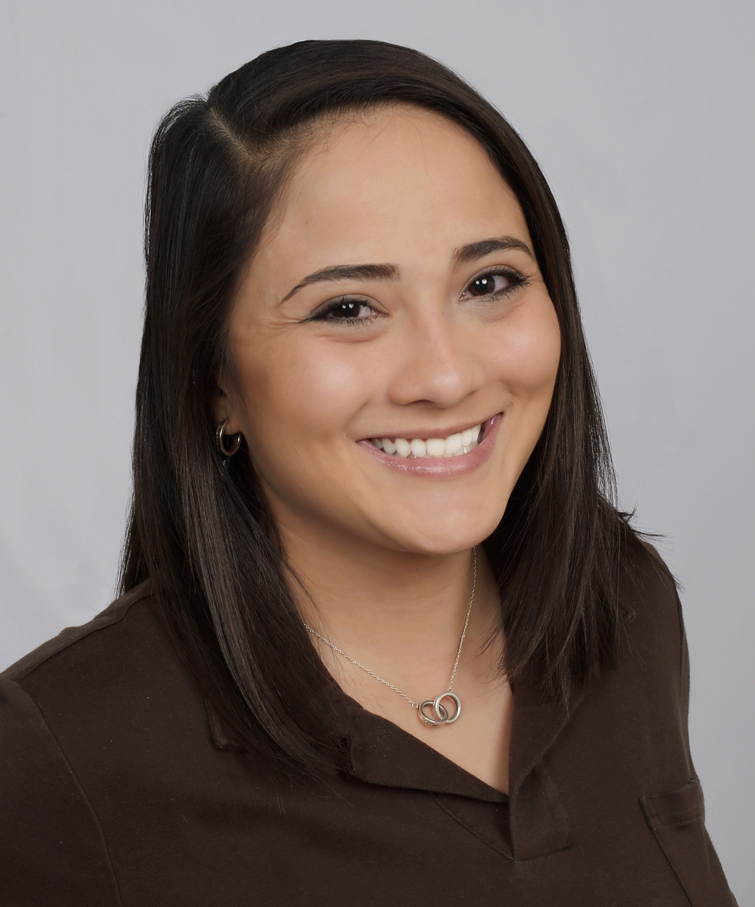

Alyssa was born and raised in Virginia where she attended James Madison University for undergrad. She earned her DPT from University of Hartford in 2016 and has had the opportunity to gain clinical experience in Connecticut, Louisiana, Missouri, and Maryland at Walter Reed National Military Medical Center. Alyssa specializes in a wide variety of outpatient conditions, enjoys treating post-op ACL reconstruction or joint replacements and working with the military population. Certifications include Dry Needling (Level 1 & 2 via BRI), Sportsmetrics (via Cincinnati Sports Medicine), and Pilates (Gateway Level 1 Mat via Polestar Pilates). Hobbies and interests include going to concerts and lives shows, traveling, arts and crafts, yoga, hiking, roller skating and DISCO (her dog). Red Rocks is her happy place – day or night and rain/snow or shine! Alyssa has been with Panorama since September of 2018.

**Logan Meyer, PT, DPT, CSCS, Cert. DN**

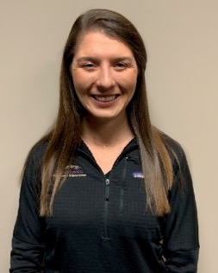As a native of Charlottesville, Virginia, Logan is a born-and-raised Virginia Cavaliers fan. Logan split her allegiances by attending James Madison University, receiving her Bachelors of Science in Kinesiology. While at JMU, Logan worked with the university’s strength and conditioning program, ultimately inspiring her to become a Certified Strength and Conditioning Specialist (CSCS). After earning her doctorate in physical therapy from the University of St. Augustine for Health Sciences in Austin, Texas, Logan moved to Denver. Over the years, Logan has developed a passion fortreating all orthopedic injuries, especially those of the knee and hip. Logan and her husband enjoy hiking, skiing, and spoiling their dog, Breck.

**Max Langevin, PT, DPT**

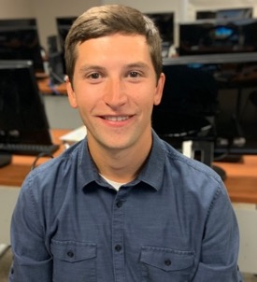Max Langevin grew up in Connecticut and completed his undergraduate degree in psychology at Boston University. After earning his DPT at Georgia Southern University in Savannah, Max moved to Colorado to begin his career in physical therapy. Max has been with Panorama since September of 2019 and in his free time enjoys playing ultimate, hiking, playing golf, and snowboarding.

**Tanner “Terry” Lange, PT, DPT**

Tanner was born in Omaha, Nebraska. Tanner attended Rockhurst University in Kansas City, MO for both undergraduate and graduate degrees receiving a Bachelor’s of Science in Exercise Science with minors in Physics of Medicine and Leadership Development and a Doctorate of Physical Therapy for graduate school. Tanner worked with Panorama during one of his clinical rotations leading him to accept a job and move out to Colorado in March 2023 following completion of his DPT to begin working for the company. In his free time, Tanner enjoys watching any and all sports, binge watching survivor, playing basketball, golfing, and wants to learn to snowboard.

**Ericka Olson, PT, DPT**

Ericka was born and raised in Massachusetts. As a former collegiate ski racer at the University of Massachusetts, she was drawn to the mountains of Colorado and received her Doctorate of Physical Therapy from the University of Colorado in 2015. She joined the Panorama team shortly thereafter. Ericka has extensive experience treating a broad spectrum of patients with orthopedic conditions. She enjoys partnering with her patients in a collaborative way to best help them achieve their own goals and maximize function. When she is not in the clinic, Ericka enjoys spending time with her husband and two young boys, skiing, hiking, running and yoga.

**Ashley Zenker, PT, DPT**

Ashley was born and raised in Toledo, OH. She attended the University of Findlay for both her undergraduate and graduate studies in which she earned her Doctorate of Physical Therapy degree. She is a retired college soccer player who has always had a love for adventuring, especially in National Parks. You’ll find her often doing anything that involves being active and being outside. She enjoys cheering on Wisconsin sports teams -GO PACK GO-, playing sports, hiking, going to concerts, playing guitar, and painting/drawing. With a history of leading service opportunities, retreats, and organization social media accounts, she loves any opportunity to be creative and serve others. She has a passion for working with individuals in the outpatient orthopedic setting. When asked why she loves physical therapy, as much as she loves encouraging others in their recovery process, she finds that she is often motivated by the individuals she treats in return.

**Elizabeth Aigner, MOT, OTR/L**

Elizabeth attended the University of St. Augustine for Health Sciences in Austin, Texas where she obtained her Master of Occupational Therapy Degree in 2019. She spent the first 4 years of her career practicing in an outpatient orthopedic setting in Albuquerque, New Mexico, where she collaborated with the Hand/Upper Extremity Surgical team to provide her patients with the best, most comprehensive care. She is currently working towards her manual therapy certification (COMT), as well as her hand therapy certification (CHT). She specializes in treating disorders of the shoulder, elbow, wrist and hand.

Elizabeth’s approach to treatment revolves around individualized, client-centered care focused on the specific concerns each patient presents. She hopes to use her clinical knowledge to provide her patients with an understanding of the extent of their injuries and collaborate with them to determine meaningful goals that lead to return to function in their daily activities and other desired occupations.

Although she is a Houston, Texas native, Elizabeth loves spending time in the mountains, whether hiking or downhill skiing. She also enjoys watching sports (hook’em horns!), traveling, live music, and cooking. Most of her time outside of work is spent with friends and family.

Fun Fact: Elizabeth can say the alphabet faster backwards than forwards.

**Mackenzie Brooks, PT, DPT**

Mackenzie originally hails from New Jersey, and is a new transplant to Colorado as of 2024.  He attended Rutgers University for his undergraduate degree in Applied Kinesiology before completing his DPT at Kean University. Since graduating, he has worked with a range of patients, from running athletes to those with chronic low back pain. Mackenzie enjoys working with athletes of all kinds, but helping athletes return to sport after knee injuries has been some of his most rewarding work. Outside of the world of athletics, Mackenzie hopes to continue his MDT certification to better assist patients with all kinds of spine related pain.

When not treating patients Mackenzie enjoys hiking, rock climbing, and singing with his local choir.

**Lauren Hoppa, PT, DPT, Cert DN,**

**Residency Trained in Sports Physical Therapy**

Lauren is originally from Milwaukee, Wisconsin. Growing up, she was a competitive Irish dancer at the World Championship level. Due to the incredible demand of the sport, she found herself undergoing several surgeries on her feet to allow her to continue dancing. As a result, she was exposed to physical therapy at a young age, and notably, the sports realm, with her personal experience to return to her highest level of competition following injury.

She moved to Colorado in 2008, where she later attended Colorado State University, earning her B.S. in Exercise Science - Sports Medicine. She later graduated with her DPT from A.T. Still University in Phoenix, AZ. With a desire to continue following her passion with sports medicine and athletics, she perused a Sports Physical Therapy residency at Gundersen Health System. While there, she dove deeper into the treatment of sports injuries with a large emphasis on return to sport, conducted research on preventative ACL treatment in high school and collegiate basketball players, taught in the entry level DPT program at the University of Wisconsin, La Crosse, and worked alongside athletic trainers covering various high school and professional events.

With her Sports Residency training, Lauren has a passion for treating athletes and weekend warriors of all ages. As a former dancer, she has an interest in treating foot and ankle conditions, hip and knee injuries, in addition to integrating injury prevention with return to sport. She is also Dry Needling certified and continues to use this as a tool to assist with her treatment.

In her free time, Lauren enjoys hiking and trail running, seeking out new local breweries with friends, and cheering on all of Wisconsin sports teams, especially the Green Bay Packers – GO PACK GO!

Fun Fact: Lauren was Junior Miss Colorado, currently known as Distinguished Young Women

**Ross Denkenberger PT, DPT**

Ross was born and raised in the Finger Lakes Region of upstate New York. Ross graduated from Clarkson University with a bachelor’s degree in biology in 2013. Following undergrad, Ross worked as a tech in an outpatient clinic and developed a drive to become a physical therapist. Ross pursued his Physical Therapist Assistant Associate’s Degree from SUNY Broome and worked as a PTA from 2018 to 2020 before beginning the Doctorate of Physical Therapy program at Mercy University.

When Ross is not in the clinic, he can be found exploring the numerous hiking trails in Colorado, skiing, running, or biking.

**Jess McLaughlin PT, DPT, Cert. DN**

**Clinic Director**

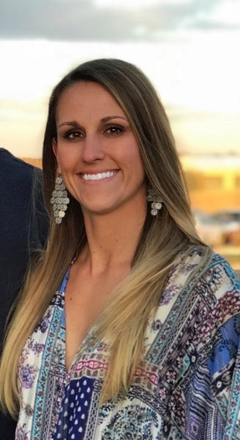

Jessie was born in Atlanta, Georgia and moved to Greenwood Village, Colorado in 1999. She attended school at Colorado Academy and then went to Gonzaga University where she played D1 soccer as a goalkeeper and received her BS in Exercise Science. She went on to physical therapy school at Duke University where she graduated with a Doctorate in Physical Therapy.

Jessie had a shoulder injury in high school that inspired her to go on to become a physical therapist. She specializes in sports medicine, hip preservation, ACL, foot/ankle, and return to sport therapy and works closely with Panorama physicians, physical therapists and performance trainers at The Institute to provide a full continuum of care for her patients. Since obtaining her certification in dry needling, Jessie incorporates this skillset to further assist her patients recover from their injuries. She greatly enjoys being a resource for her patients, staff, and anybody interested in pursuing a career in physical therapy.

Jessie loves the outdoors and in her spare time she enjoys training her horses, hiking, camping, and going on adventures with her husband and dogs. She is an avid football fan and regularly sports cowboy boots with her Atlanta Falcons jersey on casual Fridays.

Fun fact: Jessie can often be found on the dance floor at country bars perfecting her line dancing and country swing dance moves