**Lakewood Belmar Team**

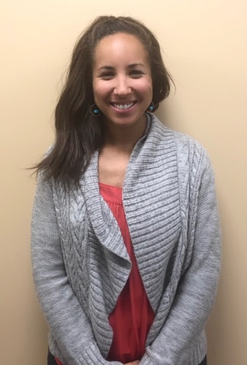**Jamie Ortiz, PT, DPT**

Jamie earned her Doctorate of Physical Therapy from the University of New England in Portland, Maine in 2014. She received her undergraduate degree from Colorado State University where she majored in Health and Exercise Science with a concentration in Sports Medicine. Jamie has focused her PT career in outpatient orthopedics and has had the opportunity to work with a variety of injuries and patients of all ages. She enjoys educating patients regarding their injuries and uses the most up to date evidence based treatments to make sure her patients return to the activities they love as quickly as possible. In her free time, she loves to hike mountains, trail run, stand up paddleboard and camp with her husband, twin boys, and their dog, Duke.

**Reba Havis PT**

Reba Havis grew up in Fort Collins, CO and went to Poudre High School. She enjoys Colorado’s expansive outdoors by hiking with her dogs, rock climbing, and mountain biking. She went to the University of Florida for her undergraduate education and received her Doctorate of Physical Therapy from Northeastern University in Boston, MA. Reba joined the Panorama Team in 2021 following the completion of her education. She treats various conditions of the musculoskeletal system, but takes special interest in chronic pain, hip conditions, and pelvic health.

**Allison White PT**

Allison was born and raised in Colorado. She received her Doctorate of Physical Therapy from CU Anschutz School of Medicine. She received her undergraduate degree in Integrative Physiology from the University of Colorado Boulder. Allison played lacrosse in college as a goalie and now coaches high school girls lacrosse. She also plays Australian Rules Football. Having endured many surgeries, herself she is passionate about treating patients recovering from surgery and helping athletes return to sport. She is certified in dry needling. In her spare time, Allison is a loyal CU Buff fan and attends as many games as possible. You will always find Allison in a cool pair of sneakers.

**Noah Hammer, PTA**

Noah grew up in Lone Tree, CO, where his love for running blossomed into a variety of sports through high school and college. He attended the University of Wyoming, where he graduated with a degree in Urban Studies and Regional Planning. After quickly realizing that the computer life was not for him, he followed in his little brother’s footsteps and pursued a career in physical therapy.

Noah earned his PTA certification from Pima Medical Institute and has been with Panorama PT since February of 2024 (and never looked back). He takes a special interest in proprioceptive manual techniques and patient-centered treatment options, in order to progress each client back to their specific goals.

In his spare time, Noah enjoys the pleasantries of what the mountains have to offer, such as skiing, hiking, fly-fishing, and camping.